**DEPARTMENT OF COSTUME DESIGN AND FASHION**

STUDENTS INDUCTION PROGRAMME FROM 19.6.19 to 25.6.19

Students Induction Programme was conducted from 19.6.19 to 25.6.19 for I year students. Conducting such programme helps the fresher’s to get awareness about the course, orientation on the course, staff members of the department was introduced to the 1st year CDF students. The students were informed about the papers what they will learn during the course time. Orientation was given on the co- curricular activities and the students were asked to enroll. Students were asked to exhibit their talents such as painting, poetry, music and dance, were motivated to participate in inter and intra collegiate competitions. The lectures on human values, yoga and meditation, women empowerment, Health is Wealth and cyber crime was very informative and helpful to the students. Students were taken LAB tour and were oriented about the Do’s and Don’ts inside the lab. They were asked to contact the tutor in charge and HOD for any counseling. On the last date of the programme feed back on students induction programme was collected.

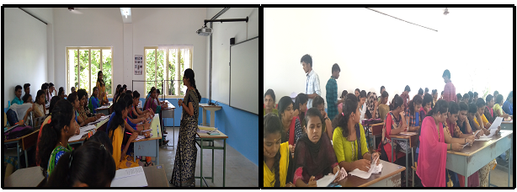

**Report of Guest Lecture on “Overview of Fashion Industry” on 27.06.19**

The Department of Costume Design and Fashion organized guest lecture on **“Overview of Fashion Industry”** by **Mr. Jeevan Xavier, Creative Head, Asian Fabricx Private Limited, Karur,** for the I, II and III yr CDF students in room no. F8 on 27.06.19 between 8.30am and 10.00am. The session began with Prayer song and Mrs. R.Umamaheswari, Head of the department welcomed the gathering.

His lecture focused on what is fashion trend, fashion forecasting, how is trend forecasted from time to time, what is branding, how the branded companies satisfies all levels of customers, the top 15 brands in Fashion, role of Merchandiser. The lecture was more informative and the students gained knowledge on how to plan, organize and when to manufacture the products for the upcoming seasons. Around 140 students actively participated and got benefitted .The session came to an end with the vote of thanks by Mr. Dhanush Kumar, I Yr CDF student.

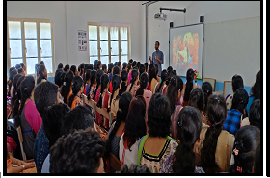

**“REPORT ON GUEST LECTURE "OVERVIEW OF TECHNICAL TEXTILES”**

The Department of Costume Design &Fashion ,Kongunadu Arts & Science College Coimbatore organized a Guest Lecture on "**OVERVIEW OF TECHNICAL TEXTILES**" by **D.Gopalakishnan**,**ResearchFellow**,**PSG Department of Fashion Technology, Coimbatore**. in Room No. F10 for III year CDF Studentson 17th July from 8.30 am-11.30am.

Mrs. R.Umamaheswari, Associate Professor & Head, Department of Costume Design and Fashion welcomed the Gathering. He delivered the guest lecture was on various aspects of technical textiles emphasized the scope of technical textiles and its growth in global export, highlighted on taking up projects in technical textile field . The session ended with the vote of thanks by A.kavinila III yr CDF student.

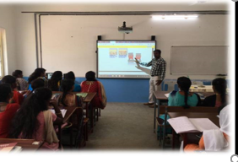

**REPORT ON NATIONAL HANDLOOM DAY CELEBRATION – 25th JULY 2019**

With regard to National Handloom Day Celebration the department of Costume Design and Fashion organized Handloom Fashion Show in Dr.Marappa G. Aruchami Auditorium on 25th July 2019 .Dr.C.A.Vasuki Secretary and Director presided over the function. Principal (i/c) .Dr.M.Lekeshmanaswamy , Chief Executive Officer. Dr.V. Chinnusamy, Dean Academics Dr.Balasubramaniam felicitated the gathering. 24 students of Costume Design and Fashion participated in the fashion show of which two students, Ms.E. Deepika, III Yr CDF and Mr.T.ANithish, III Yr CDF was selected for the final list and awarded as the “Handloom Ambassador” of the Kongunadu Arts and Science College, Coimbatore. They were also honoured with the confirmation letter to participate in the “Grand Handloom Fashion Show” on 7th August 2019 at PSG college of Arts and science, Coimbatore.

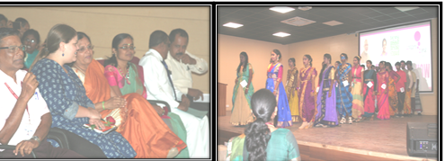

**MOU Signing**

**Report On Guest Lecture On How To Start Up A New Venture**

The Department of Costume Design and Fashion KASC signed MOU WITH AIC-NIFTTEA Incubation Centre Textiles and Apparels, Tirupur, Tamilnadu in the presence of Dr.M.Lekeshmanaswamy Principal i/c on 31.07.2019 at 10.45 am in principal chamber.

S .Periasamy CEO, AIC-NIFTTEA Incubation Centre Textiles and Apparels, Tirupur, Tamilnadu and Dr. Senthil Kumar visited the department and labs, delivered lecture on How to start up a New Venture. The session began with invocation,Mrs.R.Umamaheswari,Head of the department welcomed the gathering . Dr. Senthil Kumar discussed about the various government schemes related to start up a new ventures, S .Periasamy CEO, AIC-NIFTTEA Incubation Centre Textiles and Apparels discussed about the objectives of incubation centre, the pre- incubation facilities for the students and faculties. The session ended with vote of thanks by A. Kavinila III CDF Year student.

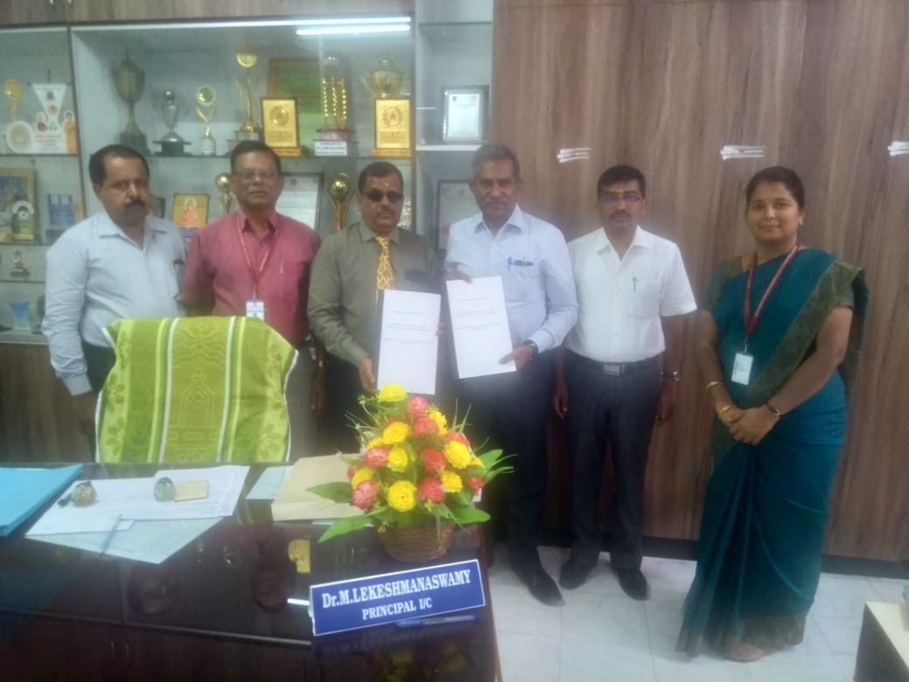

**REPORT OF THE ONE DAY WORKSHOP ON 08.08.19**

The department of Costume Design and Fashion organized one day workshop on “Basics of Draping Techniques” by Mrs. N. Nithya, Assistant Professor, Department of Costume Design and Fashion, TIPS Global Institute, Coimbatore on 8th August 2019 in room no. F14 and Draping lab between 10.00 am and 4.30 pm. In the morning session the II and III yr students was divided into two batches and the basic draping technique - basic bodice, skirt, collar and neckline, how to make functional and decorative darts, moving dart from one location to another location, French dart and equivalent dart in the bodice pattern was demonstrated. The students were also instructed to drape their own styles on the dress forms. The afternoon session was followed by draping the yoke, fullness such as pleats, gathers, tucks and different draping styles of ladies tops such as butterfly, peplum and radiant was also demonstrated. Preparation of a dress form was demonstrated to both the batches. Around 66 students actively participated in the workshop and got benefited.

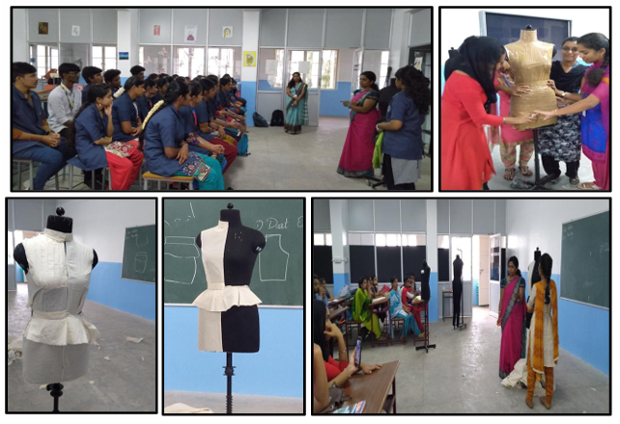

**Department of Costume Design and Fashion (2019-20)**

The Department of Costume Design and Fashion of Kongunadu Arts and Science College, Coimbatore, arranged one day field visit to TODA TRIBE village, the Nilgiris **to** understand the **“TODA Tribe Culture, Clothing and Art”** on 27.09.2019 of II-year CDF Students.

The Toda tribes of Tharanad mand village were very active and moved with friendly nature. Toda embroidery is one of the traditional tribal embroidery in south India, but it is yet to be developed in commercial scale. During the visit the students learnt techniques to work the Toda embroidery. The field visit conducted was helpful for students to get to know about tribes their daily life, language, history, culture and development today.34 students along with two staff members visited the village.

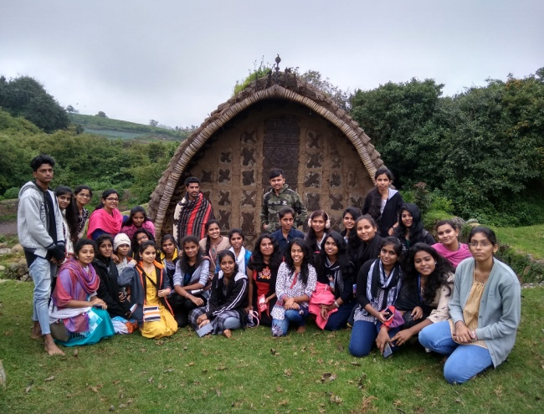

**Report on Exhibition cum Sale On 04.10.19**

The Department of Costume Design and Fashion organized one day Exhibition cum Sale on **“Indian Tribal Art and Culture”** in conference hall On 04.10.19 .Dr.C.A.Vasuki, Secretary and Director Inaugurated the exhibit, Principal Dr. M. Lakeshmanaswamy inaugurated the sale along with the Chief Executive Officer Dr. V. Chinnusamy.

The exhibit was on the major Indian tribes ,their art and culture .students grouped themselves to six and each group worked on two tribes .The Costumes of tribes was draped on live model and on dummies .Products for Exhibit and Sale were Fashion jewelleries ,paintings on tribal art, wall hangings, paper bags ,photo frames, bottle paintings, Jute furnishings and pot painting . Orders completed through designer unit- Classy missy like Aari embroidered blouse, kurthi’s were also displayed in the exhibit .

