**A report of Webinar on**

**“ Covid – 19 pandemic spurs innovation in Health care and Hygiene textiles”**

The department of Costume design and fashion, Kongunadu arts and science college have organised a webinar on **“ Covid – 19 pandemic spurs innovation in Health care and Hygiene textiles”** on June 9th 2021 at 11 am. Around 300 participants comprising of Research scholars, Faculty members, students and Industry professionals from various institutions and organizations participated in this webinar. The session was organised with an eminent resource person, Dr. V. Ramesh babu, Associate professor and Head, Department of Textile technology, Kumaraguru college of technology, Coimbatore. The webinar has been started formally with welcome address given by Assistant professor of costume design and fashion department, Mrs. R. Yamini then the felicitation address was given by Dr. S. R. Madhan Shankar, Dean academics of Kongunadu arts and science college who supported and motivated for the conduction of this webinar.

The actual crux of the webinar has been started by the resource person with the primary description about the health care and hygiene textiles and it’s application in today’s pandemic situation. The presentation further headed towards various products in the medical textiles like surgical gowns, caps, masks, gloves and so on., which were really in the need of the hour products. Clear classification of medical textiles has been clarified. The chemical finishes and the materials used for the manufacturing of the products has been explained. The application of the products and its importance were seremoned in the detailed manner.

The session reached its time with the provocating discussion regarding the recyclable properties of the medical textiles, also the apparel wastes to be turned into use for the medical textiles, which are making spurs in the innovation of health care textiles.

The enlightened webinar was concluded by the formal extension of gratitude by the department head and Assistant professor Dr. P. Sasikala with special thanks to the resource person, who gave an informative discussion on the right topic at the right time.

The vote of thanks was given by Ms. P. V Asmitha, Assistant professor of Costume design and fashion, who expressed gratitude to the college management and the department head for this constant encouragement and support in conducting the webinar, the participants and all the organizers who were joined together to make the webinar a great success.

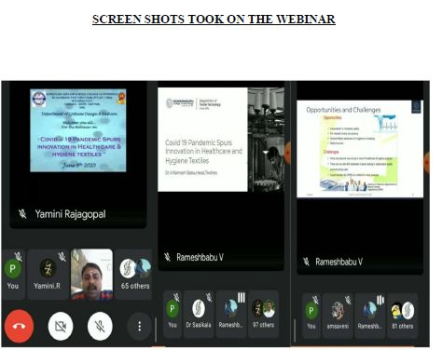

**A report of Webinar on**

**“Entrepreneurship and Innovation Management”**

The department of Costume design and fashion, Kongunadu arts and science college have organised a webinar on **“Entrepreneurship and Innovation Management”**on September 25th 2021 at 9 am. All the students from the department,around 90 people participated in this webinar. The session was organised with an eminent resource person, Mrs. B. Sujana, AssistantDesigner, Furrfido– Mumbai who was Alumni of Costume Design and Fashion, Kongunadu Arts and Science College. The webinar has been started with welcome address given by Dr. P. Sasikala, Head of the department, costume design and fashion. The actual crux of the webinarhas been started by theresource person with the primary description about the Career opportunities in the Textile and Apparel industry.

­­­­The presentation further headed towards various opportunities and skills to develop the Entrepreneurial skills in the industry. Clear explanation about Higher studies in the fashion field and the Start Up ideas in the Apparel and Textile industry. The applications of the ideas into business were seremoned in the detailed manner.

The session reached its time with the provocating discussion regarding the higher studies in the fieldwhich were clearly explained by the Resource person of the session.

The enlightened webinar was concluded by the formal extension of gratitude for giving an informative discussion on the suitable topic for the students at the right time.

**SCREEN SHOTS TOOK ON THE WEBINAR**

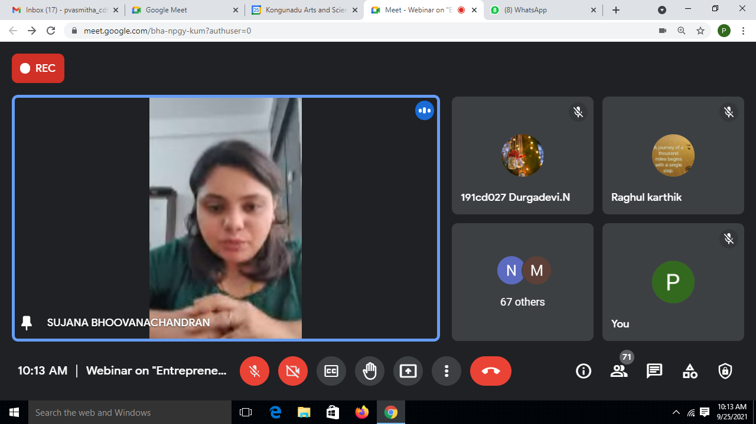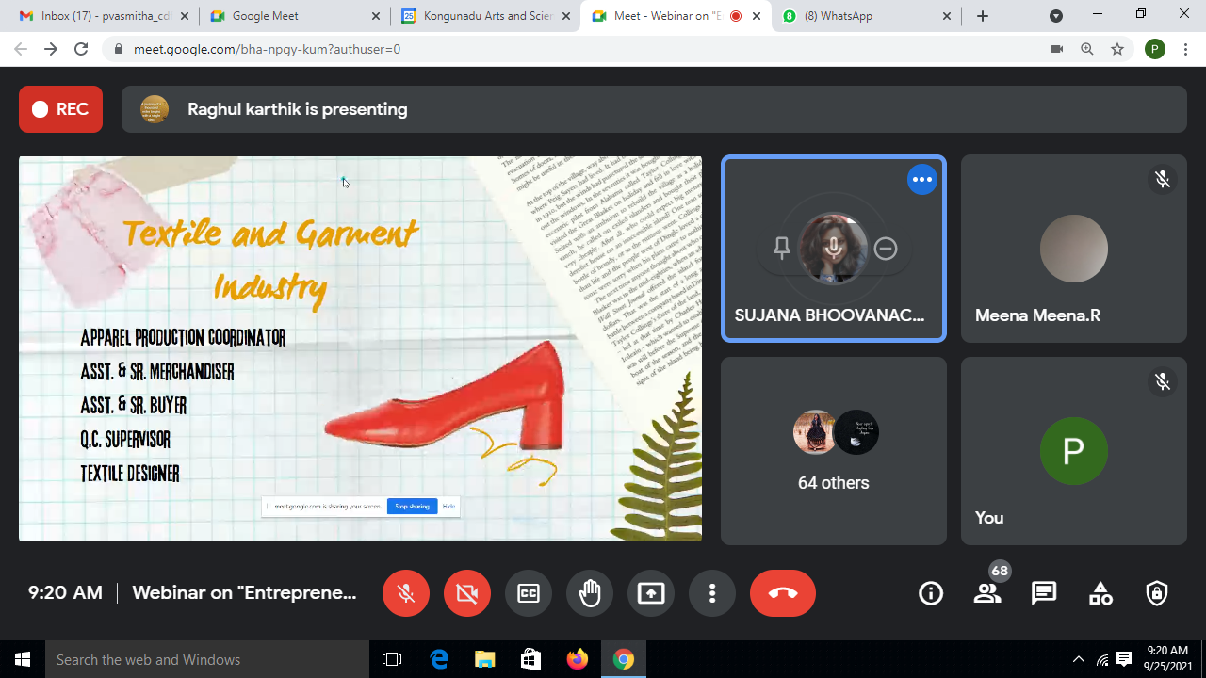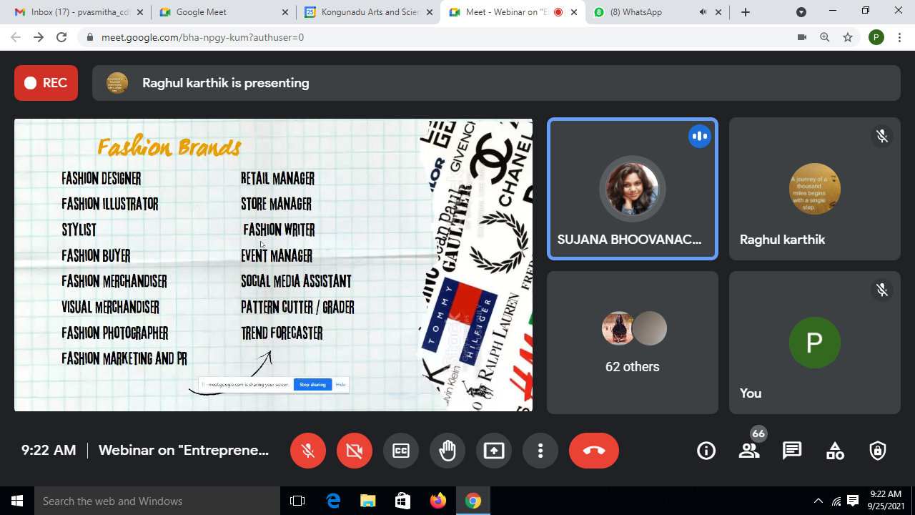

**Report of the festive event- Ayudha Pooja and Saraswathi Pooja Celebration on 12.10.2021**

Our department organized a programme for the **commemoration of Ayudha Pooja and Saraswathi Pooja on 12.10.2021 at 10.00am in II Year classroom.** All the staffs and students were cordially invited to attend this programme. Our department was beautifully with traditionally made bandhanwars using marigolds, lotuses, mango leaves and bells. All staff and students came together to worship Goddess Saraswathi, the Goddess of Knowledge, Art and Music and all staff members conducted the aarthi. The celebration came to an end with the distribution of pori, kadalai, sundal and pongal.

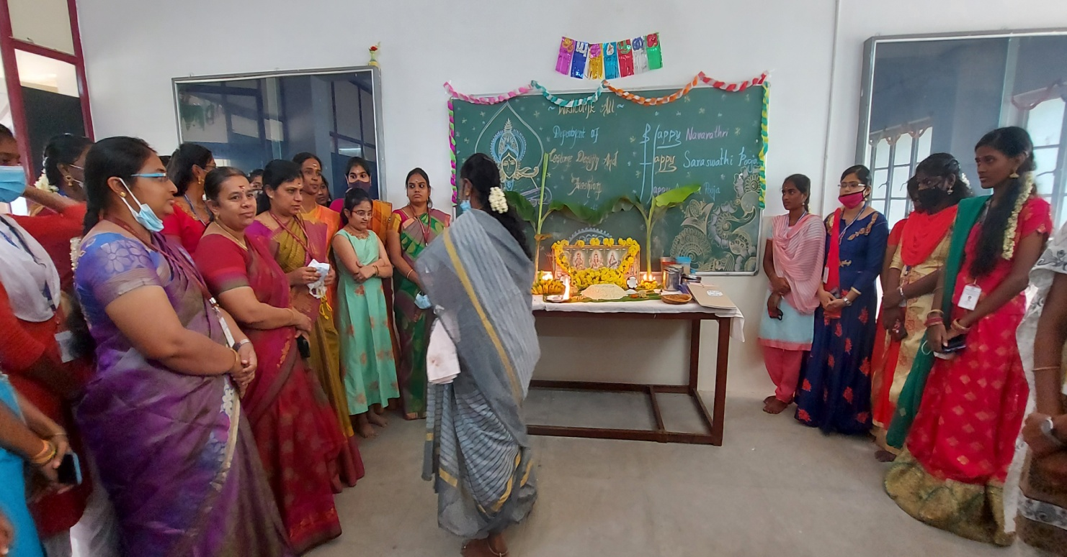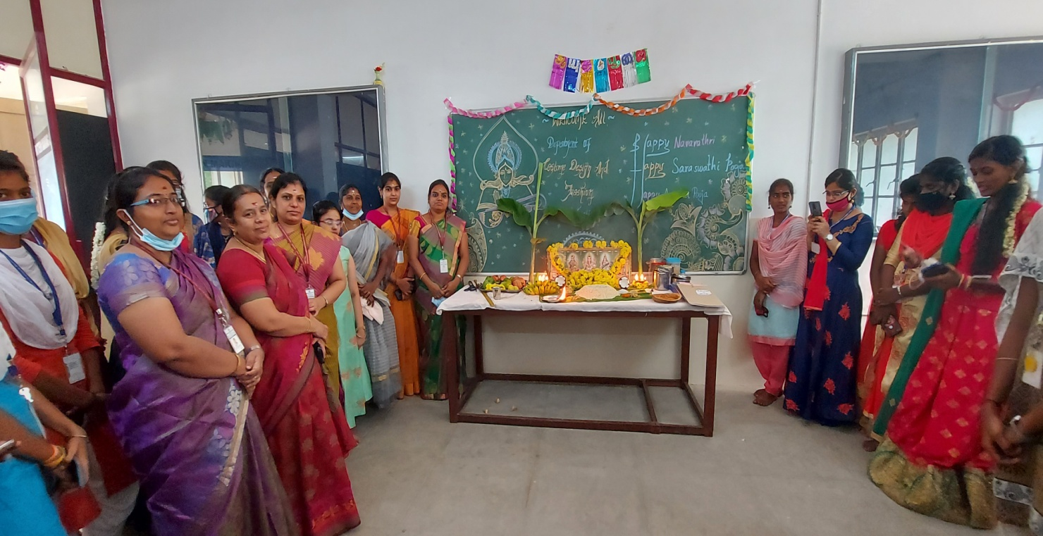

**Report For Recent Trends in Design Aspect on 9thDecember 2021**

The Department of Costume Design and Fashion organizedWebinar on **“Recent Trends in Design Aspect”** for I ,II & III year Costume Design and Fashion students on 9th December 2021 to by Ms.A.Kavinila , Designer Fashion Spot ,Gobi. who was the Alumni of our department.

The Session was begun with a Welcome Address by A.Vinothini II CDF. The session was taken over by the guest and she highlights new design trends of 2021, emerging trends of graphic design the Scope in designing field was explained clearly for the students. The session was ended with Vote of Thanks by R.MiniAnnies II CDF Around 77 Students actively participated and got benefited.

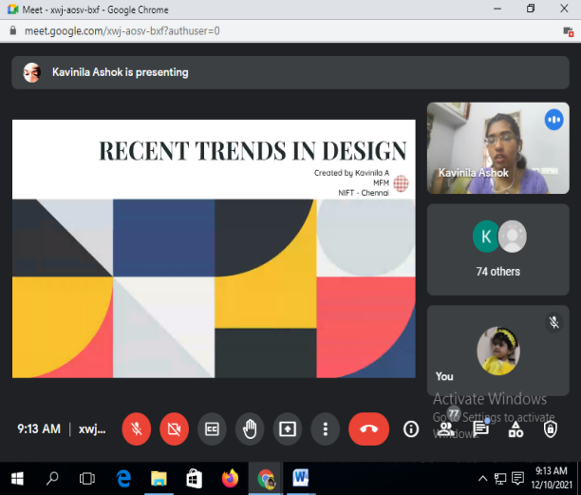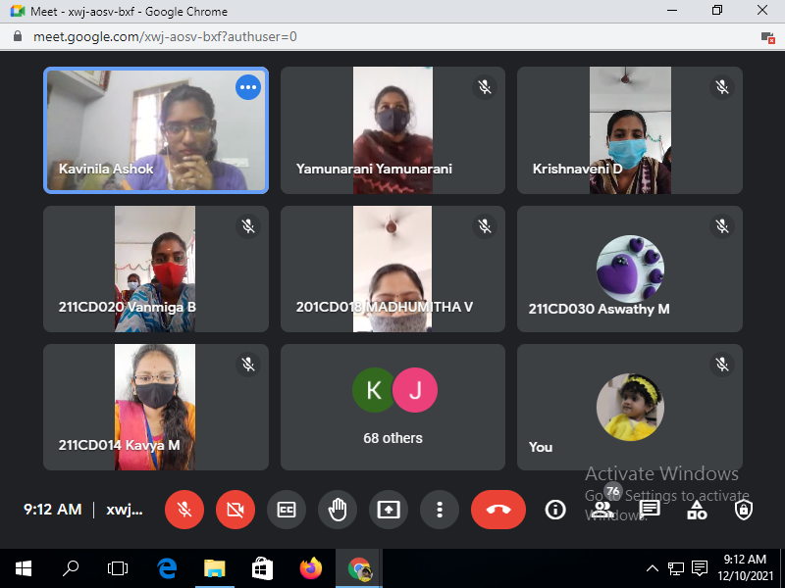

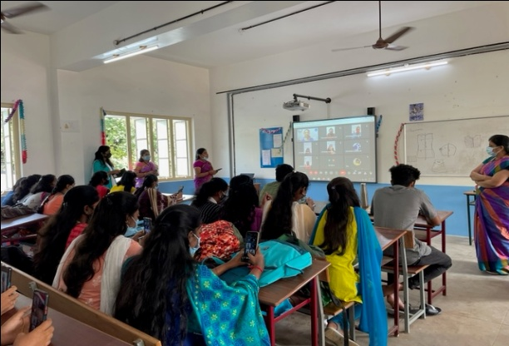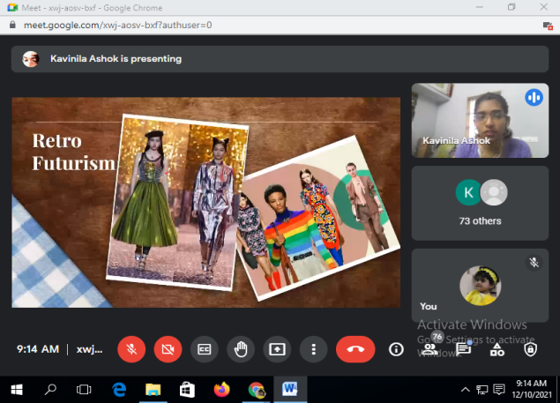

The Department of Costume Design and Fashion organizedWebinar on **“Recent Trends in Design Aspect”** for I ,II & III year Costume Design and Fashion students on 9th December 2021