**Webinar Report on**

**“Prototype Validation Converting Innovation into Startup”**

The **Department of Costume Design and Fashion, Department of Computer Science (SF) and Institution’s Innovation Council, KASC** jointly organized a Webinaron**“Prototype Validation Converting Innovation into Startup”** by **Ms.SathyaSundarraj,**Proprietor,Surekara Enterprises, Bangaloreon **28.08.2023** through MS Teams Plat form from **11.00 am to 12.00pm** (IST).

The session was started with a Prayer song byI B.Sc Costume Design and Fashion and the welcome address was given by **Mrs.M.Sindhu,** Assistant Professor,Department of Costume Design and Fashion,Student ofI B.Sc Costume Design and Fashionintroduced the Chief Guest and the session was handed over to the chief guest she explained about start-ups and the novel innovations, Job generates, and more career opportunities. Startups in India are shaping the future of the country, driving innovation and economic growth.**Dr.R.Saravana Moorthy, Academic Coordinator**,Staff members and Students from Department of Costume Designand Fashion, Department of Computer Science (SF) asked the questions about Startups the speaker clarified their doubts and the session was ended with vote of Thanks by **Dr.S.Divya,** Assistant Professor, Department of Costume Design and Fashion, KASC. Around 117 Participants actively Participated in this webinar.

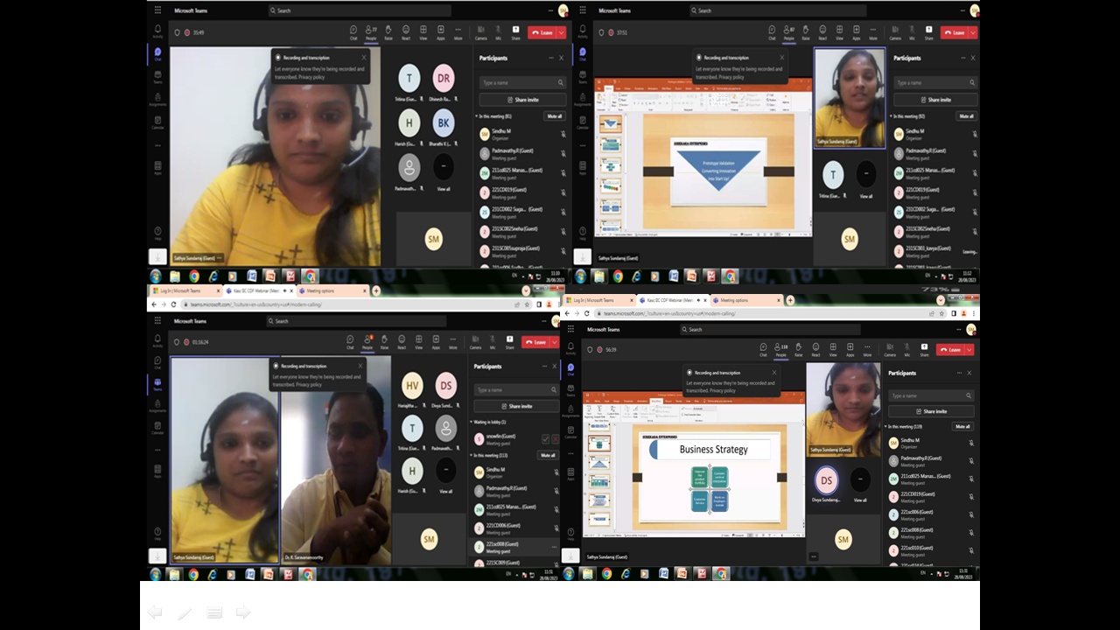

**The Department of Costume Design and Fashion, Department of Computer Science (SF) and Institution’s Innovation Council jointly organized a Webinaron “Prototype Validation Converting Innovation into Startup” by Ms.SathyaSundarraj, Proprietor,Surekara Enterprises, Bangalore on 28.08.2023 through MS Teams Plat form from 11.00 am to 12.00pm (IST).**

**KONGUNADU ARTS AND SCIENCE COLLEGE**

**DEPARTMENT OF COSTUME DESIGN AND FASHION**

**REPORT ON GENDER EQUALITY DEBATE**

The Department of Costume Design & Fashion, Kongunadu Arts& Science College Coimbatore organized a “**DEBATE ON GENDER EQUALITY”**by **Ms. Padmini.P,**Assistant Professor, Department of Tamil, KASC,Coimbatore,on **11.09.2023** venue: **F10**  from **10.00 am to 11.00am** (IST). Many students enrolled to become a part of the debate. Everyone shared their points to the Judge and made the debate more interesting. Gender equality is when people of all genders have equal rights, responsibilities and opportunities. [Everyone is affected](https://www.vic.gov.au/gender-inequality-affects-everyone) by gender inequality - women, men, trans and gender diverse people, children and families. It impacts people of all ages and backgrounds. Few students said that male has high potential in this field. But the opponent students disapproved that point and said that boys have less opportunity because of people stressed on men designers. Finally, our judges concluded that both men and women must give equal importance in every field.

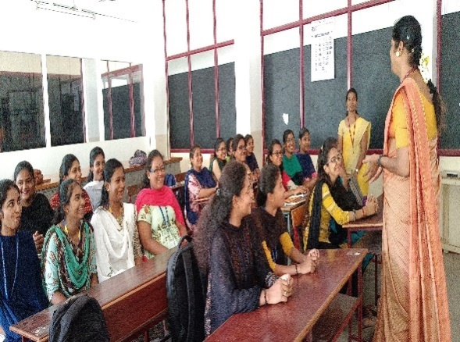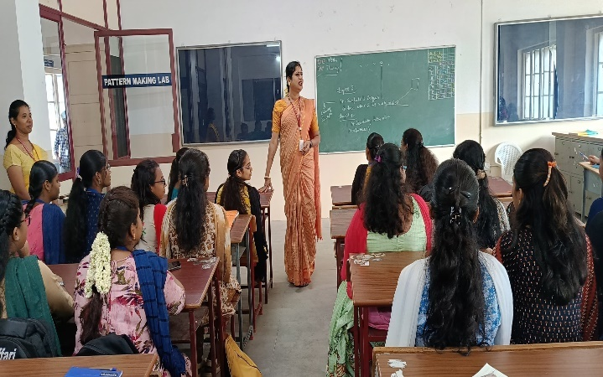

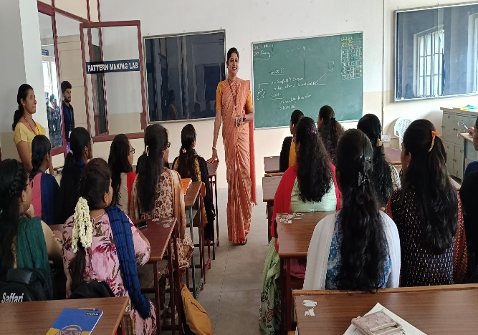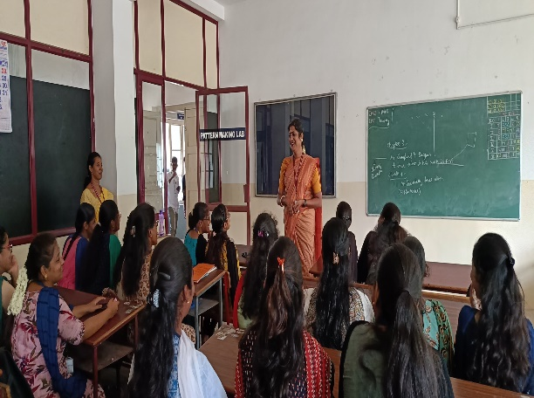

The Department of Costume Design and Fashion, organized a **DEBATE ON GENDER EQUALITY**by **Ms. Padmini.P,** Assistant Professor, Department of Tamil , KASC,Coimbatore, on **11.09.2023**Time **10.00 am to 11.00am (IST).**

**Report of the Guest Lecture on Personality Development**

**Date**  : 20/12/2023 **Time** : 11.30am to 12.30pm **Platform** : MS Teams **No. of. Participants** : 120 **Speaker** : Mr.A.NawazBabu **Topic**: Personality Development

The Department of Costume Design and Fashion and NDLI Club of Kongunadu Arts and Science College jointly organized a Guest Lecture on Personality Development on 20th December2023 through MS Teams platform by Mr.A.Nawazbabu, Technical lead, LTI Mindtree.

The session was started with a prayer song by Sowbaranika from IstB.Sc Costume Design and Fashion, Welcome Address given by yaasika from IIndB.Sc CDF, Srinithi from IIndB.Sc CDF introduced the chief guest and the session was handed over to the chief guest, he has started the session aimed to shed light on various facets of personality, the factors influencing its development and strategies to enhance one's personality for personal and professional growth. Discussed how genetics, environment, experiences, and upbringing contribute to shaping personality.Emphasized the importance of self-reflection for understanding one's strengths, weaknesses, and personal growth opportunities. The interactive nature of the session, including discussions and practical exercises, facilitated an engaging and enriching experience for all participants. Around 120 participants actively participated in this event.

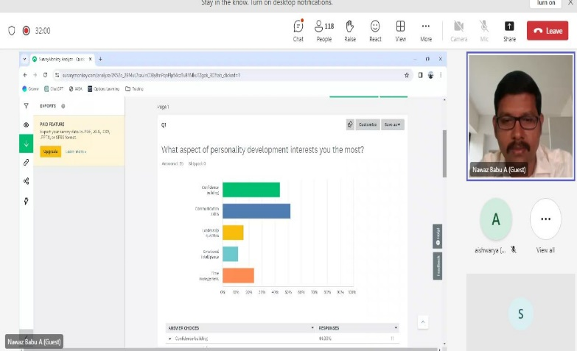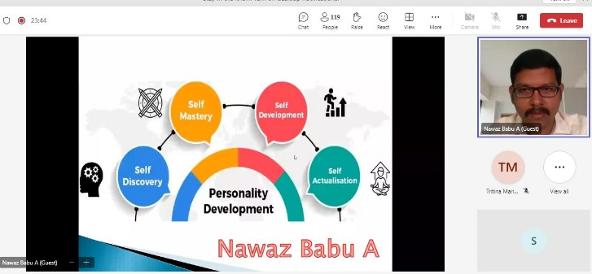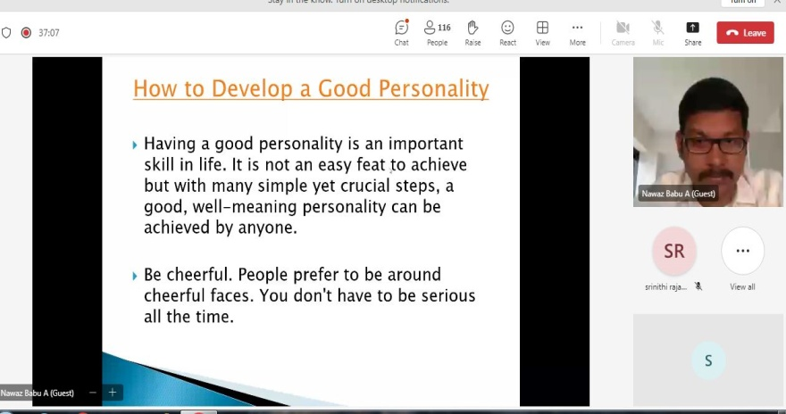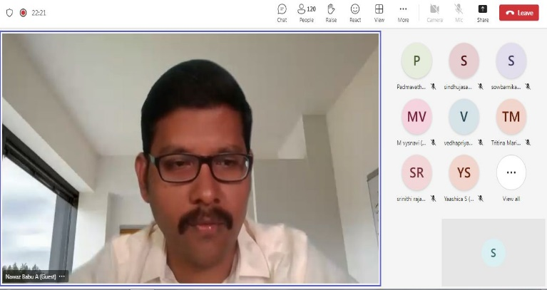

**Report of the Community Activity on “An Awareness Program on Plastic Free Bags for Local Community”**

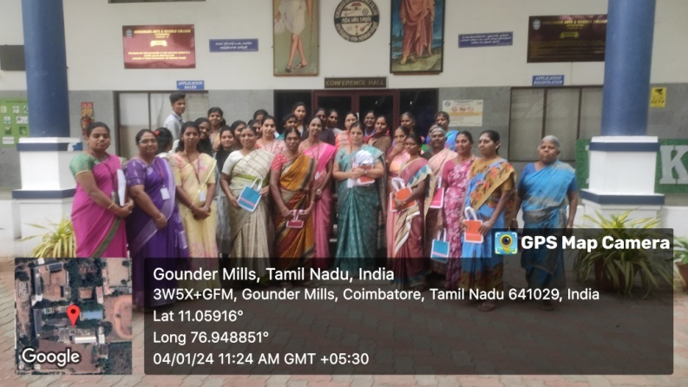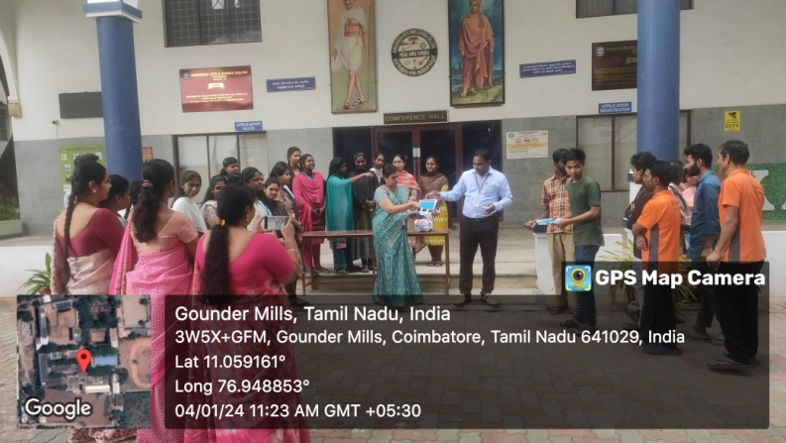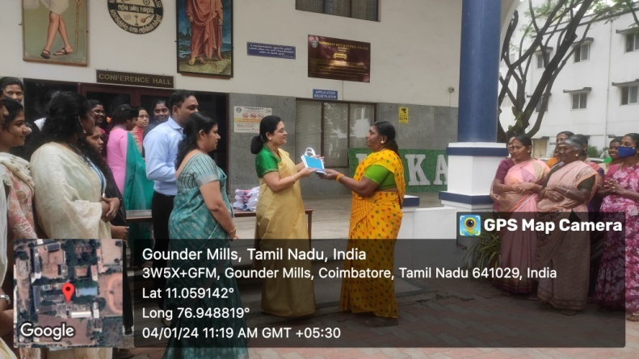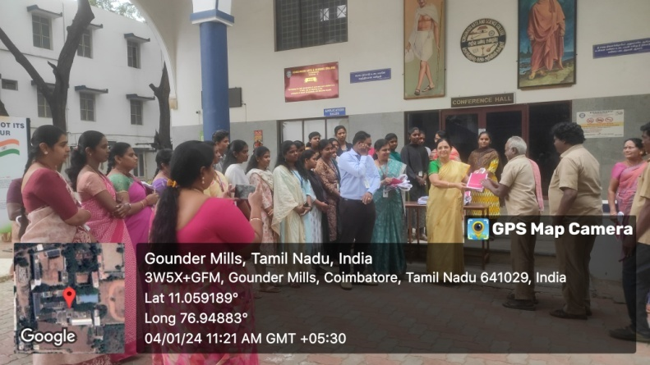The Department of Costume Design and Fashion has organized a Community Activity on “**An Awareness Program on Plastic Free Bags for Local Community”** on 4thof January 2024. Our department students dyed the jute materials in three different colors (Pink, Blue & Orange) and the dyed material was given tostitching unit of women’s self help group to construct around 60 jute bags, In front ofthe conference hall at 11.00am the jute bags were distributed by Dr.C.A.Vasuki, Secretary & Director and Dr.R.Saravana Moorthy, Academic coordinator. OurSecretary has delivered a note regarding the environmental impact of plastic pollution and creating awareness on jute bags for housekeeping staffs. The awareness program aimed to educate andengage the local community in adopting a plastic-free lifestyle.

**Report on National Level Symposium - “VASTHRAM 2K24”**

The National level Symposium -“VASTHRAM 2K24”organised by the Department of Costume Design & Fashion of Kongunadu Arts & Science College, GN Mills, Coimbatore was held on 2nd February 2024.Every aspect of the event, from its inception tothe execution had been the outcome of the culminated efforts of students and the faculty members of Costume Design & Fashion department.

The online registration for the symposium was opened on 1st January 2024 and spot registrations also accepted till 02ndFebruary 2024.On the time of registration an over warming response had been received from the participants from various college over Tripur, Erode and Coimbatore district.

The chief guest for the event **Dr. M. Revathi Bala,** Associate Professor & Head Department of Commerce with Professional Accounting, Kongunadu Arts & Science College, GN Mills, Coimbatore shared wonderful words of encouragement with the students quoting the need to invest in improving the practical know-how of every Costume Design student apart from the theoretical knowledge they gain in the course of their study.

This symposium witnessed the enthusiastic participation of over 80 students in over 6 events. The following are the events that were organized as part of theNational level Symposium:**Mehandi, Nail Art, Trendy Face Painting, Fashion Draping, Hair Do and Designer Contest.** The participated students were tested their wits and abilities and the certificates distributed for theparticipated students.

During the valedictory function the Head of the Department **Dr.P.Sasikala**, Associate professor, Department of Costume Design & Fashion and **Dr. M. Revathi Bala,** Associate Professor & Head Department of Commerce with Professional Accounting, Kongunadu Arts & Science College,appreciate the winners with medals & certificates. **Dr.S.Divya, VASTHRAM 2K24 Organizer,** Assistant Professor, Department of Costume Design & Fashion gave the vote of thanks

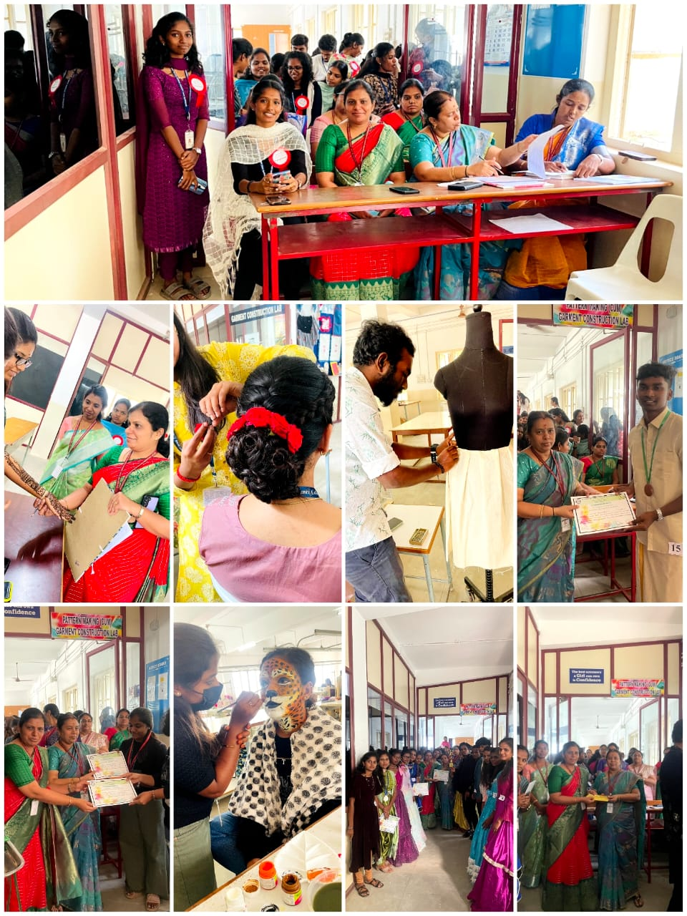

**The Department of Costume Design and Fashion Organized National Level Symposium - “VASTHRAM 2K24” on 02/02/2024.**

**REPORT ON TRIBAL EXHIBITION 22.02.2024**

The Department of Costume Design and Fashion organized a Tribal Exhibition in collaboration with The Centre for Tribal Studies on 22nd February 2024 at Conference hall. The exhibition was inaugurated by our Secretary Dr.C.A.Vasugi, in the presence of Dr. M. Lekeshmanasamy, Principal and Dr. R. Saravanamoorthy, Academic Co-Ordinator, Kongunadu Arts and Science College, Coimbatore. Our students displayed the miniature model of tribal habitat, tribal paintings, Art and Crafts products to enlighten their life style and culture of our Indian tribes. Our students dressed up like the different Indian tribal people depict the Indian tribal culture. Toda tribes from Niligris displayed their own handmade products to showcase their unique embroidery patterned products.

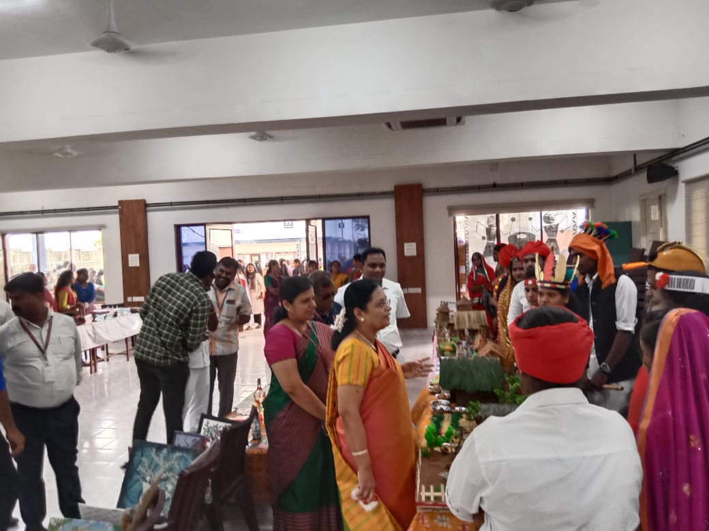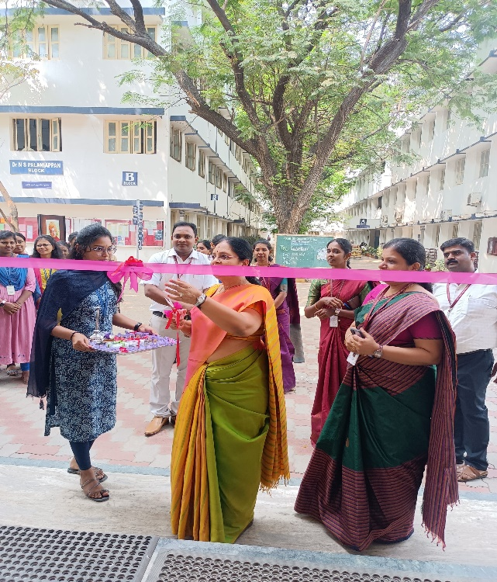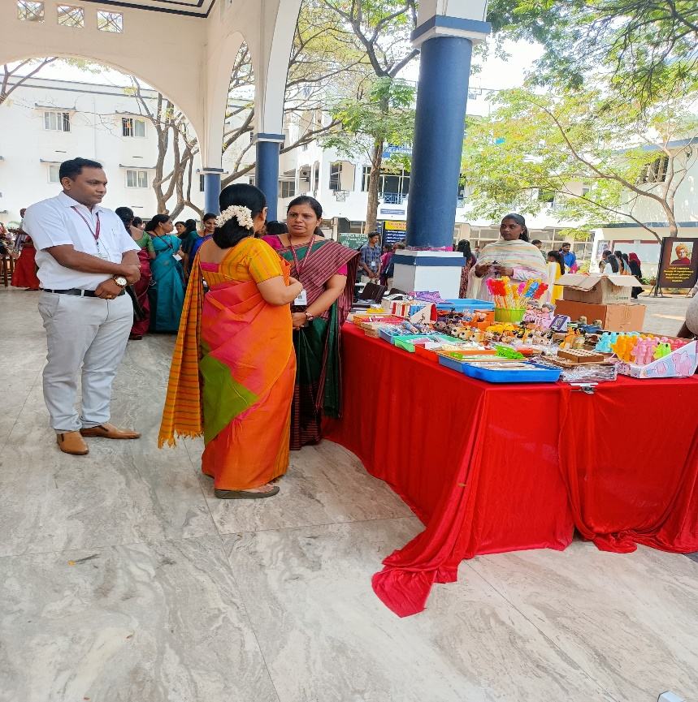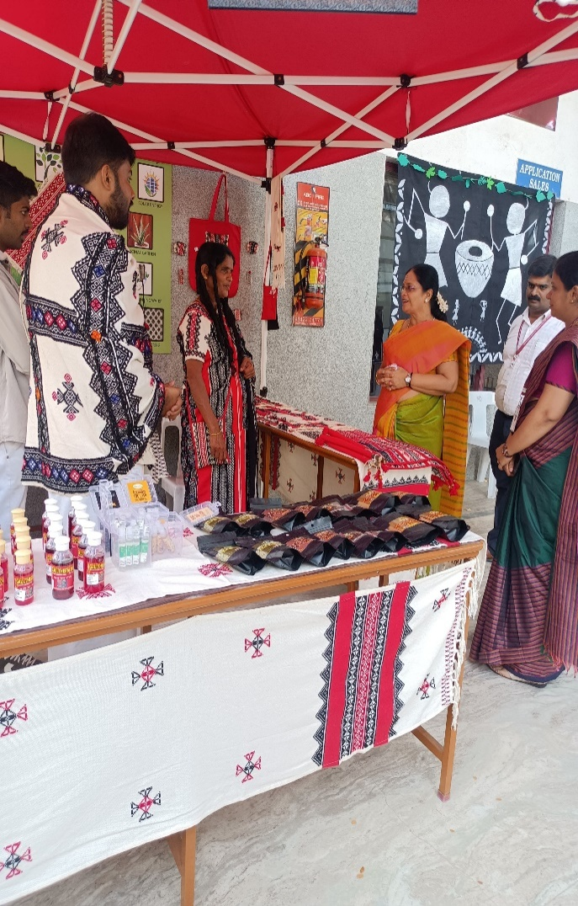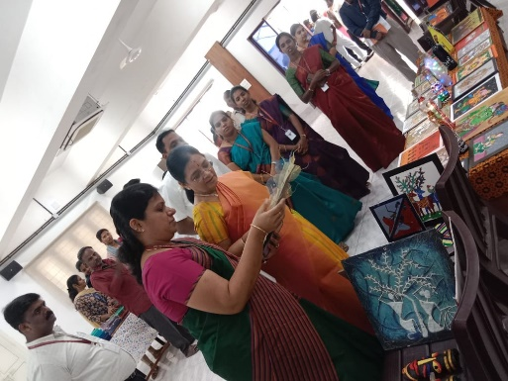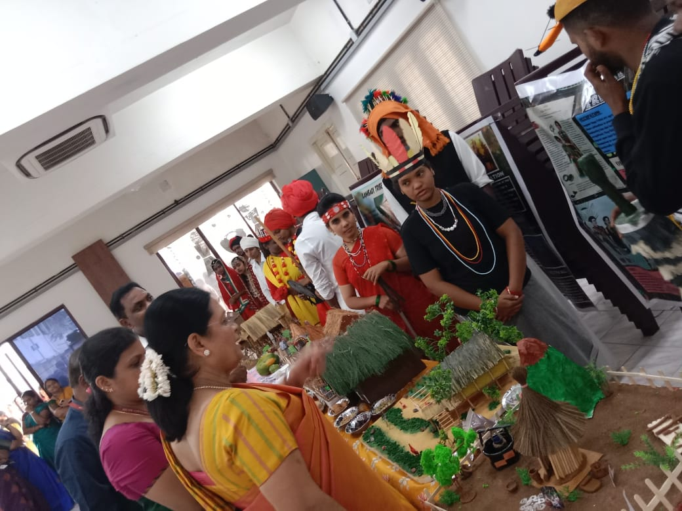

**FRAMES OF THE TRIBAL EXPO CUM SALE**

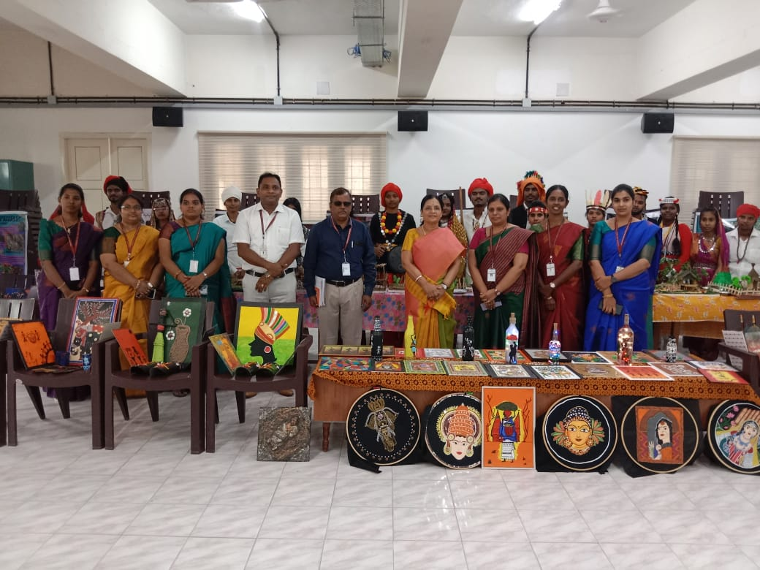

**Webinar Report on**

**“Over usage of Social Media Problem Faced by the Student”**

The **Department of Costume Design and Fashion,** organized a **Group Counselling** on**“Over usage of Social Media Problem Faced by the Student”**by **Mrs.B. Kavitha,**Assistant Professor & Head I/C, Department of Psychology, KASC,Coimbatore,on **16.03.2024** venue: **F10**  from **10.00 am to 11.00am** (IST).

The session was started with a Prayer song byI B.Sc Costume Design and Fashion and the welcome address and introduction of the Chief Guest was given by **Dr.P.Sasikala,**AssociateProfessor& Head,Department of Costume Design and Fashion. The session was handed over to the chief guest she explained about the problems in Social media, behavioral disorder and she given hypnotic-oriented counseling for our students by using a hypnotic-oriented counseling approach. The Staff members and Students from Department of Costume Design and Fashion asked the questions about their mental stress and how to overcome from the social media issues the speaker clarified their doubts and the session was ended with vote of Thanks by **Dr.S.Divya,**Assistant Professor, Department of Costume Design and Fashion, KASC, Coimbatore.

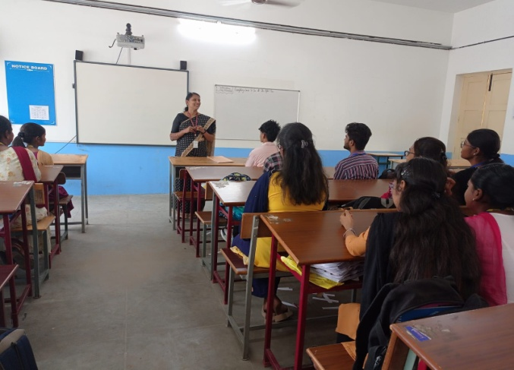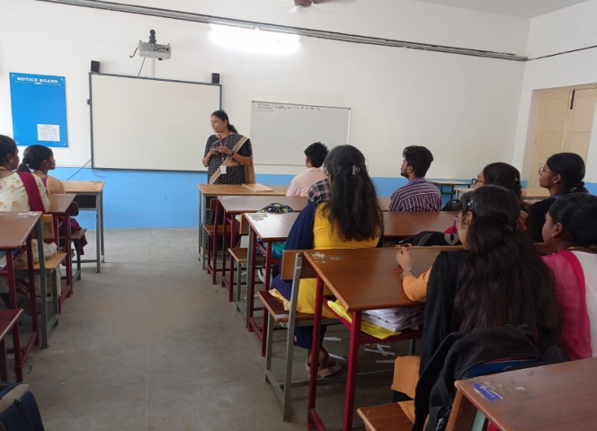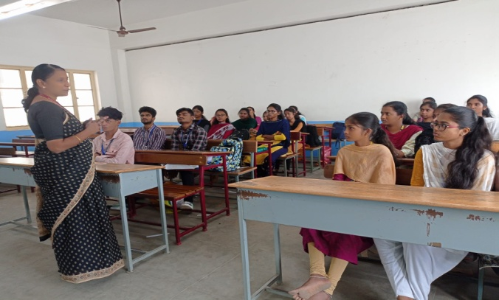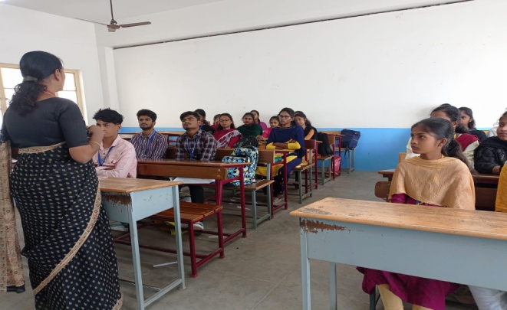

The Department of Costume Design and Fashion, organized a **Group Counselling -**on **“Over usage of Social Media problem faced by the Student”** by **Mrs.B.Kavitha,** Assistant Professor & Head I/C, Department of Psychology, KASC,Coimbatore, on **16.03.2024** Time **10.00 am to 11.00am (IST).**

**REPORT ON FACE PAINTING COMPETITION ON**

**AWARNESS ABOUT 100% VOTING**

**AMONG THE FIRST TIME VOTERS**

The Department of computer science with data analytics and the Department of costume design and fashion jointly organised a “Face Painting Competition on Awareness About 100% Voting Among the First Time Voters” on 23.03.2024 at 11 am in F8 – CDF Department Garment Construction lab. The programme aimed to raise awareness about the importance of 100% voting among the First Time Voters. The event served a creative platform for the students to express their thoughts and ideas regarding the Democratic Duty of every citizen of our country. The diverse perspectives and innovative thoughts of the students, added depth to the competition. Participants created their creativity through vibrant and meaningful face paintings. The event was presided by Dr. P. Sasikala, Associate Professor & Head, Department of costume design and fashion and Dr. L. Kathirvelkumaran, Assistant Professor & Head, Department of computer science with data analytics. The panel decided the Prize winners and they distributed the prizes for the winners. To add with, students were gathered to form a Human Chain representing a collective determination to form – “100% VOTING”, which advocated the pivotal role of college students as the First Time Voters. The human chain symbolized the interconnectedness of the individuals in shaping the democracy and emphasized the role of every citizen in upholding the electoral participation.

