**KONGUNADU ARTS AND SCIENCE COLLEGE**

**DEPARTMENT OF COSTUME DESIGN AND FASHION**

**REPORT ON GENDER EQUALITY DEBATE**

The Department of Costume Design & Fashion, Kongunadu Arts& Science College Coimbatore organized a “**DEBATE ON GENDER EQUALITY”** by **Ms. Padmini,** Assistant Professor, Department of Tamil, KASC, Coimbatore, on **10.07.2024** venue: **F10**  from **10.00 am to 11.00am** (IST). Many students enrolled to become a part of the debate. Everyone shared their points to the Judge and made the debate more interesting. Gender equality is when people of all genders have equal rights, responsibilities and opportunities. [Everyone is affected](https://www.vic.gov.au/gender-inequality-affects-everyone) by gender inequality - women, men, trans and gender diverse people, children and families. It impacts people of all ages and backgrounds. Few students said that male has high potential in this field. But the opponent students disapproved that point and said that boys have less opportunity because of people stressed on men designers. Finally, our judges concluded that both men and women must give equal importance in every field. *“The path to equal faces many obstacles. Yet it is the only path to a more peaceful, prosperous and sustainable world.*

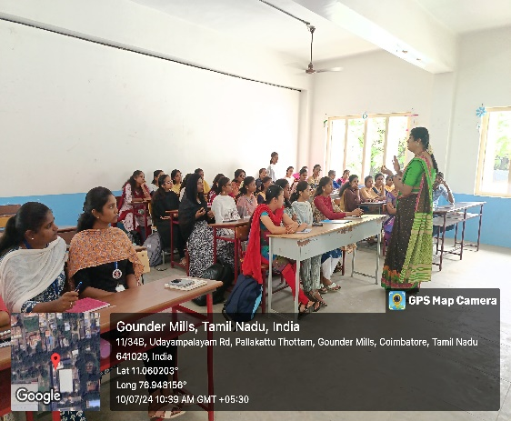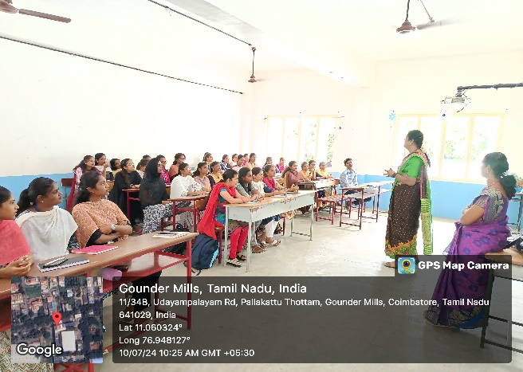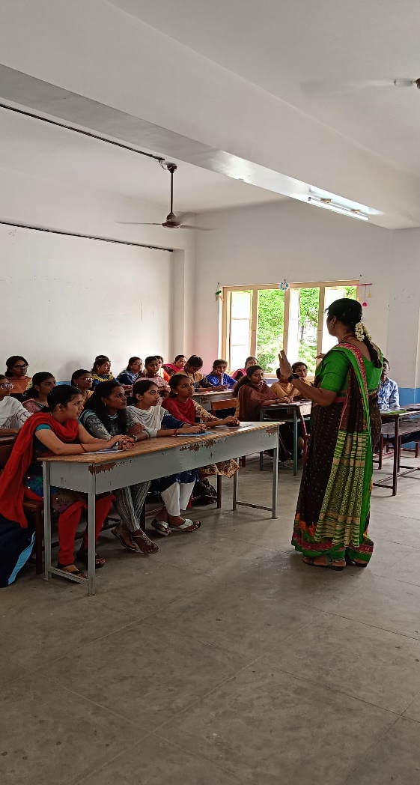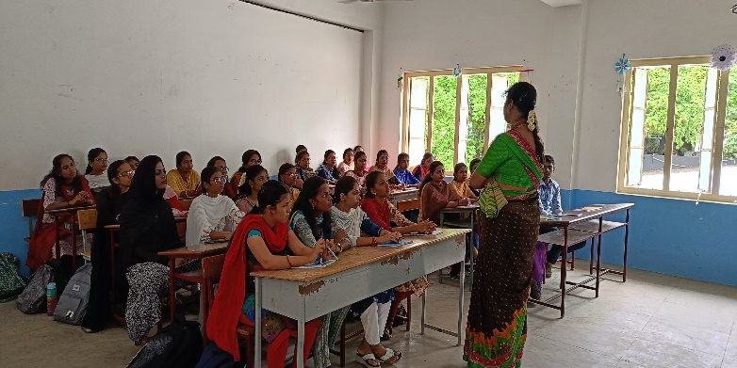

The Department of Costume Design and Fashion, organized a **DEBATE ON GENDER EQUALITY** by **Ms. Padmini. P,** Assistant Professor, Department of Tamil, KASC, Coimbatore, on **10.07.2024** Time **10.00 am to 11.00am (IST).**

**KONGUNADU ARTS AND SCIENCE COLLEGE**

**DEPARTMENT OF COSTUME DESIGN AND FASHION**

**REPORT ON ADVANCE BLOUSE DESIGNING -WORKSHOP**

The Department of Costume Design & Fashion, Kongunadu Arts & Science College Coimbatore, organized an **“Advance Blouse Designing” workshop**by **Mr.S.Aaron Issac,** Eve Tailors, Sai babacolony, Coimbatore,on **29.07.2024.** Venue: **Construction Lab** from **8.30 am to 3.15 pm** (IST).  The workshop creates a discernment understanding of Advance Blouse designing technique, which is very important to get progressive knowledge about the blouse designing and constructing. Students have learned about the sewing procedure of the advanced blouse designing. They also learned about pattern making, cutting, and sewing methods of advanced blouse. The workshop program helps our students to improve their practical knowledge in patterning and constructing the blouse, stimulate their own creative impulses, and also helps in new ideas and inspirations for future work. After attending this session, the students got more knowledge on blouse designing and making in an operative way.

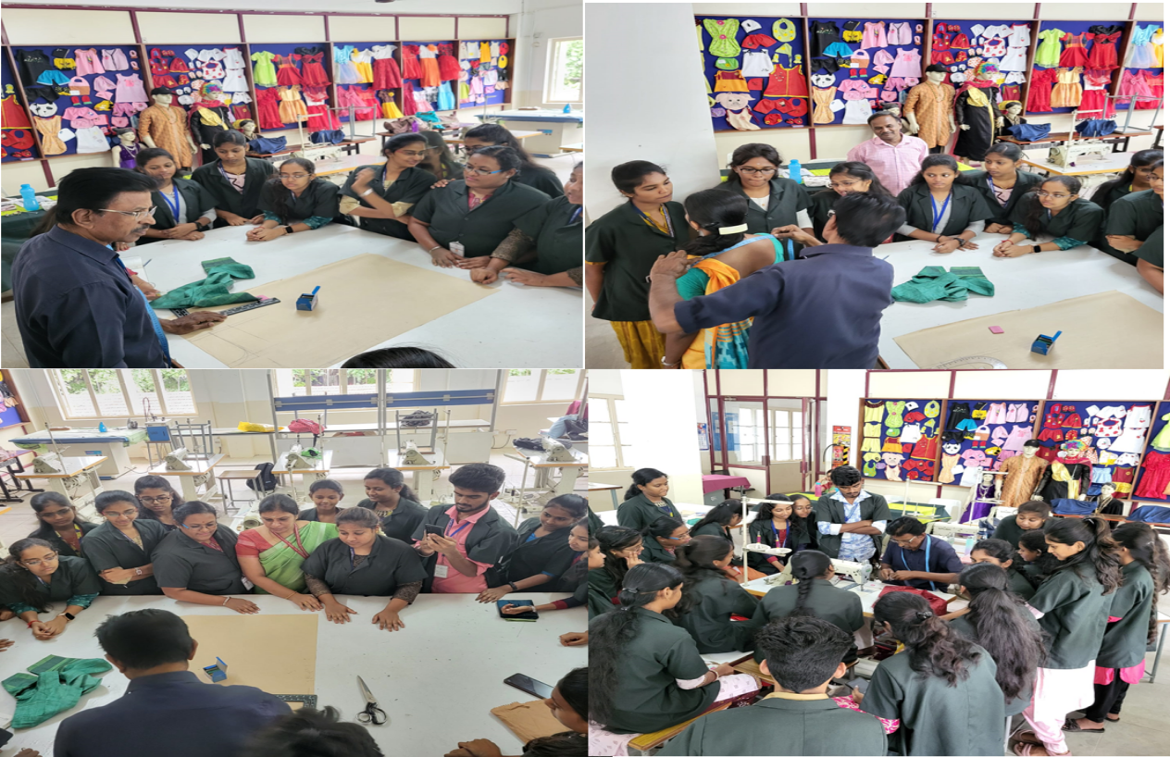

The Department of Costume Design and Fashion, organized an **Advance Blouse Designing,** workshopby **Mr.S.Aaron Issac,** Eve Tailors, Sai babacolony, Coimbatore,on **29.07.2024.** Venue: **Construction Lab** from **8.30 am to 3.15 pm** (IST).

**Report on “TUKAcad” Workshop 10.01-2025**

The **Department of Costume Design and Fashion,** organized a Two days hands-on training workshop on **“TUKAcad”** by **Mr.S.Sathiyaraj, C-Cube Technology, Erode,** dated on **09/01/2025** and **10/01/2025,** Venue: **Lab 1** from **10.00 am to 4.00pm** (IST).

The session commenced with a prayer song by **III B.Sc Costume Design and Fashion students**, followed by a welcome address and introduction of the Chief Guest by **Dr. P. Sasikala**, Associate Professor and Head of the Department of Costume Design and Fashion.The session was then handed over to the Chief Guest, **Mr. S. Sathiyaraj**, who explained the features of **TUKAcad software** and demonstrated the potential of digital pattern tools in transforming the fashion industry. He highlighted how designers can leverage TUKAcad's advanced features to streamline their workflow and improve efficiency.The students from the Department of Costume Design and Fashion actively participated in the session, asking questions and clarifying their doubts regarding pattern software tools, grading tools, and marker tools. The Chief Guest provided clear explanations, addressing all their queries.The session concluded with a vote of thanks by **Dr. S. Divya,**  Assistant Professor, Department of Costume Design and Fashion, KASC, Coimbatore.

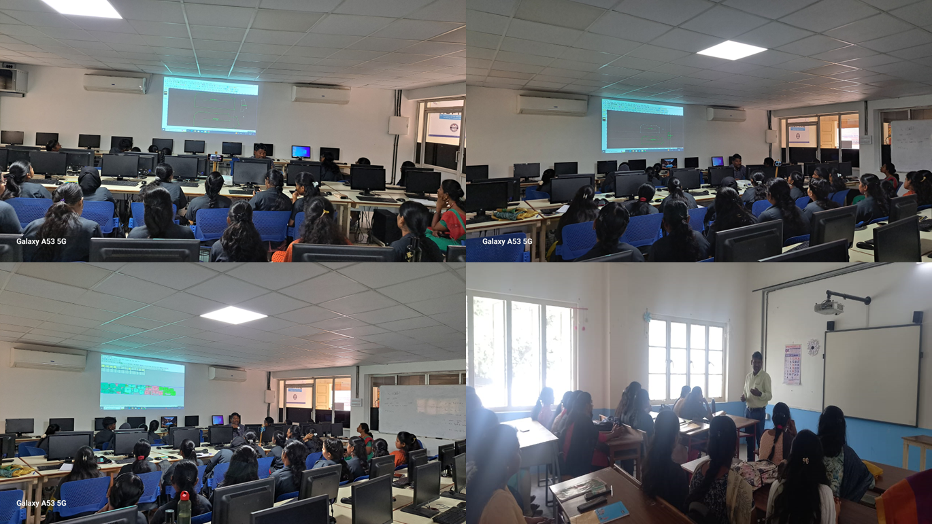

The **Department of Costume Design and Fashion**, organized a **Two days hands-on training workshop on “TUKAcad”** by **Mr.S. Sathiyaraj** from **C-Cube Technology, Erode,** on **09.01.2025 and 10.01.2025** from **10.00 am to 4.00 pm (IST).**

**REPORT ON ISHA TAMIL THEMBU EVENT -05/03/2025**

**DEPARTMENT OF COSTUME DESIGN & FASHION**

**Exploring Traditional Indian Crafts at Isha Foundation**

The Department of Costume Design & Fashion students attended the Isha Tamil Thembu Event at Isha Yoga Centre in Coimbatore, India is Velliangiri Foothills, Ishana Vihar Post, Coimbatore, Tamil Nadu. The programme aimed to raise awareness about to experience and learn about various traditional Indian crafts. The workshop, which took place on 05/03/2025aimed to promote cultural awareness and appreciation among the students, while also providing them with hands-on experience in crafting techniques.

The workshop consisted of five sessions, each focusing on a different traditional craft:

1. **Netti carving:** Netti carving, also known as Thanjavur Netti Works, is a traditional art form of Tamil Nadu that involves carving from pith, a plant called Aeschynomene Aspera. Students learned the art of Netti carving from skilled artisans. They were introduced to various techniques, including designing, cutting, Dyeing and polishing.

**2. Karuppur Kalamkari** paintings: Karuppur Kalamkari paintings are done in Karuppur and its surrounding villages in Tamil Nadu. Purpose: The paintings are done on pure cotton cloth and are predominantly used in temples for umbrella covers, cylindrical hangings, chariot covers and asmanagiri .In this session, students learned the ancient art of Kalamkari painting, which involves using natural dyes and hand-painting techniques. They learned about the history and significance of this art form while creating their own Kalamkari paintings.

**3. Arani Silk Saree Hand Weaving:** Arani silk sarees are woven by hand on looms in the town of Arani in Tamil Nadu. The sarees are known for their softness, durability, and lightweight nature. Our Students were fascinated by the traditional Aarani silk saree hand-weaving technique. They learned about the entire process, from warping to weaving, and even got to try their hand at weaving a small section of the saree.

**4. Chennimalai Bedsheet Weaving:** Chennimalai in Tamil Nadu is famous for its bedsheets and other home decor items, including towels, blankets, and napkins. The town was once a center for handloom sheeting, but powerloom has since taken over. In this session, students learned about the traditional Chennimalai bedsheets, which are known for their unique designs and durability. They were taught the basics of weaving and got to create a small sample of the bedsheets.

**5. Toda Embroidery:** Toda embroidery, also locally known as "pukhoor", is an art work among the Toda pastoral people of Nigiri’s, in Tamil Nadu, made exclusively by their women. The embroidery, which has a fine finish, appears like a woven cloth but is made with use of red and black threads with a white cotton cloth background. In this Session Students learned about the significance of this embroidery and were guided through the process of creating intricate designs using traditional techniques.

Throughout the workshop, our students demonstrated enthusiasm and dedication to learning these traditional crafts. They showed a deep appreciation for the artisans' skills and the cultural significance of each craft.

**DEPARTMENT OF COSTUME DESIGN & FASHION**

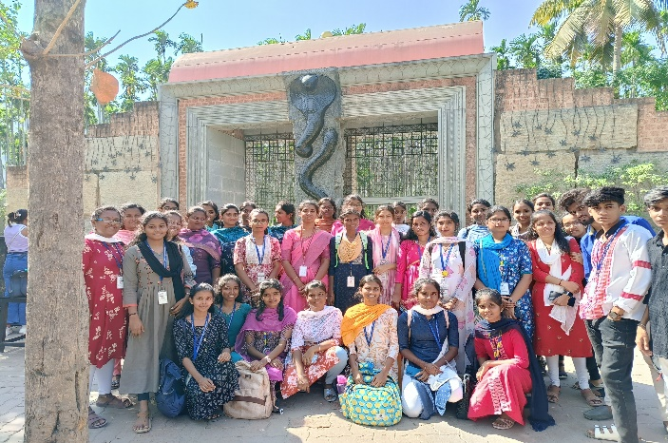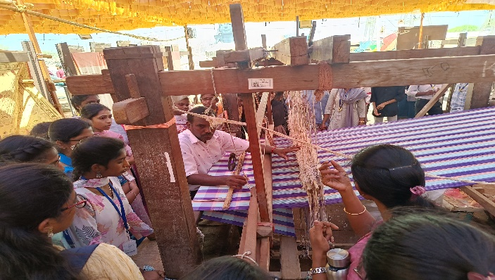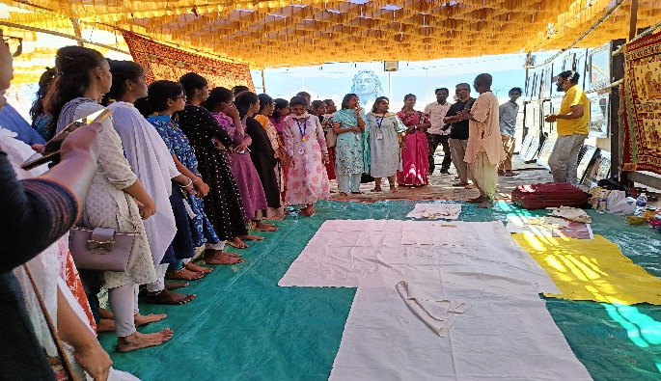**ISHA TAMIL THEMBU EVENT -05/03/2025**

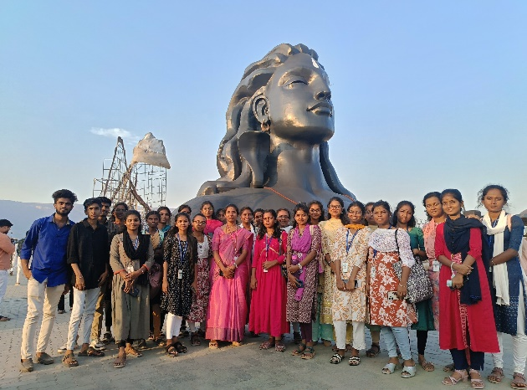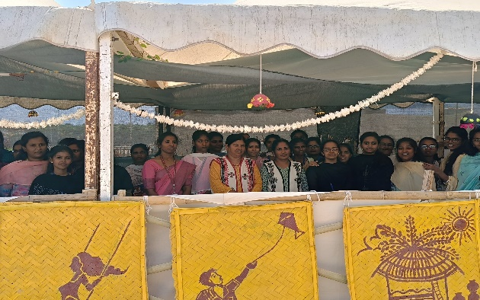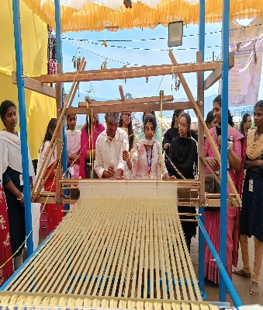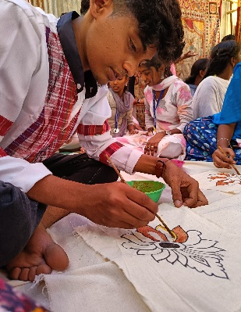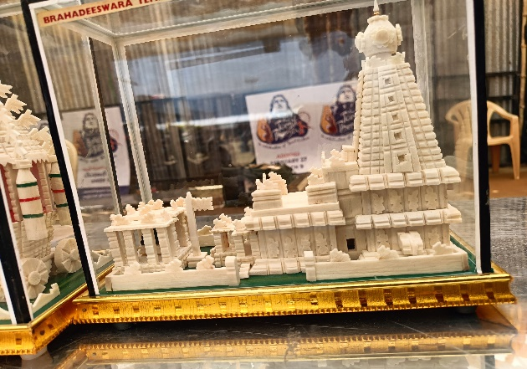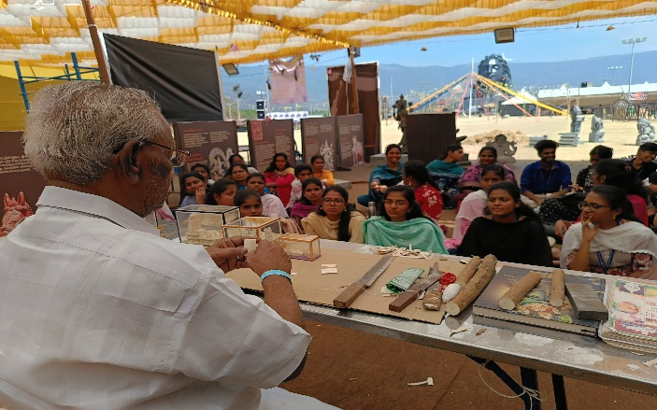

pa

**KON**

**Report on National Symposium - “Sustainable Textile Materials from the Western Ghats: Opportunities and Challenges”**

The Department of Costume Design and Fashion and Department of PG & Research Department of Zoology, Kongunadu Arts and Science College jointly organized the “**National Symposium on the Western Ghats: Biodiversity Conservation and Ecosystem on Management"** In Connection with Thematic Session: “**Sustainable Textile Materials from the Western Ghats: Opportunities and Challenges”** on **6th & 7th March, 202**5.

This symposium witnessed the enthusiastic participation of students, researchers and academicians from various colleges from Coimbatore, Tamil Nadu. The participants contributed research papers that advance the development of sustainable textile materials and eco-friendly fashion, highlighting the importance of the Western Ghats natural resources in this field. The Chief Guest of the National Symposium was **Dr. S. Kannan,** Head and Chairperson, Department of Environmental Studies, School of Energy, Environment and Natural Resources, Madurai Kamaraj University. Dr. Kannan evaluated the paper presenters abilities, providing valuable feedback to the participants, and congratulated them on their contributions to the field of sustainable textile materials from the Western Ghats.

The abstract book of the National symposium on "Sustainable Textile Materials from Western Ghats: Exploring Eco-Friendly Fashion" has been published with the ISBN: 978-81-985002-1-2. The book contains abstracts of research papers presented by students, researchers and academicians from various institutions from Coimbatore, Tamil Nadu.

The stall featured with innovative Western Ghats hut modules designed by students from the Department of Costume Design and Fashion, totally 9 tribal hut modules was displayed over two days of the symposium. The huts showcased a unique and eco-friendly approach, using locally sourced materials to minimize carbon footprint. The stall attracted a diverse audience, including the chief guest, and received the "Best Stall" award secured 3rd prize at the symposium. In the cultural event, our department secured the 1st prize in the fashion show, showcasing garments inspired by the traditional attire of Western Ghats communities.

During the valedictory function, **Dr. P. Sasikala,** Associate Professor & Head, Department of Costume Design & Fashion, Kongunadu Arts and Science College and the Chief Guest **Dr. S. Kannan**, Head and Chairperson, Department of Environmental Studies, School of Energy, Environment and Natural Resources, Madurai Kamaraj University, appreciated the participants and distributed certificates and the session was ended with vote of Thanks by  **Dr. P. Sasikala,** Associate Professor & Head, Department of Costume Design and Fashion, Kongunadu Arts and Science College,Coimbatore.

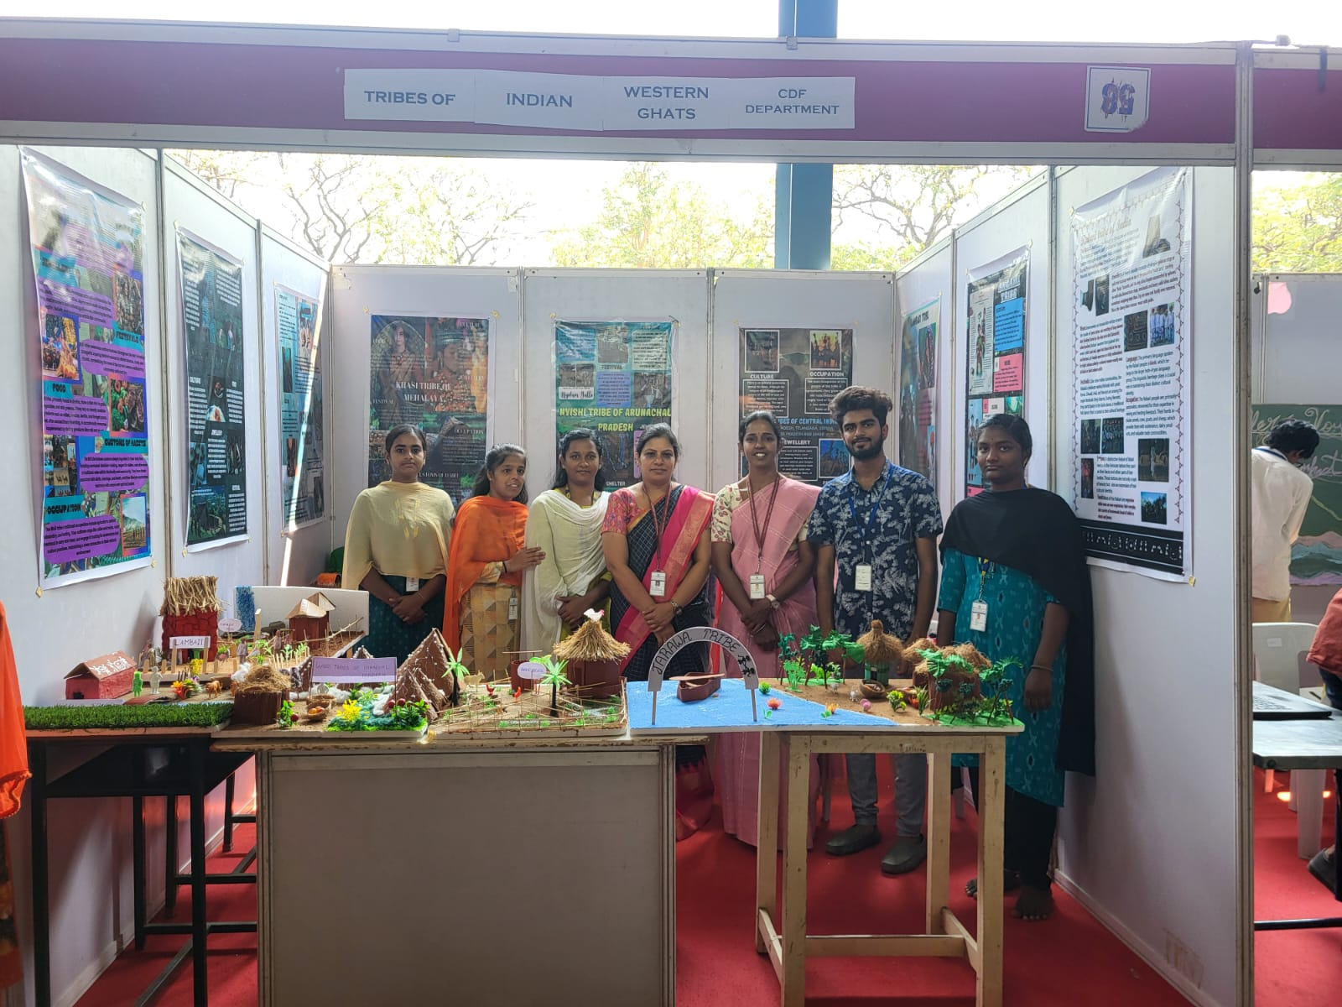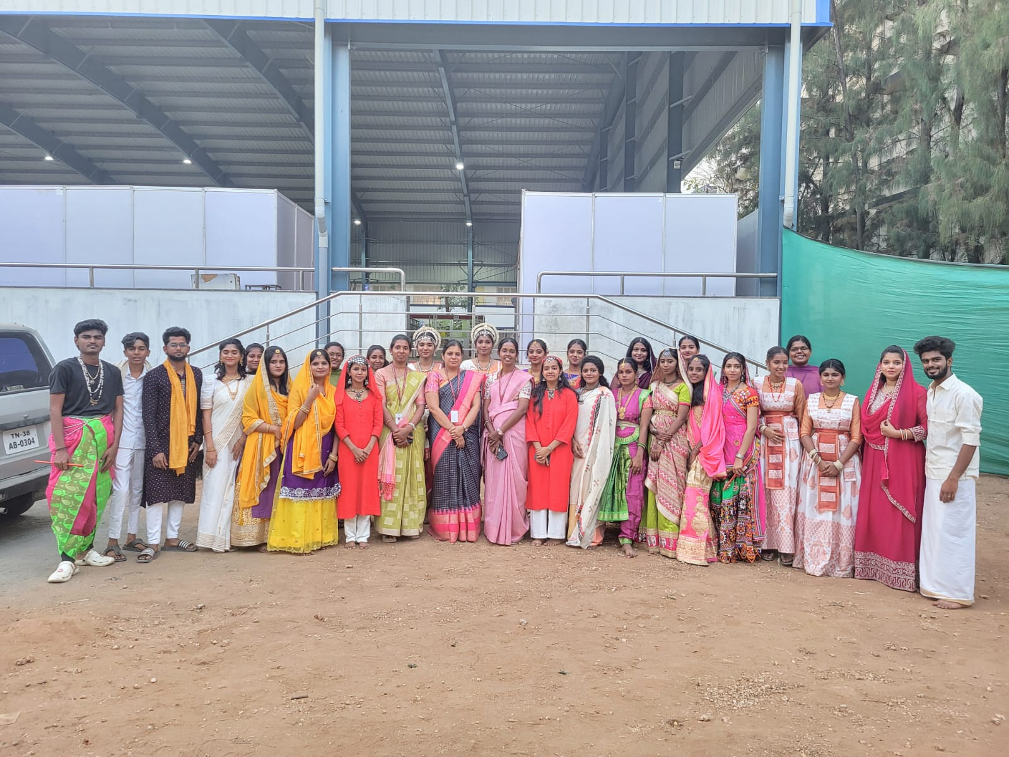

The Department of Costume Design and Fashion Kongunadu Arts and Science College jointly organized the “**National Symposium on the** “**Sustainable Textile Materials from the Western Ghats: Opportunities and Challenges”** on **6th & 7th March, 202**5.