C:\Users\BCOM-CA\AppData\Local\Temp\ksohtml8564\wps3.png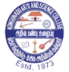**KONGUNADU ARTS AND SCIENCE COLLEGE**

(Autonomous)

Re-Accredited by NAAC with ‘A+’ Grade (4th Cycle)

29th Rank among Colleges in NIRF 2023

College of Excellence (UGC)

Coimbatore -641029, Tamil Nadu, India.

**DEPARTMENT OF COMMERCE WITH COMPUTER APPLICATIONS**

**Entrepreneurship Boot Camp Report**

Department of Commerce with Computer Applications of Kongunadu Arts and Science College organized an one week Entrepreneurship bootcamp from 11.09.2024 to 18.09.2024, 32 Students from the department have participated enthusiastically and benefited out of this training**. Ms. Tara, Founder & CEO, Poo Vriksham Company, Coimbatore** was the Resource Person. Dr.A.Revathy, Assistant Professor, Department of Commerce with Computer Applications, welcomed the gatherings and handed over the session to Ms.Tara and the resource person gave an overview about being an Entrepreneur, her real life stories, testimonies and gave hands on training for one week. The objective of the programme is to encourage the young entrepreneurs to start and earn passive income during their college tenure. Dr.Rekha, Assistant Professor, Department of Commerce with Computer Applications, Proposed Vote of Thanks and the resource person along with the Head of the department issued the certificates to the students who have completed the training successfully.

**OUTCOMES OF THE PROGRAM**

* Students had a physical learning from the expert about the preparation of various herbal products like face creams, hair oils, Soaps etc.
* Students are trained and started their business account in social media for advertising their own products.
* Students have started producing herbal products, kept the stall the campus with their product of sale and also earned the income.

C:\Users\BCOM-CA\AppData\Local\Temp\ksohtml8564\wps4.jpg

C:\Users\BCOM-CA\AppData\Local\Temp\ksohtml8564\wps5.jpg

**Invitation**

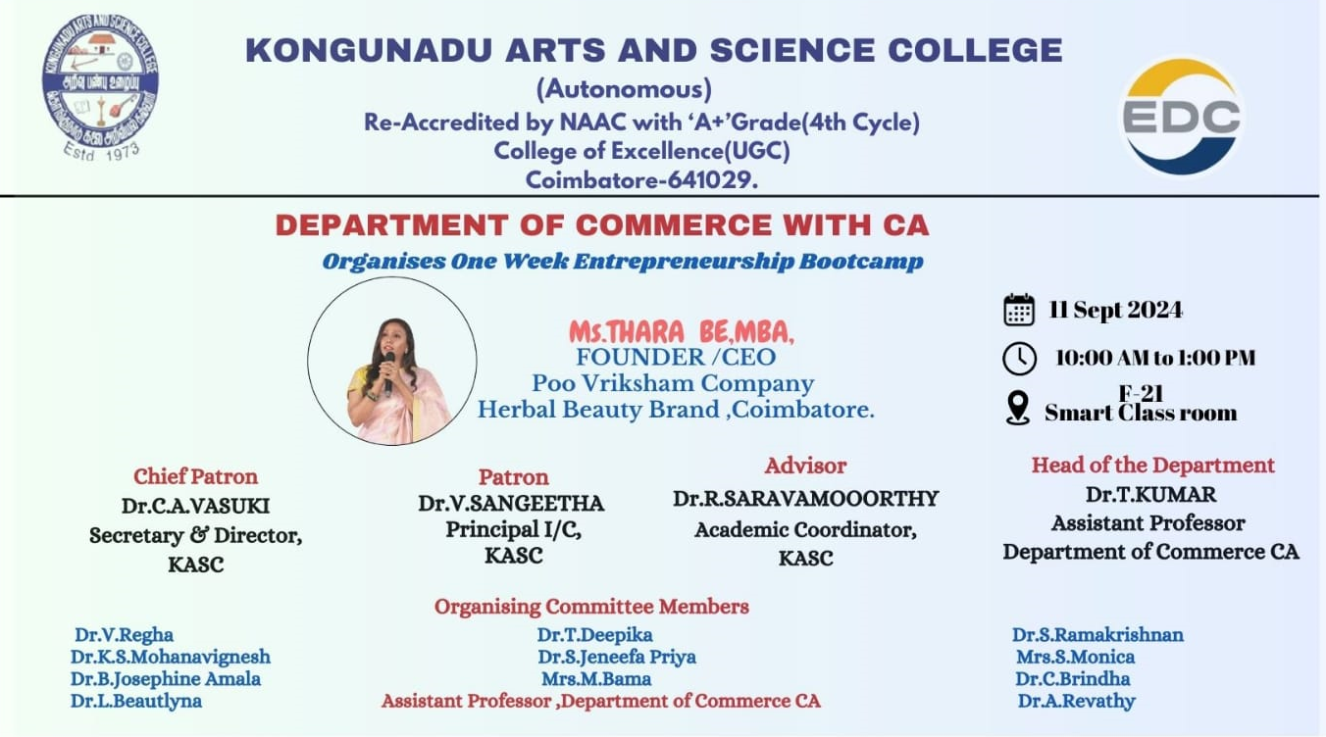

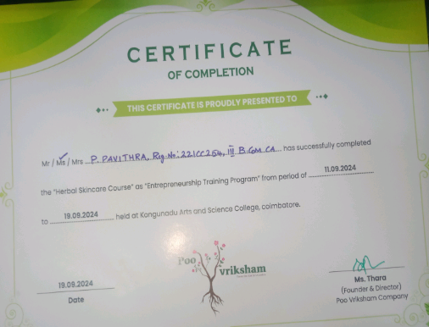**Sample Certificate**

**Photo Clips of Entrepreneurship Boot Camp**

