**KONGUNADU ARTS AND SCIENCE COLLEGE**

**(Autonomous)**

**Re-Accredited by NAAC with ‘A+’Grade (4th Cycle)**

**College of Excellence (UGC)**

**Coimbatore-641029.**

**COMMERCE WITH COMPUTER APPLICATIONS**

### Report on MSME Short-Term Course

#### ****Program Details:****

* **Course Duration:** 36 hours
* **Focus:** Direct Practical Training on the Latest Version of Tally Prime
* **Training Methodology:**
  + **Business Segment Scenarios:** Manufacturing, Trading, and Service
  + **Practical Component:** 80% of sessions dedicated to hands-on practice

#### ****Program Timeline:****

* **Start Date:** 23.09.2024
* **End Date:** 28.09.2024
* **Assessment Date:** 30.09.2024

#### ****Organizers:****

The **Department of Commerce with Computer Applications**, Kongunadu Arts and Science College, and the **Ministry of MSME, Government of India (Coimbatore Extension Centre)** jointly organized a **one-week short-term hands-on training program** on **Tally Prime with GST.**

#### ****Participation:****

A total of **34 students** registered for the course and successfully completed the assessment process conducted on **30.09.2024**.

**COURSE OUTCOMES:**

**Comprehensive Knowledge of Tally Prime:**  
Students acquired in-depth understanding and practical expertise in the latest version of Tally Prime software, focusing on accounting and GST compliance.

**Real-Time Problem-Solving Skills:**  
The training enabled students to handle real-world business scenarios in manufacturing, trading, and service sectors using Tally Prime.

**Mastery in GST Applications:**  
Participants developed skills in GST-related processes, including tax calculations, filing, and compliance, making them industry-ready.

**Proficiency in Practical Accounting:**  
With 80% of the sessions dedicated to practical training, students gained hands-on experience in bookkeeping, inventory management, and financial reporting.

**Enhanced Employability:**  
The course equipped students with industry-relevant skills, increasing their job prospects in commerce, accounting, and related fields.

**Certification:**  
Successful completion of the course and assessment added value to students’ profiles, demonstrating their capability to apply knowledge in professional settings.

**Collaboration Experience:**  
Exposure to a training program organized in collaboration with the **Ministry of MSME** gave students an understanding of how academic knowledge is applied in industry-linked contexts.

The outcomes reflect the effectiveness of the program in bridging academic learning with practical applications, empowering students for future opportunities.

#### ****Attachments:****

The list of students who completed the course, along with the courseware, is enclosed herewith for reference.

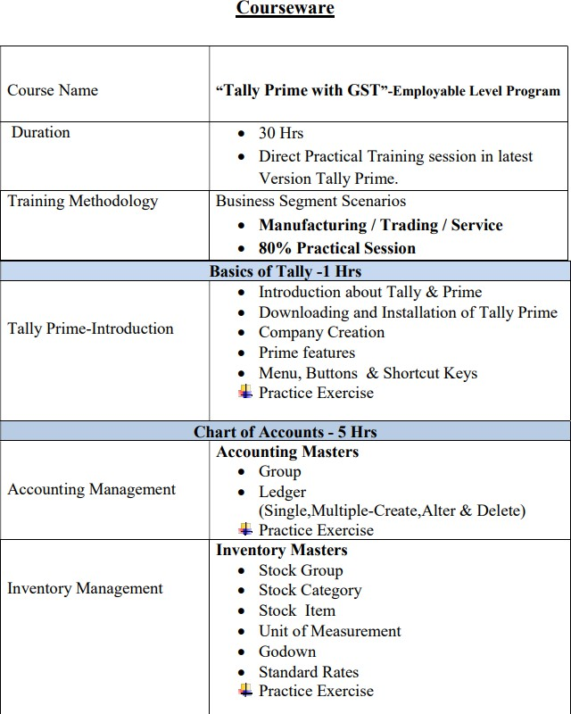

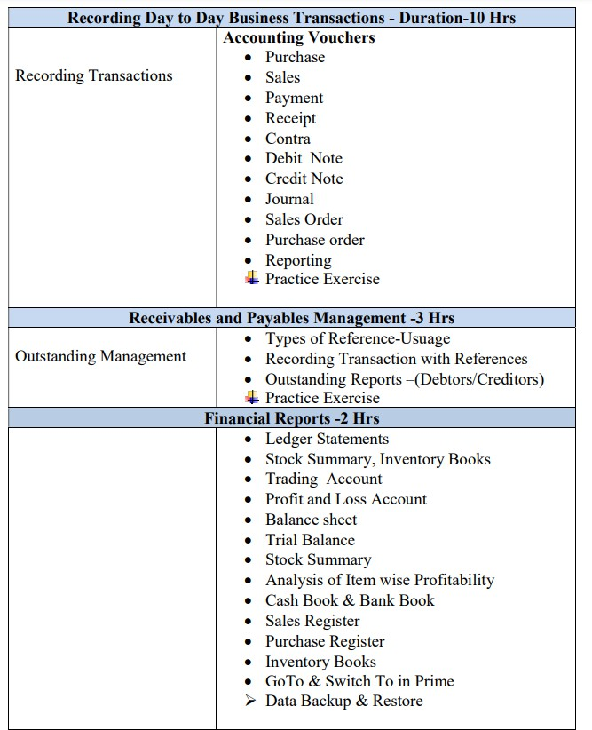

**MSME NAME LIST-III BCOM CA (MAIN &ADDITION)**

|  |  |  |
| --- | --- | --- |
| **S.NO.** | **REG.NO.** | **NAME** |
|  |  |  |
| 1 | 221CC002 | JANANI H |
| 2 | 221CC003 | SOFIYA LOURDU MARY A |
| 3 | 221CC007 | DEVASHREE A |
| 4 | 221CC012 | KAVYA S |
| 5 | 221CC013 | KISHORE S |
| 6 | 221CC014 | SIDDHAARTH MANIAN J |
| 7 | 221CC017 | SEDHU KUMAR S |
| 8 | 221CC018 | YOGESH M |
| 9 | 221CC019 | AKALYA J |
| 10 | 221CC020 | GOKUL R |
| 11 | 221CC022 | DHURKAIYANANTHAN D |
| 12 | 221CC024 | PRABHU V |
| 13 | 221CC027 | GOKULAKRISHNAN A |
| 14 | 221CC033 | KANNAN K |
| 15 | 221CC034 | NITHISH KUMAR .M |
| 16 | 221CC036 | DINESH BALA M S |
| 17 | 221CC042 | KOWSALYA S |
| 18 | 221CC044 | PRAVEEN S |
| 19 | 221CC045 | MYTHILI KAMACHI S |
| 20 | 221CC051 | SWATHI M |
| 21 | 221CC054 | BALA KRISHNAN V |
| 22 | 221CC211 | YESURAJ. R |
| 23 | 221CC215 | MANEESH.K |
| 24 | 221CC216 | RATHISH. M |
| 25 | 221CC219 | RISHIKESHWAR.J |
| 26 | 221CC225 | SHARUKESH.M |
| 27 | 221CC229 | SOUNDHAR RAJ S |
| 28 | 221CC231 | DUSHYANTH.S |
| 29 | 221CC236 | THEEPAKSARAN.M |
| 30 | 221CC243 | KABILA KRISHNAN. N |
| 31 | 221CC245 | SHANKAR.S |
| 32 | 221CC246 | SIDDHARTH. I |
| 33 | 221CC248 | HARIKESH. L |
| 34 | 221CC256 | GOKULNATHAN.R |

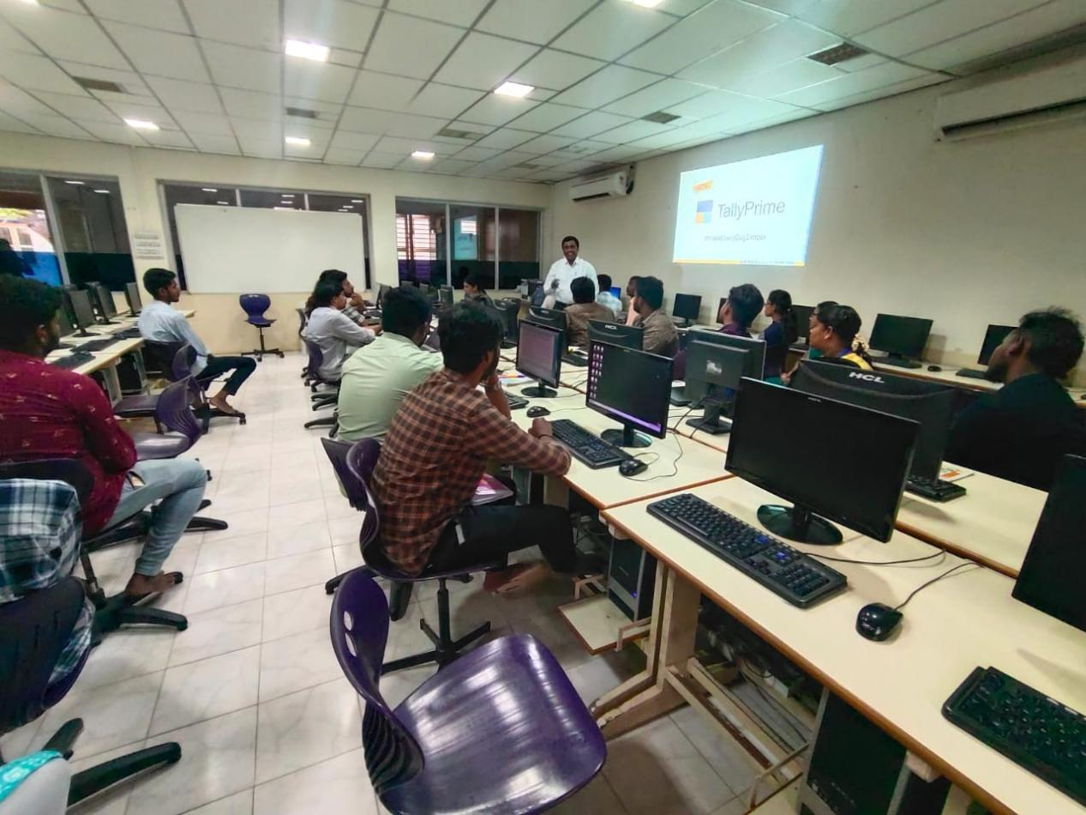**s**