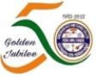
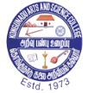
KONGUNADU ARTS AND SCIENCE COLLEGE (Autonomous)
College of Excellence (UGC)
Re-Accredited by NAAC with ‘A+’ Grade (4th Cycle)
29th Rank among Colleges in NIRF 2023
Coimbatore -641029.

DEPARTMENT OF COMMERCE WITH COMPUTER APPLICATIONS

WORKSHOP on “GST& E-FILING”

Department of Commerce with Computer Applications organized a workshop on “GST & E-FILING” for enlightening the mind for Second and Final year students on 01.08.2024. The Workshop was inaugurated with a prayer song. Dr.S. Ramakrishnan, Associate Professor in Department of Commerce (CA) welcomed the gatherings. The Chief Guest for the event was Mr.C.MUTHUKUMAR , Tax Practitioner from SRIKARA Training &Placement Academy, Coimbatore . He gave a wonderful Session about E-Filling anfd Hands on Practice for the students. The wonderful workshop was end up with vote of thanks by Dr.K.S.Mohana vignesh, Associate Professor in Department of Commerce (CA).
OUTCOMES OF THE WORKSHOP
- The workshop helps the students to identify their careers that matches for Skills, Interest and Personality traits.
- This Workshop help the students to develop Practical Knowledge about E-Filling.
- Students learned the importance of E-Filling
INVITATION
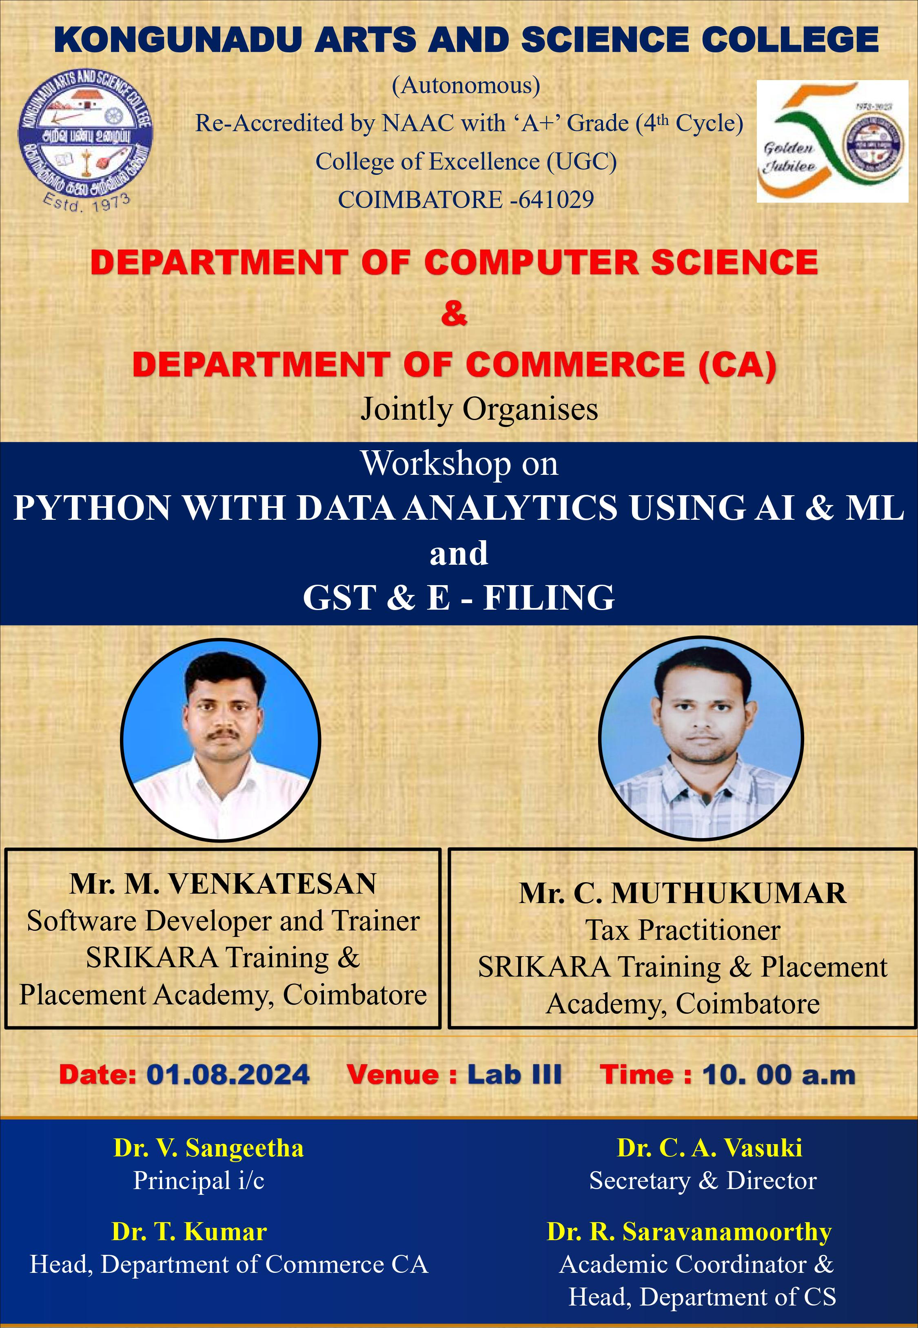
PHOTO CLIPPINGS OF E-FILLING WORKSHOP
