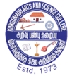**KONGUNADU ARTS AND SCIENCE COLLEGE** (Autonomous)

 Re-Accredited by NAAC with ‘A+’ Grade (4th Cycle)

29th Rank among Colleges in NIRF 2023

College of Excellence (UGC)

Coimbatore -641029, Tamil Nadu, India.

**DEPARTMENT OF COMMERCE WITH COMPUTER APPLICATIONS**

**Report on**

**EXTENSION ACTIVITY**

**on**

**“BANK ACCOUNT OPENING & AADHAR CORRECTION CAMP”**

Department of Commerce with Computer Applications of Kongunadu Arts and Science College in association with Indian Overseas Bank, Kavandam Palayam Branch, GN Mills, Coimbatore and Indian Postal Services, GN Mills, Coimbatore Organized a Five Days Extension Activity Camp for Opening Bank Account and Aadhar Correction in front of College Premises for the benefit of Public and Students. During the Five days Camp 285 people in and Around GN Mills Area got Benefited. 62 Bank accounts was opened by the Student Volunteers of the department with the help of Bank Personals and 223 Public used this camp for Linking mobile number with Aadhar card, Bio metric Correction, Change of Address, Change of Mobile number.

**OUTCOMES OF THE PROGRAM**

* Extension Activity helped the students to develop social responsibility in the Society.
* The Extension Activity created Service attitude among the Student Volunteers, which is important for any Profession in the Future.
* Ethical values and Leadership Qualities was developed among the students



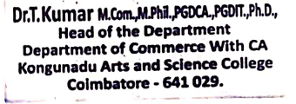

**Invitation**

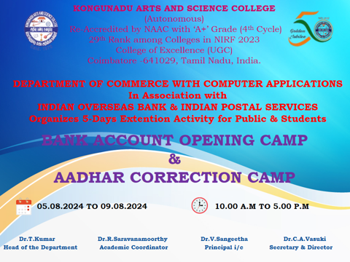

**PHOTO CLIPS OF FIVE DAYS EXTENSION ACTIVITY**

