**KONGUNADU ARTS AND SCIENCE COLLEGE**

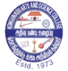(Autonomous)

Re-Accredited by NAAC with ‘A+’ Grade (4th Cycle)

52nd Rank among Colleges in NIRF 2024

College of Excellence (UGC)

Coimbatore -641029, Tamil Nadu, India.

**DEPARTMENT OF COMMERCE WITH COMPUTER APPLICATIONS**

**Report**

**on**

**FACULTY DEVELOPMENT PROGRAMME**

**on**

**ADVANCED RESEARCH AND QUALITY PUBLICATION**

Department of Commerce with Computer Applications of Kongunadu Arts and Science College organized a Faculty Development Programmeon the topic **“Advanced Research and Quality Publication” on** 10.09.2024 in which 12 Faculties from our department participated and benefited by the programme**. Dr.M.Gowri,** Associate Professor, Department of Commerce with CMA, PSG College of Arts and Science, Coimbatorewas the Resource Person. Dr.T.Deepika, Assistant Professor, Department of Commerce with Computer Applications, welcomed the gatherings and Dr.V.Regha, Assistant Professor in Commerce CA honoured the guest with a memento. Dr.M.Gowri mam took over the session and gave an insight knowledge about Article Writing, Preparation of Research Proposals, citations, h-index, i-index Etc.,. Dr.T.Kumar, Assistant Professor & Head, Department of Commerce with Computer Applications, Proposed Vote of Thanks.

**OUTCOMES OF THE PROGRAM**

* Faculties came to know about citation techniques, h-index and i-index.
* Faculties gained knowledge about proposal writing for major and minor Projects.
* The FDP was useful for the faculties to find out the cloned journal and how to write article for Scopus.

C:\Users\BCOM-CA\AppData\Local\Temp\ksohtml8564\wps4.jpg

C:\Users\BCOM-CA\AppData\Local\Temp\ksohtml8564\wps5.jpg

**Invitation**

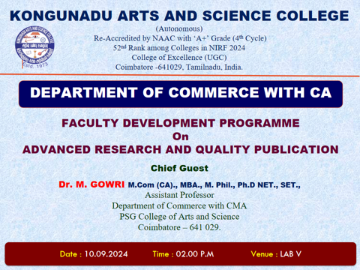

**Photo Clips of Faculty Development Program**

