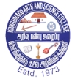**KONGUNADU ARTS AND SCIENCE COLLEGE** (Autonomous)

 Re-Accredited by NAAC with ‘A+’ Grade (4th Cycle)

29th Rank among Colleges in NIRF 2023

College of Excellence (UGC)

Coimbatore -641029, Tamil Nadu, India.

**DEPARTMENT OF COMMERCE WITH COMPUTER APPLICATIONS**

**Report on**

**FUTURE TRAINING PROGRAM**

**on**

**“DECISION MAKING, TIME MANAGEMENT & BUILDING RELATIONSHIP”**

Department of Commerce with Computer Applications of Kongunadu Arts and Science College organized a Future Training Program on the topic “**Decision Making, Time Management & Building Relationship**”on8th August 2024 in which 64 Undergraduate Students from the department participated and benefited by the programme**. Mr. (JC).** **P.Vijay,** Provisional Zone Trainer, JCI Avinashi Jasmine, JCI Tirupur Kashvi, Tirupur was the Resource Person. Dr.T.Deepika, Assistant Professor, Department Of Commerce with Computer Applications welcomed the gatherings. Dr.T.Kumar, Head of the Department Honoured the guest with a Memento. Mr.P.Vijay took over the Session and started with the topic Decision Making skills. He also presented his insight views on time management and Relationship Building. Students was grouped into teams and many Case studied was given for them to analysis and explain. Mrs.S.Monica, Assistant Professor, Department of Commerce with Computer Applications Proposed the Vote of Thanks.**OUTCOMES OF THE PROGRAM**

* Students developed their Decision-Making Skills
* Students Learned how to Manage Time in the working Environment
* Students gained skill in Team Building and they also got an opportunity for Soft Skill Development



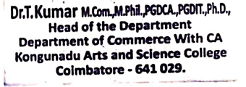

**Invitation**

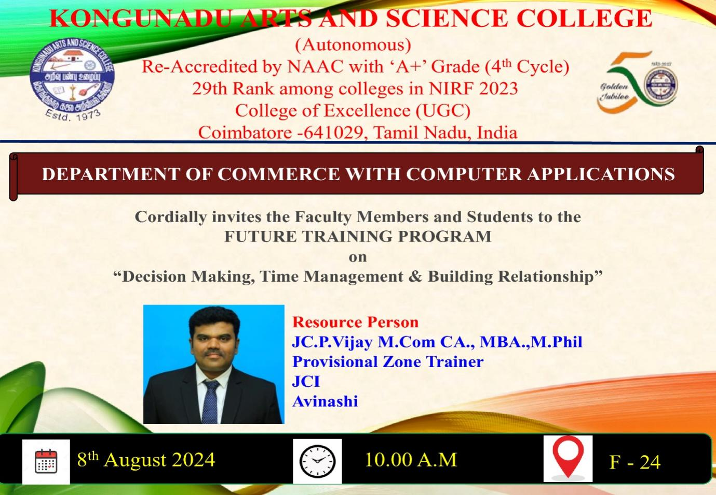

**Photo Clips of Future Training Program**

**on**

**“DECISION MAKING, TIME MANAGEMENT & BUILDING RELATIONSHIP”**

