**KONGUNADU ARTS AND SCIENCE COLLEGE**

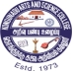**(Autonomous)**

**Re-Accredited by NAAC with ‘A+’Grade (4th Cycle)**

**College of Excellence (UGC)**

**Coimbatore-641029.**

**DEPARTMENT OF COMMERCE WITH COMPUTER APPLICATIONS**

**Report on Knowledge Enrichment Program for Advance learners – “Strategies for Updating Online Course"**

**Date: 06.09.2024 Duration: 10 a.m to 1.00 p.m**

**Theme: "Empowering Advanced Learners: Next-Gen Approaches to Online Course Enhancement"**

**Speaker Details:**

**Name:** Dr. C. KARTHIK DEEP

**Designation:** Assistant Professor, Department of Education

**Organization:** Avinashilingam Institute for Home Science and Higher Education for Women

**Dr. Karthik Deepa**, an accomplished educator, has been shaping minds in the Department of Education since 2005. Her teaching career began while pursuing her Ph.D., and over the years, she has become a prominent expert in **Educational Technology, ICT Tools for Language Teaching, e-Assessment, MOOC, Digital Storytelling, Artificial Intelligence in Education, Creativity, and Drama**.With dual Master's degrees in **English and Comparative Literature (M.A.)** and **Educational Technology (M.Ed. Tech.)**, Dr. Deepa brings a unique blend of linguistic and technological expertise to her classroom. Known for her dynamic and interactive teaching style, she masterfully integrates ICT tools to keep students engaged and active participants in their learning process. Her passion for technology-driven education is evident through her curriculum, where **E-Content Development** and **CIA Packages** are central components of the **M.Ed. Tech.** program she leads.

A sought-after speaker, Dr. Deepa has delivered **over 40 invited lectures** and acted as a resource person for numerous workshops and seminars. She has made significant academic contributions with **34 publications** in national and international journals and book chapters. Additionally, she has guided research scholars and successfully secured research grants worth **Rs. 28,00,000** from prestigious organizations such as **UGC, ERIC-NCERT,** and **ICSSR** for major projects.

Her influence extends into the digital learning space as the **coordinator of the 'e-Assessment' course on SWAYAM MOOC**, running successfully since 2018. Now in its **9th cycle**, the course has attracted **over 10,000 learners**. Beyond this, she has contributed to **more than 50 MOOC modules**, leaving an indelible mark on online education.

Dr. Deepa’s motivational speaking and personalized guidance has further endeared her to students, who look up to her not just as a teacher, but as a mentor who inspires them to excel.

**Outcome of the activity:**

The students were taught how to find and enroll in free online courses, and they also guided on how to create engaging content for online platforms.

The students who participated are meritorious, and through this program, they gained the skills to effectively register for and navigate online course.

Through this program, students gained knowledge about free digital skills training. They were introduced to platforms like Salor.org, Openstax org, and Merlot,org etc. Additionally, they were thought how to effectively use digital libraries.

All students have been accepted and have committed to create content online and enrolling in various online courses. They also expressed desire for guidance on how to help other students stay updated.

**Key Highlights:**

Mrs. M. Bama ,Assistant Professor ,Department of Commerce CA, welcomed all participants and expressed gratitude to the key supporters and organizers.

Dr.Karthik Deepa, Assistant Professor, Department of Education , Avinashilingam Institute was introduced and her expertise in e-assessment and AI in education was highlighted.

Dr.Karthik Deepa, instructed students on how to effectively use free online platforms for digital libraries and guided them on writing content for online platforms.

Students actively participated in hands-on training sessions and engaged in meaningful interactions with the resource person

The program concluded with a vote of thanks delivered by Dr.Revathy , Assistant Professor in the Department of Commerce CA. She recognized and appreciated the contributions of the speaker, organizers, and participants.

Total no of Student participation: 60

Total no of staff participation: 4

**INVITATION**

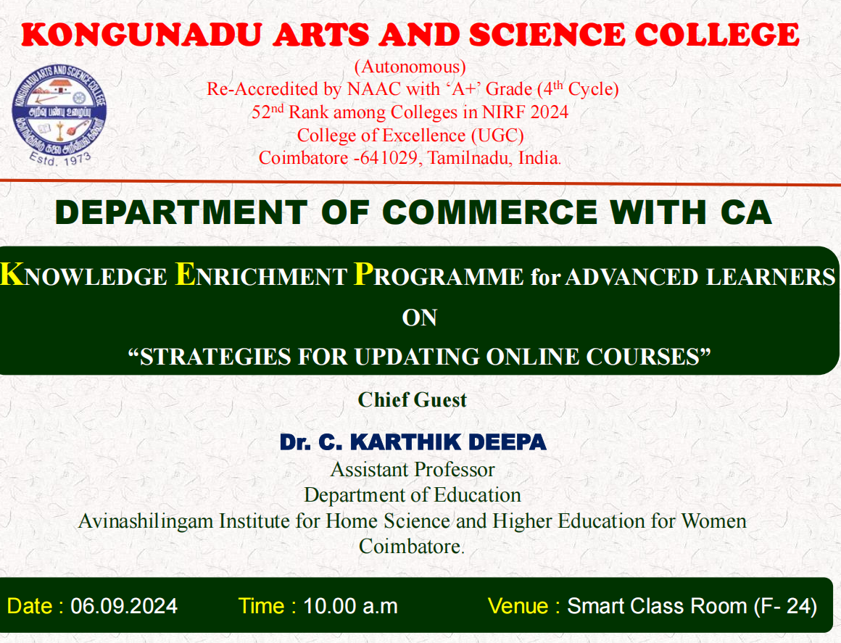

**PHOTO CLIPS OF THE EVENT**

.

