C:\Users\BCOM-CA\AppData\Local\Temp\ksohtml8564\wps3.png**KONGUNADU ARTS AND SCIENCE COLLEGE**

(Autonomous)

Re-Accredited by NAAC with ‘A+’ Grade (4th Cycle)

29th Rank among Colleges in NIRF 2023

College of Excellence (UGC)

Coimbatore -641029, Tamil Nadu, India.

**DEPARTMENT OF COMMERCE WITH COMPUTER APPLICATIONS**

**Report on Seminar**

**on**

**TALLY ERP9 Vs TALLY PRIME**

Department of Commerce with Computer Applications of Kongunadu Arts and Science College organized a Seminar on “Tally ERP 9 Vs Tally Prime”on06.08.2024 in which 71 Students from the department participated and benefited by the programme**. Mr. SATHYAN, Tally Trainer, United Infotech Training & Development, Coimbatore** was the Resource Person. Dr.B.Josiphine Amala, Assistant Professor, Department of Commerce with Computer Applications, welcomed the gatherings and handed over the session to Mr. Sathyan and the resource person gave an insight knowledge about Tally ERP9 Vs Tally prime. Mrs.S.Monica, Assistant Professor, Department of Commerce with Computer Applications, Proposed Vote of Thanks.

**OUTCOMES OF THE PROGRAM**

* Students gained knowledge about the use of tally software in small and medium scale business
* Students learned the function and short cuts in Tally Prime.
* Students learned the difference between the features of Tally ERP 9 Vs Tally Prime.

C:\Users\BCOM-CA\AppData\Local\Temp\ksohtml8564\wps4.jpg

C:\Users\BCOM-CA\AppData\Local\Temp\ksohtml8564\wps5.jpg

**Invitation**

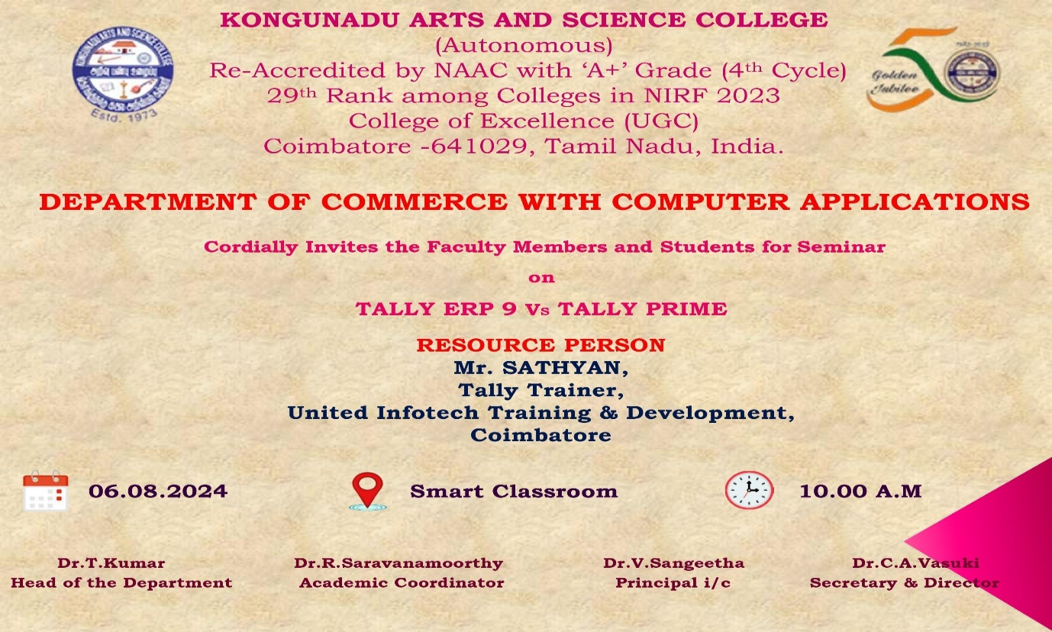

**Photo Clips of Seminar on TALLY ERP9 Vs TALLY PRIME**



