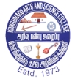**KONGUNADU ARTS AND SCIENCE COLLEGE** (Autonomous)

 Re-Accredited by NAAC with ‘A+’ Grade (4th Cycle)

29th Rank among Colleges in NIRF 2023

College of Excellence (UGC)

Coimbatore -641029, Tamil Nadu, India.

**DEPARTMENT OF COMMERCE WITH COMPUTER APPLICATIONS**

**Report on Seminar onADVANCED FEATURES IN TALLY PRIME**

Department of Commerce with Computer Applications of Kongunadu Arts and Science College organized a Seminar on “Advanced Features in Tally Prime”on24.07.2024 in which 121 Students from the department participated and benefited by the programme**. Mr.** **Joel M Andrew,** Founder & CEO, Karams I-Tech Solutions, Coimbatorewas the Resource Person. Dr.B.Josiphine Amala, Assistant Professor, welcomed the gatherings and handed over the session to Mr. Joel M Andrew and the resource person gave an insight knowledge about various new features of Tally prime. It was a eye opening session for the students about Tally. Dr.T.Deepika, Assistant Professor, Proposed Vote of Thanks.

**OUTCOMES OF THE PROGRAM**

* Students gained knowledge about Business Management Software
* Students gained insight information about advanced Features of Tally Prime.
* Students learned the difference between the features of Tally ERP 9 and Tally Prime.



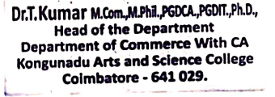

**Invitation**

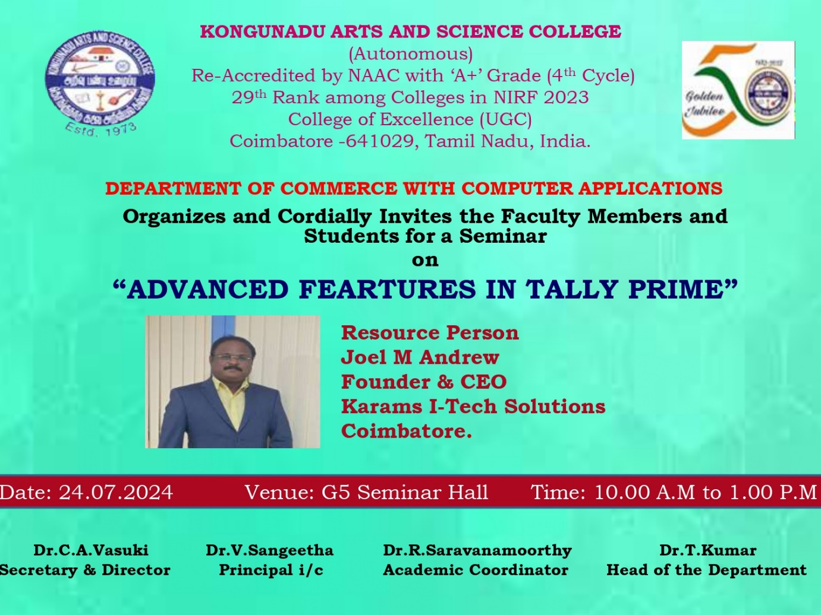

**Photo Clips of Seminar onADVANCED FEATURES IN TALLY PRIME**

