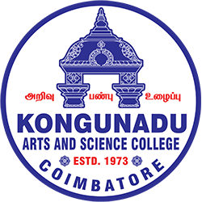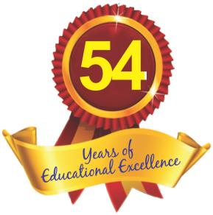

KONGUNADU ARTS AND SCIENCE COLLEGE
Re-accredited by NAAC with ‘A+’ Grade (4th Cycle)
(Autonomous)
College of Excellence (UGC)
Coimbatore- 641029, Tamilnadu, India
DEPARTMENT OF BUSINESS ADMINISTRATION WITH COMPUTER APPLICATIONS
Title of the programme | Introduction to Capital Markets
Date | 01.09.2026
Time | 10.00 AM to 11.00 AM
Venue of the Programme | F 14A
Objective of the Programme | To provide students with a basic understanding of the stock market and online share trading. The programme aimed to familiarize students with the concept, features, and functions of a DEMAT account and provide practical knowledge about buying and selling shares through online trading platforms. It also focused on creating awareness about market trends, investment strategies, risk and return, and responsible investment practices. The programme focused on enhancing students’ understanding of financial markets and developing their investment decision-making skills..
Details of the Resource person | Mr.Karthik Prabhu.T, Channel Partner and Mr.Ramesh .R, Cluster Manager from Angel One Ltd.
Title of the Invited Talk (s)/ technical Session (If Applicable) | Online Share Trading using DEMAT account.
Outcome of the Programme | The programme enabled students to gain a practical understanding of online share trading and DEMAT accounts. Students became familiar with the process of opening and operating a DEMAT and trading account, placing buy and sell orders, and monitoring share prices through online platforms. The session also improved their awareness of stock market operations, investment opportunities, risk management, and market trends. Overall, the programme enhanced students’ financial knowledge, investment awareness, and confidence in making investment decisions.
Number of Beneficiaries(Both Staff & Student) | 2 Staffs  50 students
Geotag Photos. Max4 Nos. | 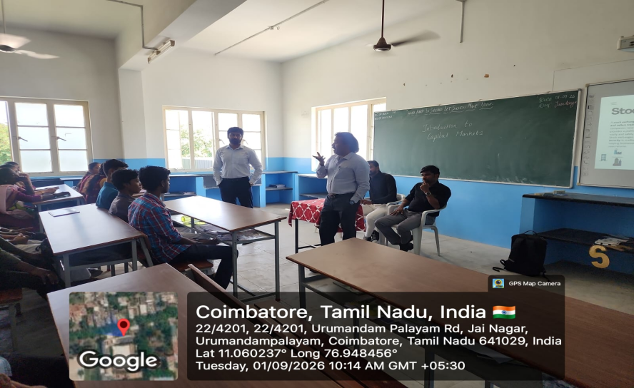  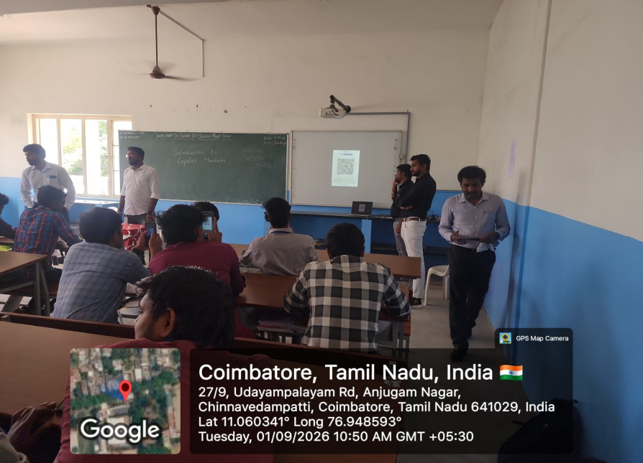

Signature of the HOD

