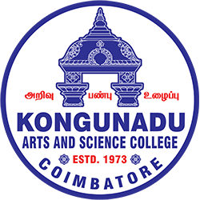

KONGUNADU ARTS AND SCIENCE COLLEGE
Re-accredited by NAAC with ‘A+’ Grade (4th Cycle)
(Autonomous)
College of Excellence (UGC)
COIMBATORE - 641 029

Session Details
Title of the Session: “Transitioning an Innovation to Commercialization - From Early Incubation to Consumer Table”
Date: 31st July, 2026
Duration: 10.00 to 1.00 PM
Activity Category: IIC Calendar/MIC Driven/Self Driven/Celebration
Theme: “Bridging the gap between innovation and the market by transforming early-stage ideas into commercially successful products and consumer-ready solutions.”

Expert/Speaker Details:
Mr.Sarathi R, Founder & CEO of SHADE, and Mr.Sree Lenin. S, Founder & COO of SHADE

The KASC - Institutions Innovation Council (IIC), Research and Development Cell, Department of B.Com and Department of Business Administration with Computer Applications (BBA CA), jointly organised a Boot Camp on “ Transitioning an Innovation to Commercialization - From Early Incubation to Consumer Table” on 31st July, 2026 at 10.00 AM.
The Resource persons for the session was Mr.Sarathi R, Founder & CEO of SHADE, and Mr.Sree Lenin. S, Founder & COO of SHADE. The session started with a formal prayer song, welcome address and guest introduction.
The session started by Mr.Sarathi R; he narrated the history behind starting up of “SHADE” and investment made by them, and their current growth. He also explained about the opportunities and schemes provided by the government for startup entrepreneurs. Mr.Sree Lenin, briefed about the operations of “SHADE” and how important it is for society and how they work in a small group of members.

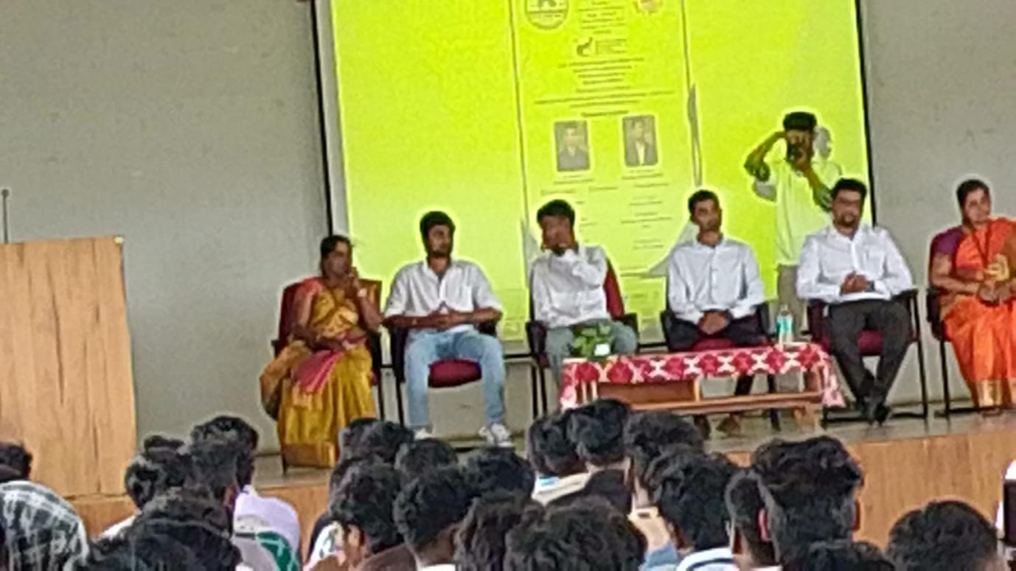
Participant details:
Total no. of Student participation: 165
Total no. of Staff (Teaching/Non-teaching) participation: 10

