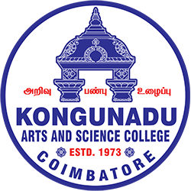

KONGUNADU ARTS AND SCIENCE COLLEGE
Re-accredited by NAAC with ‘A+’ Grade (4th Cycle)
(Autonomous)
College of Excellence (UGC)
COIMBATORE - 641 029

Session Details
Title of the Session: “SESSION ON ANGEL INVESTMENT AND VC FUNDING OPPORTUNITIES”
Date: 31st August, 2026
Duration: 9.30AM to 1.00 PM
Activity Category: IIC Calendar/MIC Driven/Self Driven/Celebration
Theme: “Exploring Angel Investment and Venture Capital Funding Opportunities for Startups and Emerging Entrepreneurs”

Expert/Speaker Details:
Mr.B.Bala Senthilkumar, Director/Career Coach, Ze Bancairo iStudy Hub

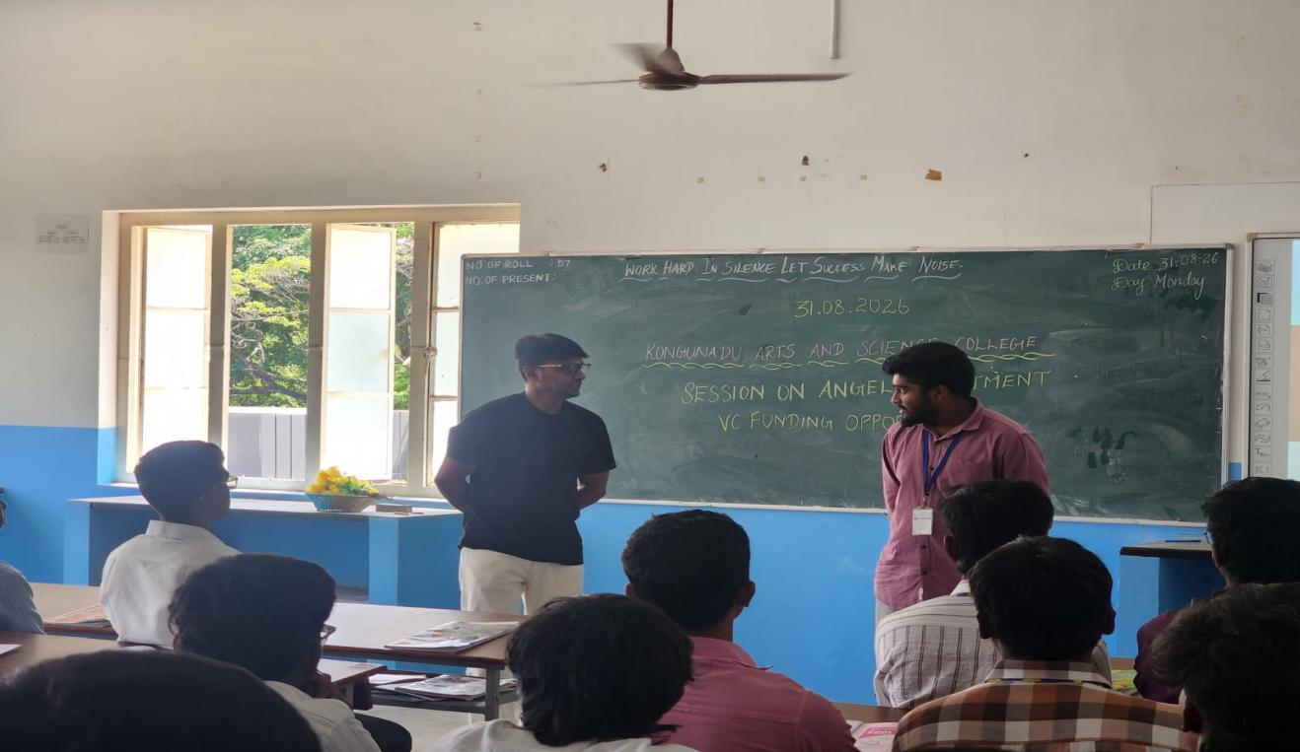

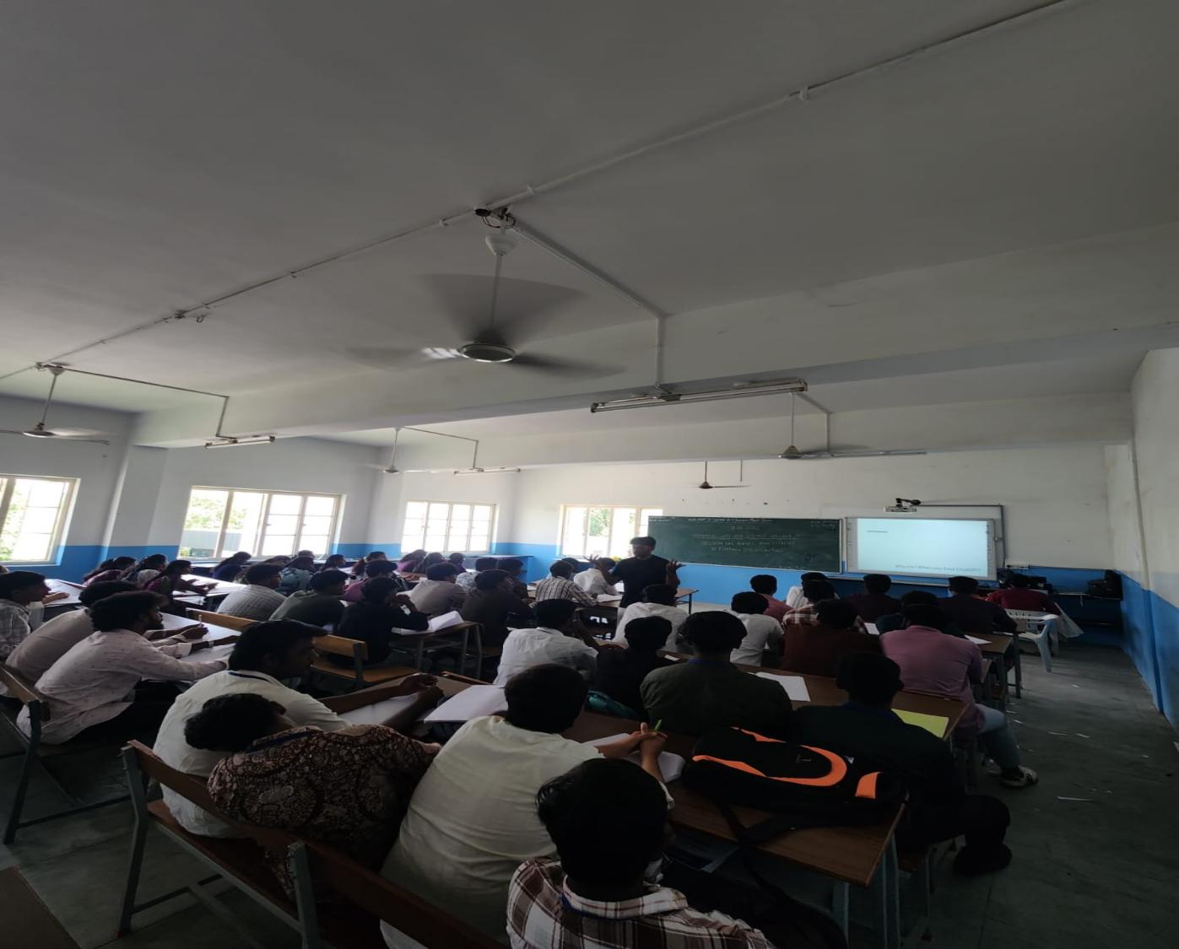

The KASC - Institutions Innovation Council (IIC), Research and Development Cell, Department of Business Administration with Computer Applications (BBA CA), organised a session on “ANGEL INVESTMENT AND VC FUNDING OPPORTUNITIES ” on 31st August, 2026 at 9.30 AM in venue 14A.
The Resource persons for the session were Mr.B.Bala Senthilkumar, Director/Career Coach, Ze Bancairo iStudy Hub. The session started with a formal prayer song, welcome address and guest introduction.
The resource person gave a brief about why Investment and opportunities are available for emerging startup companies. He explained about angel investors and venture capitalists, their roles, and how do they help budding entrepreneurs to start their entrepreneurship and early stage funding. He also shared his knowledge on the career opportunities in various fields.

Participant details:
Total no. of Student participation: 121
Total no. of Staff (Teaching/Non-teaching) participation: 4

Signature of the HOD

