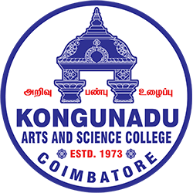 

**KONGUNADU ARTS AND SCIENCE COLLEGE (Autonomous)**

**Re-accredited by NAAC with ‘A+’ Grade (4th cycle)**

**College of Excellence (UGC)**

**52nd Rank among Colleges in NIRF 2024**

**Coimbatore – 641 029.**

**DEPARTMENT OF BUSINESS ADMINISTRATION WITH COMPUTER APPLICATIONS(BBA CA) & KASC IIC**

**Session Details**

Title of the Session: “Incubation Support For Early Stages Entrepreneurs”

Date: 28.08.2025

Duration: 9.00 AM Onwards

Activity Category**:** IIC Calendar/MIC Driven/Self Driven/Celebration

Theme: Early stage Entrepreneurs

**Expert/Speaker Details:**

Dr.C.Ramkumar,

Director,IQAC & Professor Department of ECE

**Brief about Expert/Speaker:**

Name: Dr.C.Ramkumar,

Designation: Director,IQAC & Professor Department of ECE

Organization: Sri Krishna College of Technology, Coimbatore.

The Department of Business Administration with Computer Applications (BBA CA) &, KASC IIC has organised “Incubation Support For Early Stages Entrepreneurs”on 28th August, 2025 at 9.00 AM onwards at F14A class room. The Chief Guest for the session was Dr.C.Ramkumar, Director IQAC,Professor Department of ECE, Sri Krishna College of Technology, Coimbatore. The session started with the welcome note by Mrs.M.Sangeetha, Assistant Professor, Department of BBACA, gave a warm welcome to the esteemed guest. Dr.S.Punitha Devi, honored the guest with a memento.

### The session focused on empowering student’s withe insights into the incubation support system, funding resources, and strategic growth pathways for upcoming entrepreneurs. He also spoke about the role of Angel Investors and Venture Capitalists in funding for early- stage entrepreneurs.

The session provided students with a comprehensive understanding of early-stage entrepreneurs incubation support. The event concluded with a vote of thanks by Ms.Varshini of II BBACA, acknowledging his contribution to shaping future early-stage entrepreneurs. The session was well-received, leaving students motivated and better prepared for real-world business challenges. The session was very interesting, and a total of 93 students were part of this session and benefited.

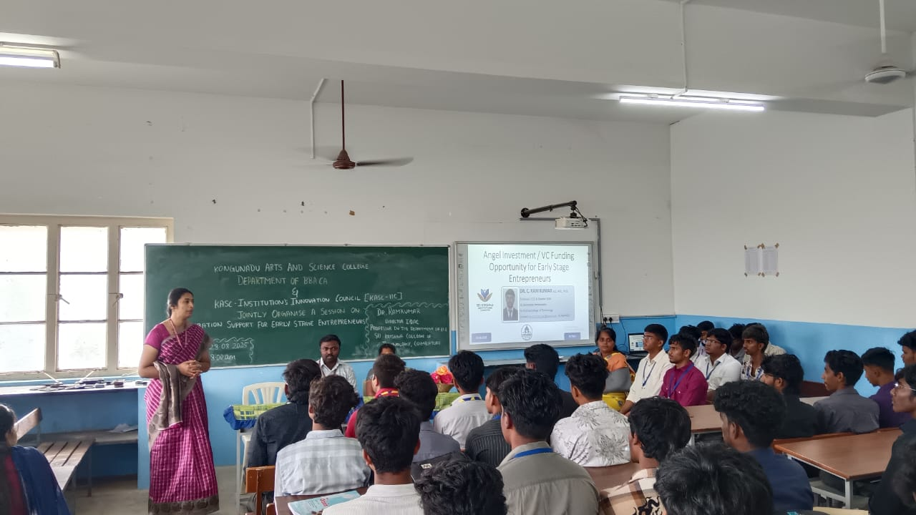

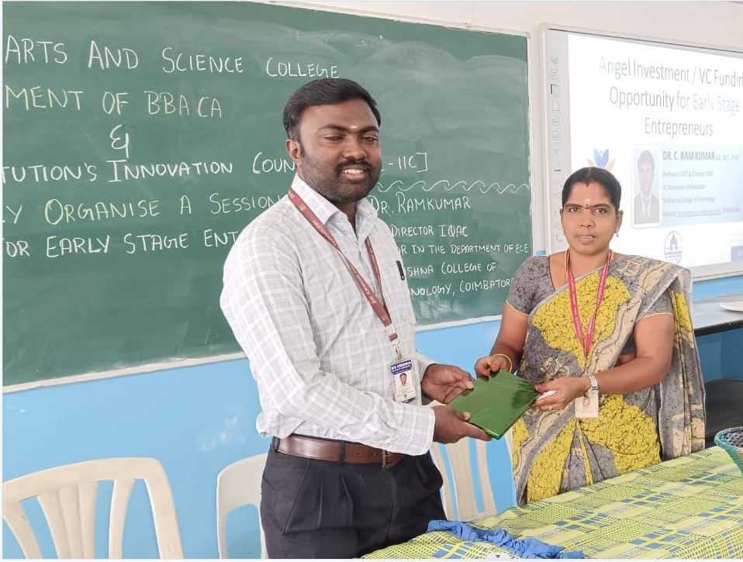

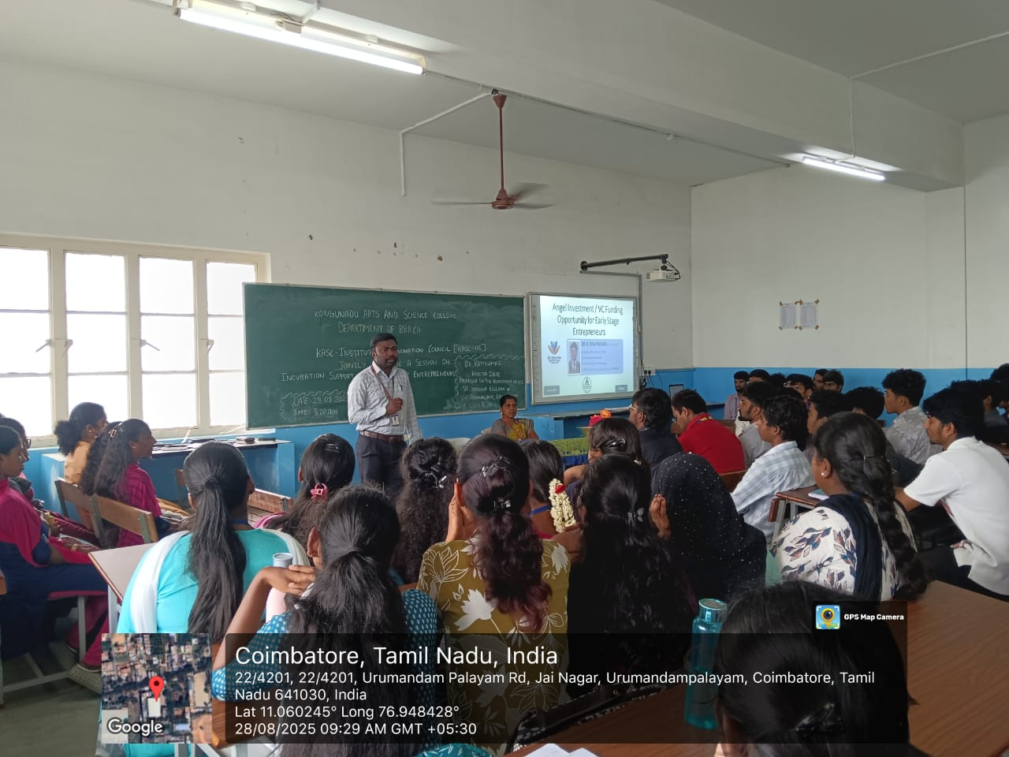

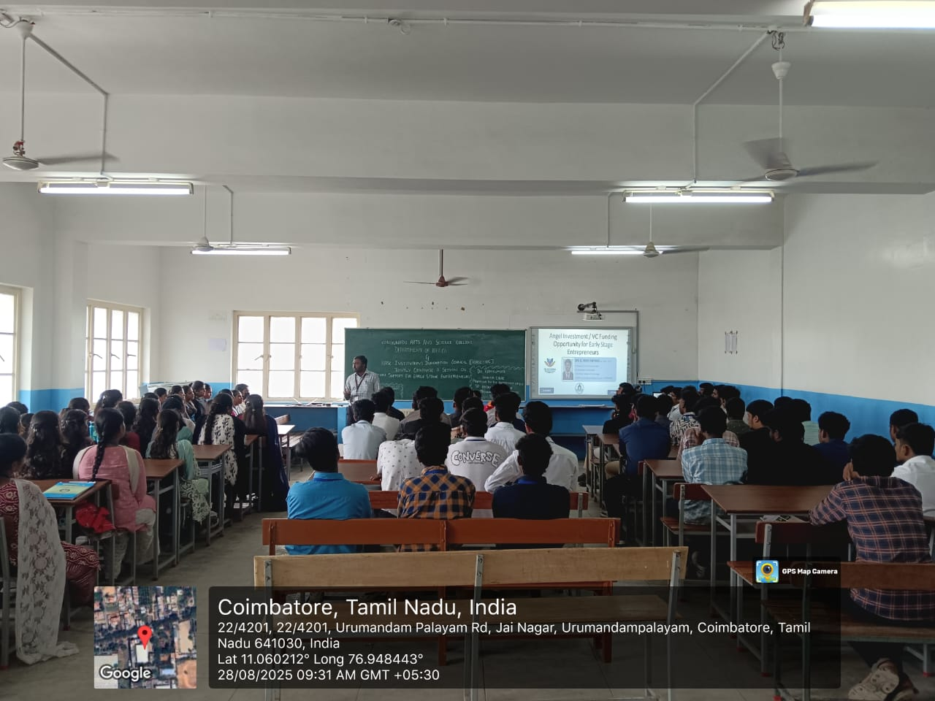

**Outcome of the activity:**The session provided students with a comprehensive understanding of early-stage entrepreneurs incubation support.

**Key Highlights:** Early stage Entrepreneurs, Venture Capital, Angle Investors, Incubation Centers.

**Participant details:**

Total no. of Student participation: 101

Total no. of Staff (Teaching/Non-teaching) participation: 5