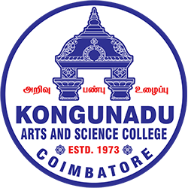 

**KONGUNADU ARTS AND SCIENCE COLLEGE**

Re-accredited by NAAC with ‘A+’ Grade(4th Cycle)

*(Autonomous)*

*College of Excellence (UGC)*

***COIMBATORE - 641 029***

***DEPARTMENT OF BUSINESS ADMINISTRATION WITH***

***COMPUTER APPLICATIONS (BBA CA)***

**WORKSHOP ON RISK PROFILING AND ASSET ALLOCATION BASED ON AGE AND GOALS ON 21/08/2025**

The Department of BBA- CA Kongunadu Arts and Science College organized a seminar on “Risk Profiling and Asset Allocation Based on Age and Goals” on 21/08/2025 at 10.00 am to 12.00 pm in F14 classroom. The chief guest for the program was Mrs.S.Chitra, Finance and Investment Expert /Educator/Mentor, SEBI Certified SMART Trainer.

The session was interesting and she shared about the importance of savings and Investment and different opportunities available to invest based on their age. She delivered a brief note on investment patterns and profitable investment ideas. She gave a deep insight regarding the stocks, Bonds, Insurance, ULIP and Mutual Funds. She also gave a complete insight into share market trading and the role of speculators in the share market. The session was very interesting, and a total of 95 students were part of this seminar and benefited.

