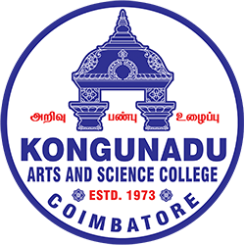 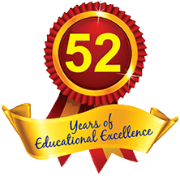

**KONGUNADU ARTS AND SCIENCE COLLEGE**

Re-accredited by NAAC with ‘A+’ Grade(4th Cycle)

*(Autonomous)*

*College of Excellence (UGC)*

***COIMBATORE - 641 029***

The Department of Business Administration with Computer applications (BBACA), and the Placement Cell, KASC, jointly with Samarthanam Trust for the Disabled, organized a Mega Job Fair on August 22, 2025. The event aimed to connect employers with job seekers by providing a platform for students and job aspirants to interact with top recruiters from various industries. The event was inaugurated by Dr.V.Sangeetha, Principal KASC, Dr.T.Kumar, Dr.R.Saravanamoorthy, Dr.K.Sumangala Co-Ordinators for SF stream, Dr.S.Punitha Devi, HOD BBACA, Dr.J.Vijayalakshmi, Placement Cell, gave a welcome note followed by Presidential address by Dr.V.Sangeetha, Principal, and the program was felicitated by Mr.Senthilkumar Regional Head, Samarthanam Trust, Bangalore, and Vote of Thanks by Mr.Raja, Centre Head, Samarthanam Trust, Coimbatore.

The job fair featured the participation of 26 reputable employers from diverse sectors, including IT, manufacturing, construction, banking, and automobile industries. A total of 375 candidates attended the job fair in search of career opportunities. The job fair provided an excellent platform for candidates to network with recruiters and gain valuable insights into industry expectations. The Mega Job Fair was a tremendous success, benefiting both employers and job seekers. The event not only offered job opportunities but also enhanced the relationship between academia and industry.

