**KONGUNADU ARTS AND SCIENCE COLLEGE**

Re-accredited by NAAC with ‘A+’ Grade (4th Cycle)

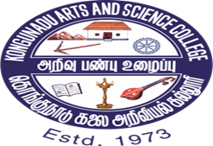

***DEPARTMENT OF BUSINESS ADMINISTRATION [CA]***

**CARER SCOPE IN CURRENT TREND JOBS FOR BBA GRADUATES 24/09/2024.**

The Department of BBA- CA of Kongunadu Arts and Science College has Organized a guest lecture on Career Scope in current trend jobs Management students on 24/09/2024 at 9.00 am to 11.00am in Hall no G4. The chief guest for the program was Mr.K.Dineshkumar, Business Development Head Imarticus Learning, Coimbatore.

The session started with the prayer song.

Mrs.J.Gayathiri Manchubhashini, Assistant Professor, Department of BBA CA welcomed the gathering, and honored the guest.

Mr.K.Dineshkumar, Business Development Head Imarticus Learning, Coimbatore headed the session with the topics of investment in banks, share market , crypto currency, job opportunities, introduction about CMA (Certified Management Accountant) course. The session was very interesting, he gave a deep insights regarding the course, and the opportunities. Totally 118 students attended the program.

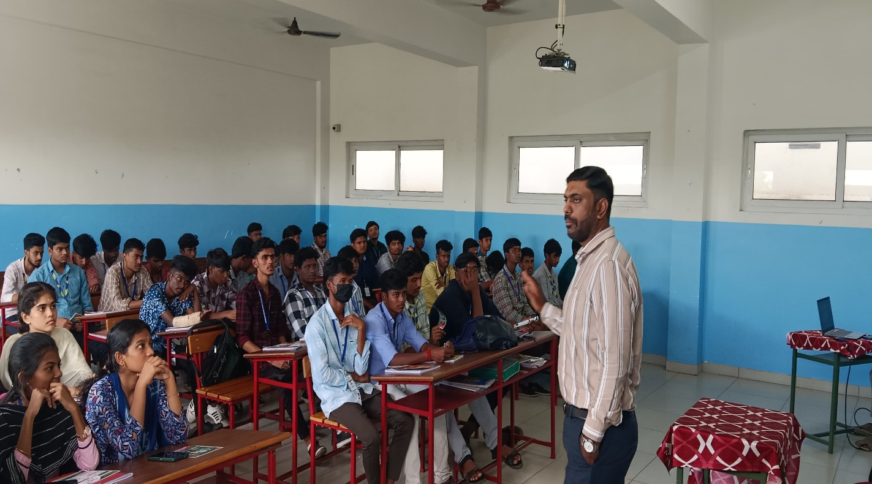

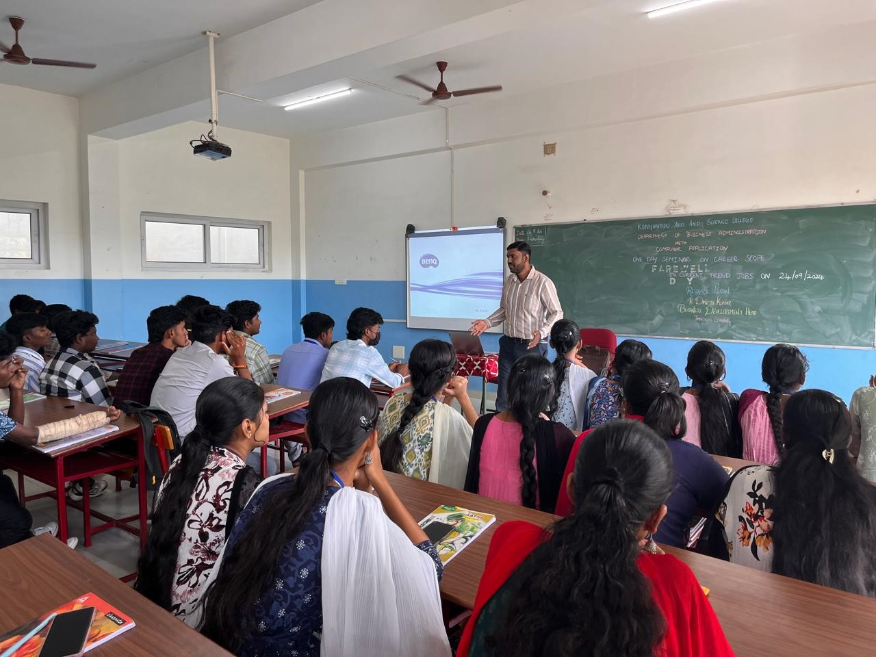

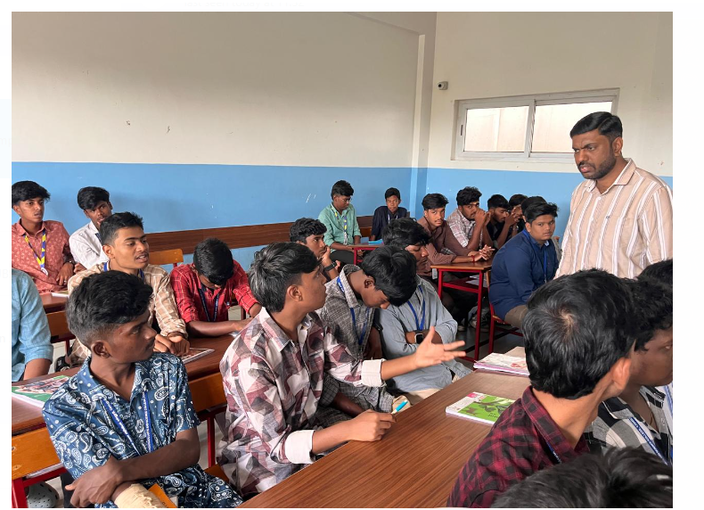

Signature of Head of the Department