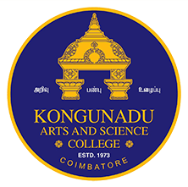 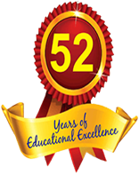

**KONGUNADU ARTS AND SCIENCE COLLEGE**

*(Autonomous)*

Re-accredited by NAAC with ‘A+’ Grade (4th Cycle)

*College of Excellence (UGC)*

*52nd Rank among Colleges in NIRF 2024*

***COIMBATORE - 641 029***

***DEPARTMENT OF BUSINESS ADMINISTRATION [CA]***

**“GUEST LECTURE ON CAREER GUIDANCE”**

The Department of Business Administration with Computer Applications (BBA CA) organized a one-day Career counseling session on 1st February 2025 for students to make them aware of various opportunities and trends in the field of Management after graduation. The Resource persons for the session were Dr K.Gunaseela Prabhu, Associate Professor & Head, Department of Management, Sri Ramakrishna College of Arts and Science, Coimbatore. He suggested varied ways how to opt for a career in one’s life depending on one’s capabilities and potential. He talked about how to focus on the chosen career and what efforts to put in to make that dream come true, how to compete for various entrance exams and prepare for entering IIM and other recognized institutions. He explained by giving examples of various successful people, and how they achieved the status despite having a lack of facilities and financial support. Number of participants - 86 Students

