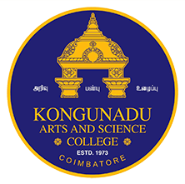 

**KONGUNADU ARTS AND SCIENCE COLLEGE**

*(Autonomous)*

Re-accredited by NAAC with ‘A+’ Grade (4th Cycle)

*College of Excellence (UGC)*

*52nd Rank among Colleges in NIRF 2024*

***COIMBATORE - 641 029***

***DEPARTMENT OF BUSINESS ADMINISTRATION [CA]***

**“GUEST LECTURE ON CAREER OPPORTUNITIES IN MARKETING “**

The Department of Business Administration with Computer Applications (BBA CA) organized a guest lecture on career opportunities in the marketing sector session on 5th February 2025 for students to make them aware of various opportunities and trends in the field of Marketing. The Resource person for the session was Mr Melvin Dario. J.K, Marketing Executive, Ads Spark, Coimbatore. He talked about upcoming opportunities in the marketing sector, and the training to approach the customers. He also spoke about the job opportunities available to students for full-time & part-time. The BBACA 90 students of both II & III years attended the session and benefited.

