***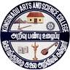*KONGUNADU ARTS AND SCIENCE COLLEGE**

Re-accredited by NAAC with ‘A+’ Grade(4th Cycle)

*(Autonomous)*

*College of Excellence (UGC)*

***COIMBATORE - 641 029***

***DEPARTMENT OF BUSINESS ADMINISTRATION [CA]***

“SEMINAR ON STARTUP UNLOCKING INFINITE POTENTIAL”

KASC – Institution’s Innovation Council (KASC – IIC) and the Department of BBA CA in commemorate National start up day 16th January 2025 has organized a seminar on “Startup unlocking Infinite Potential” on 28/01/2025 from 9.00 am to 12.00pm in G4 hall .

The Chief Guest for the event was Mr.M.Kishore Kumar, Managing Partner, Bluebell Apparels, Tirupur, Tamilnadu.

The session started with the welcome address by Mrs.M.Sangeetha, Assistant Professor, followed by the guest introduction . The chief guest, Mr.M.Kishore Kumar took over the session and started with the basics of features of entrepreneur and the startup ecosystem. He briefed on the process of creating, developing, and managing a new business venture, and the need for innovation. He also explained leadership qualities, the importance of innovation, risk-taking, and resilience as essential qualities of successful entrepreneurs.

He also shared real-life examples that inspired the  
students and provided them with valuable insights into the world of entrepreneurship. The  
seminar has undoubtedly ignited the entrepreneurial spirit among the students and equipped them  
with the necessary knowledge and skills to embark on their startup journeys

The session was very interactive, the students were given activities all of them engaged and attended the activity enthusiastically. He had a discussion with the students regarding their ideas on startups. The session ended with a vote of thanks by Harshini of II BBA CA. Totally 88 students attended the session. 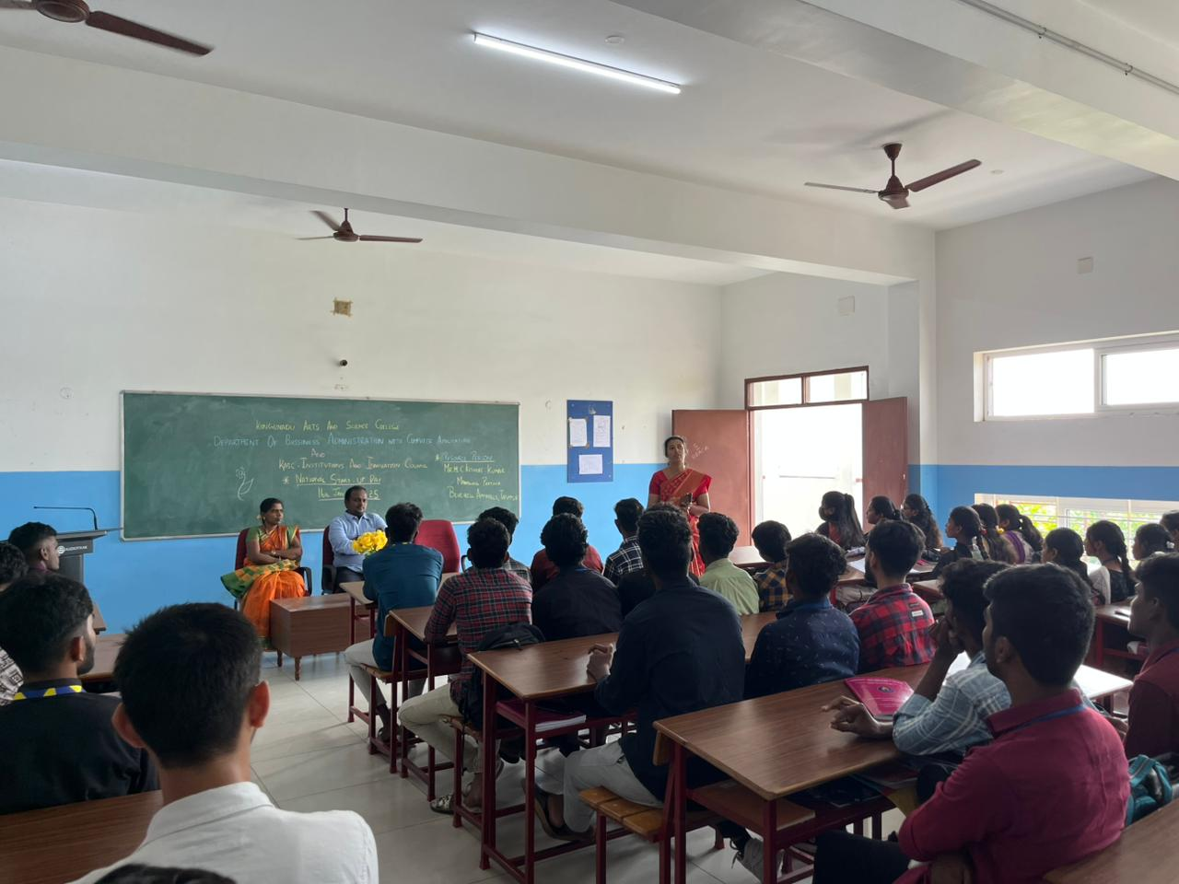

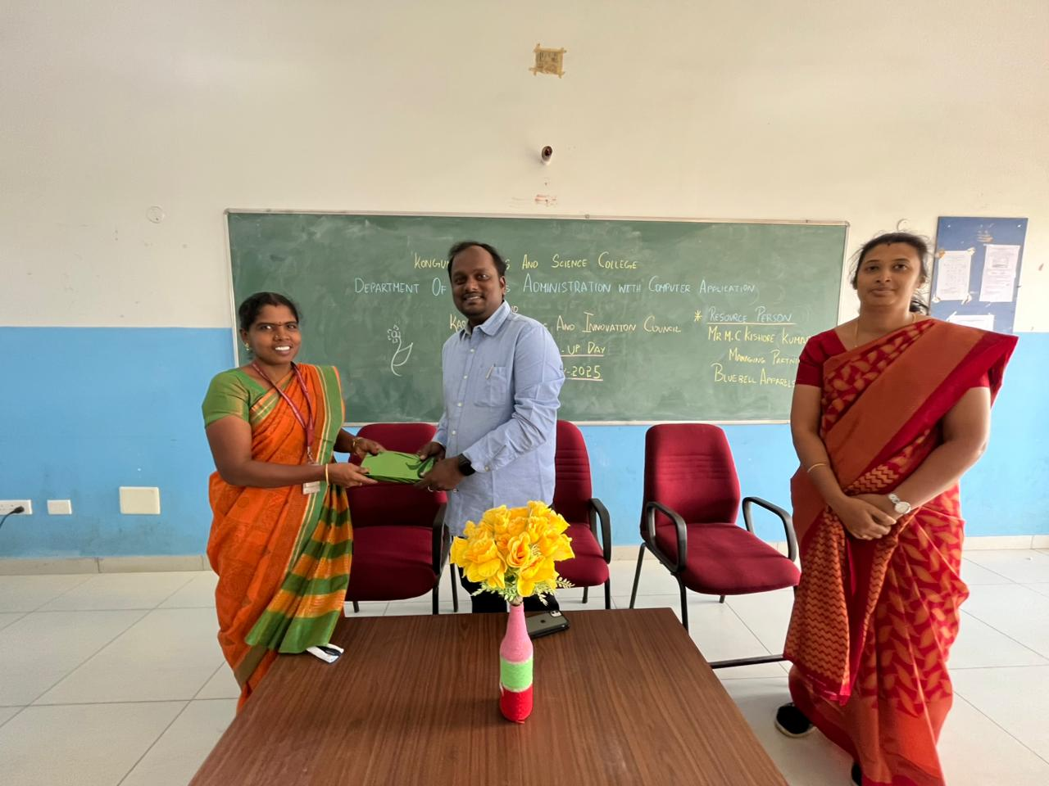

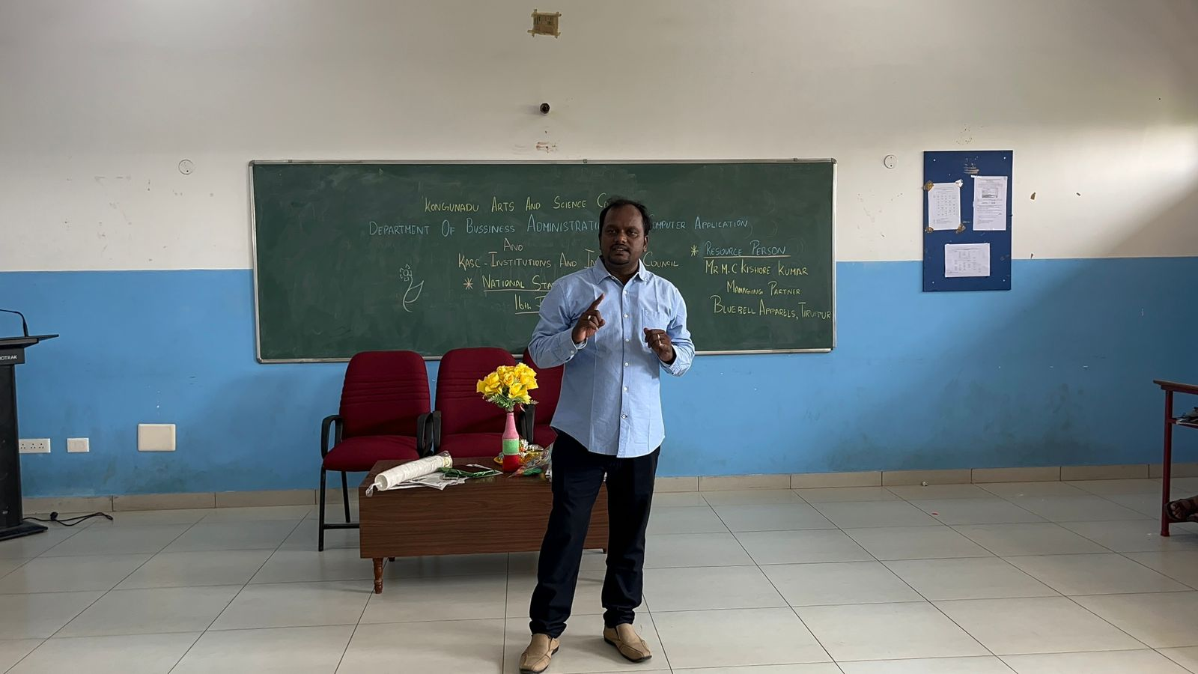

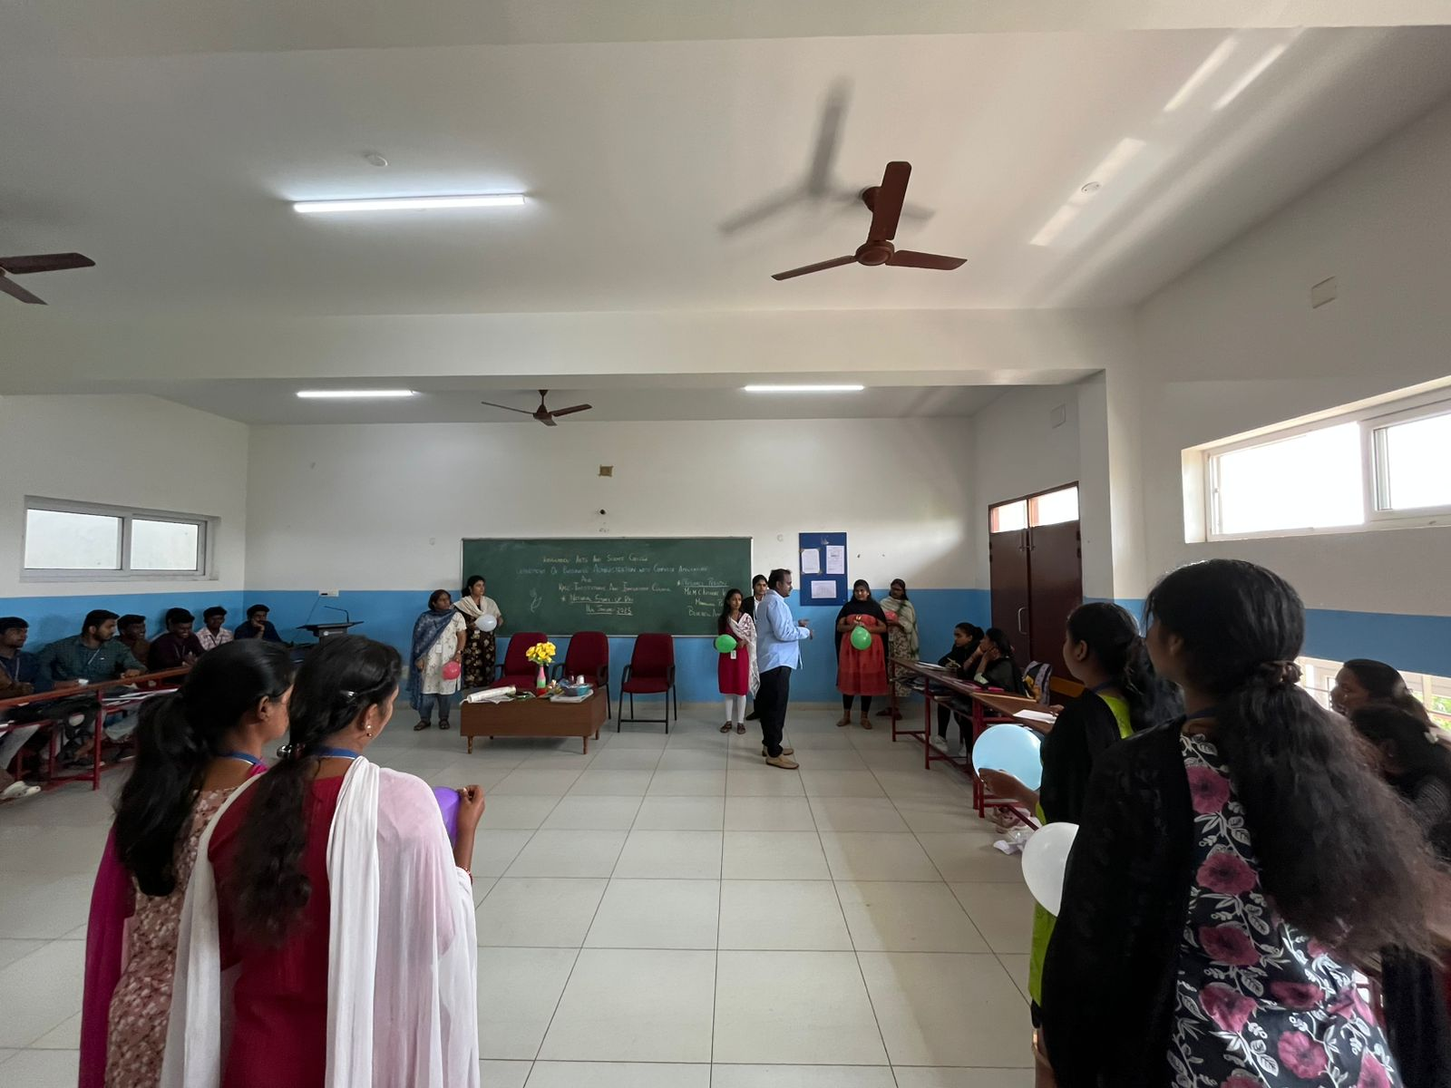

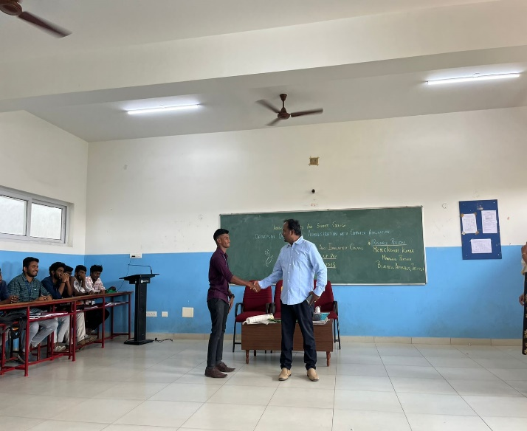 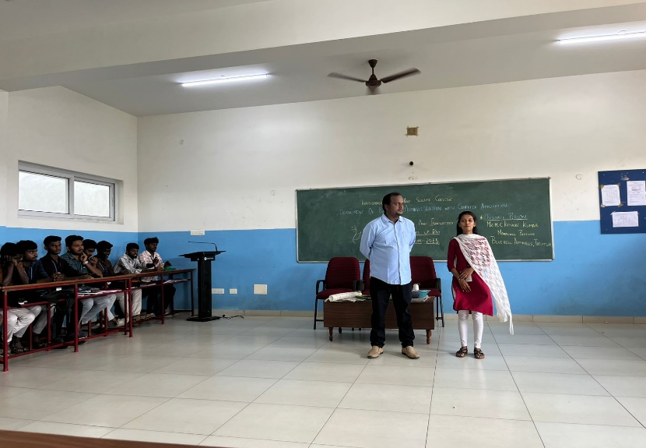

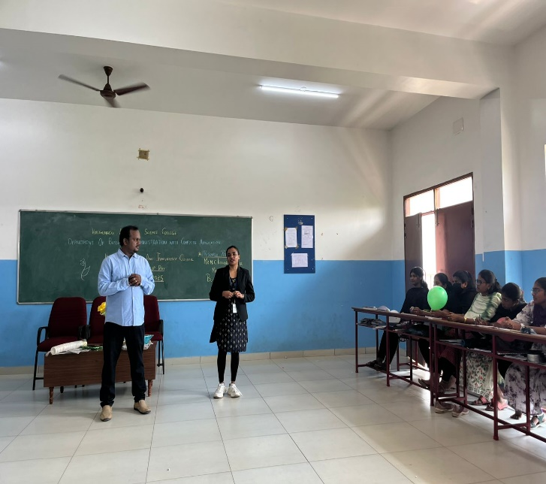 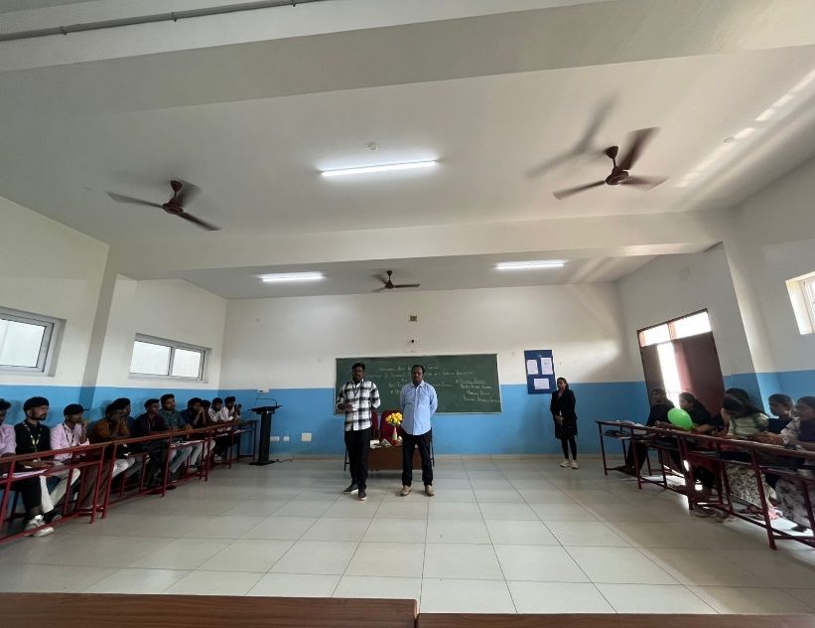

Signature of the HOD