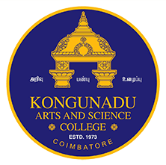 

**KONGUNADU ARTS AND SCIENCE COLLEGE**

*(Autonomous)*

Re-accredited by NAAC with ‘A+’ Grade (4th Cycle)

*College of Excellence (UGC)*

*52nd Rank among Colleges in NIRF 2024*

***COIMBATORE - 641 029***

***DEPARTMENT OF BUSINESS ADMINISTRATION [CA***

“MARKETING BONANZA”

The Department of BBA- CA Organized a Marketing Bonanza held on 3rd February 2025 at the conference hall, which was an impressive showcase of the talents and creativity of budding management professionals. The event was inaugurated by Dr.V.Sangeetha, Principal, Dr.V.Kokilavani, Controller of Examination, Dr.K.Sumangala, Academic Coordinator and by all the HODs of Commerce and Management, Nearly 4500 students from various departments, 250 Teaching faculty members and 200 non–teaching faculty members visited the stalls.

The event aimed to provide a platform for students to apply their marketing knowledge, gain practical experience, and connect with industry professionals. The Expo featured a diverse range of exhibits from students, including marketing campaigns, food stalls fun games etc. The students gained practical marketing skills by planning, organizing, and executing the event.

The event was a resounding success, demonstrating the dedication, creativity, and potential of students.

