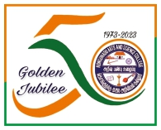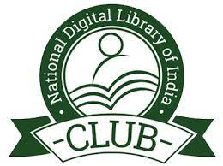**KONGUNADU ARTS AND SCIENCE COLLEGE (Autonomous)**

**Re-accredited by NAAC with ‘A+’ Grade (4th cycle)**

**College of Excellence (UGC)**

**29th Rank among Colleges in NIRF 2023**

**Coimbatore – 641 029.**

**DEPARTMENT OF BUSINESS ADMINISTRATION WITH COMPUTER APPLICATIONS(BBACA)**

**& NDLI CLUB, KASC**

**“FINANCIAL FREEDOM FOR COLLEGE STUDENTS – STRATEGIES FOR SUCCESS” Report**

The Department of Business Administration with Computer Application (BBACA) and KASC NDLI club jointly organized a International Seminar on “Financial Freedom for college students – strategies for success on 01/08/2024 at 10.00 am to 12.00 pm in Room No: G4.

The session started with the prayer song sung by Ms.M. Poornamirthaa, Ms.Surya Prabha, & Ms.S.Maria Jina of I BBA CA followed by the welcome address by Ms.Varshini of I BBACA, she gave a warm welcome to the guest of honor, HOD of BBACA, faculty members, and the students of BBACA & Mr.Avendran of I BBACA gave a brief Introduction about the chief guest Dr.P.Karthika.

The guest for the program was Dr.P.Karthika, SEBI, NISM, and NSE recognized resource person & Associate Professor, Department of Management, Kebri Dehar University, Ethiopia. She gave detailed insights on the importance of Investments and also the various arenas for investment. She explained about NSE and BSE and companies listed in share market and gave a detailed demonstration on online share trading using DEMAT account. 110 participants attended the program and benefited.

