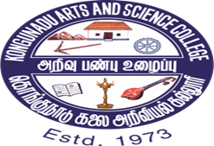

**KONGUNADU ARTS AND SCIENCE COLLEGE (Autonomous)**

**Re-accredited by NAAC with ‘A+’ Grade (4th cycle)**

**College of Excellence (UGC)**

**29th Rank among Colleges in NIRF 2023**

**Coimbatore – 641 029.**

**DEPARTMENT OF BUSINESS ADMINISTRATION WITH COMPUTER APPLICATIONS (BBA CA) &, KASC IIC**

**“A Two Day Session on Business Model Canvas (BMC)”**

The Department of Business Administration with Computer Applications (BBA CA) &, KASC IIC has organised “**A Two-Day Session on Business Model Canvas (BMC)”** on 30th & 31st July, 2024 at 9.30 AM onwards at G4 class room.

The Chief Guest for the day one session was Dr.Swarnalatha, Associate Professor and Head, the Department of Management Science – Retail Management, PSG College of Arts and Science.

The Chief Guest for the second day session was Dr.B.Dhivya Priya, Associate Professor and Head, the Department of B.Com (IT), Kongunadu Arts and Science College.

The first day session started with the prayer song sung by Ms.M. Pooja of III BBACA followed by the welcome address by Ms. M.S Sruthilla of III BBACA, she gave a warm welcome to the guest of honor, HOD of BBACA, Staff members of the department and the students. Mr.Shivay Mahajan of III BBACA gave a brief Introduction about the chief guest.

### Dr.Swarnalatha, took over the session, she started with the meaning of an Entrepreneur and also discussed the need for creativity and innovation in the new era. She also touched upon the Global Innovation Index and countries that are in the GII. The session was very interactive and the students were given activities. She also included “How India Will be in 2030” and what are innovations going to come in various sectors. She also explained the “Nine Building Blocks of Business”

### Customer Segments, Value Propositions, Channels, Customer Relationships, Revenue Streams,Key Resources, Key Activities, Key Partnerships, and Cost Structure and also explained the business models followed by different companies, she added the qualities of an Entrepreneur and also the meaning of an Intrapreneur.

The first day session ended with a Vote of Thanks by Mr. Mohit Jangir of III BBACA. 103 participants attended the session and benefited through the program.

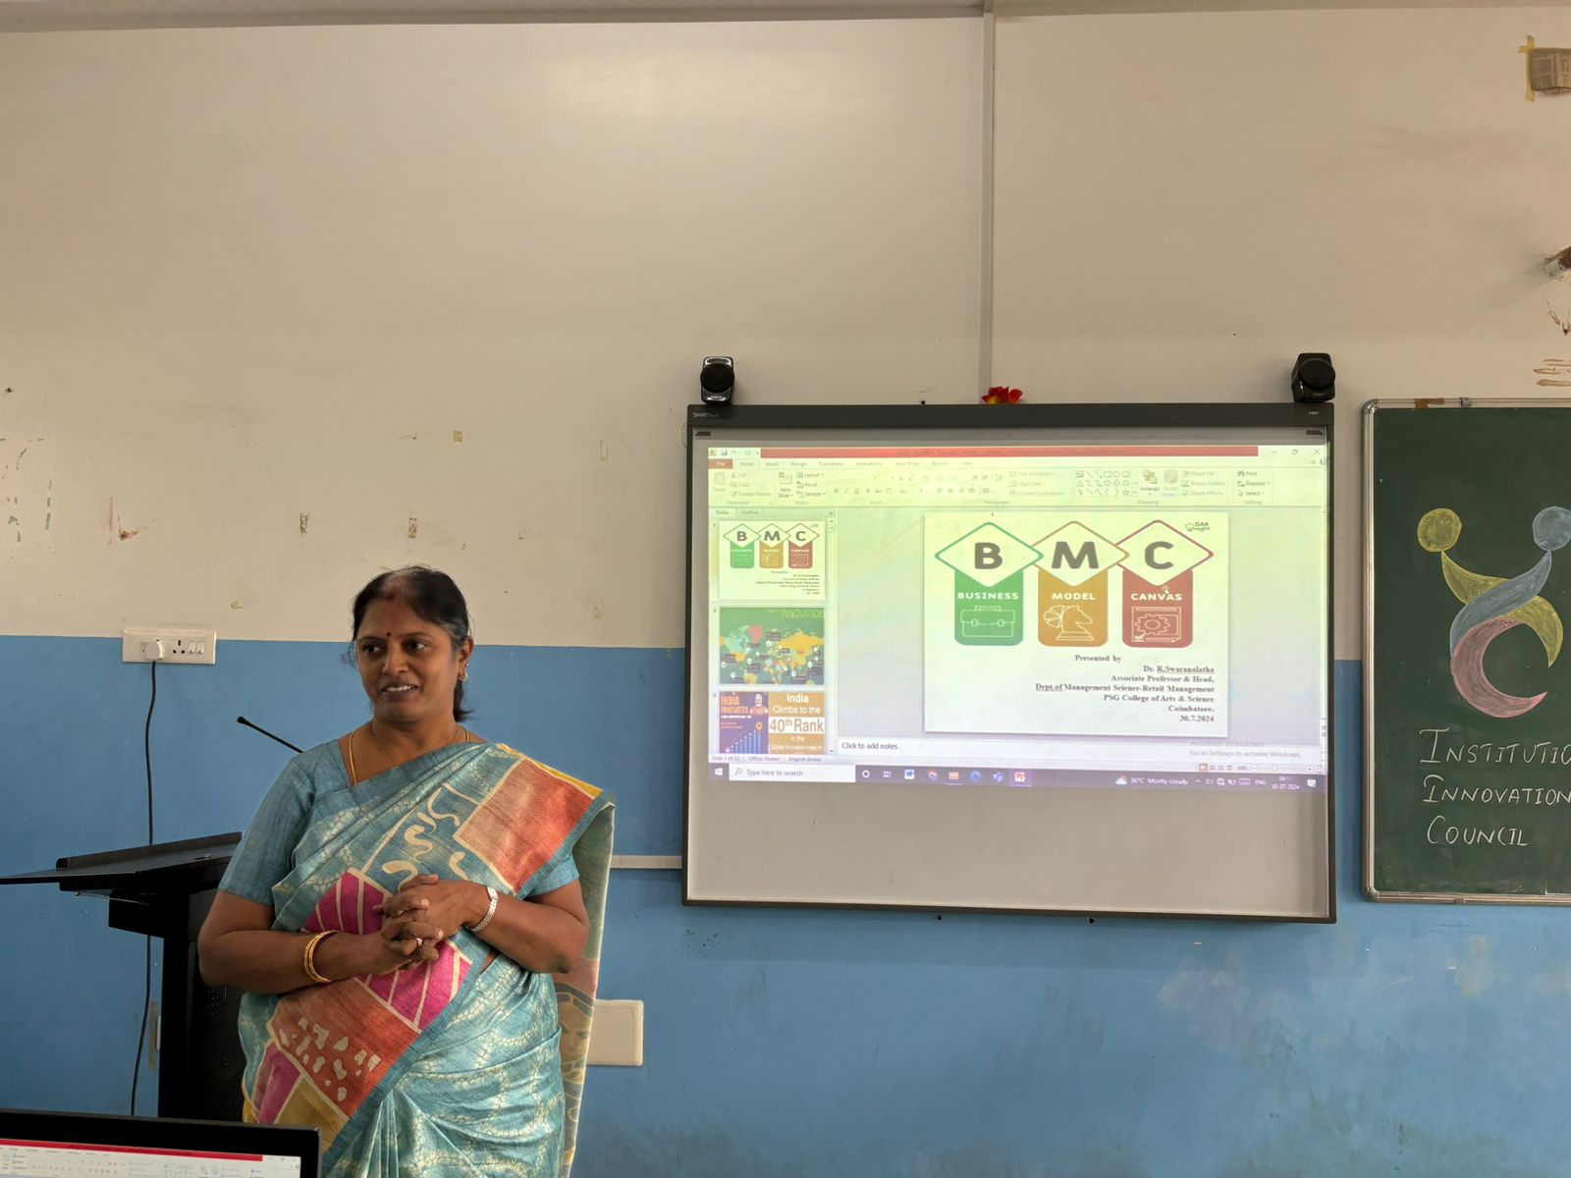

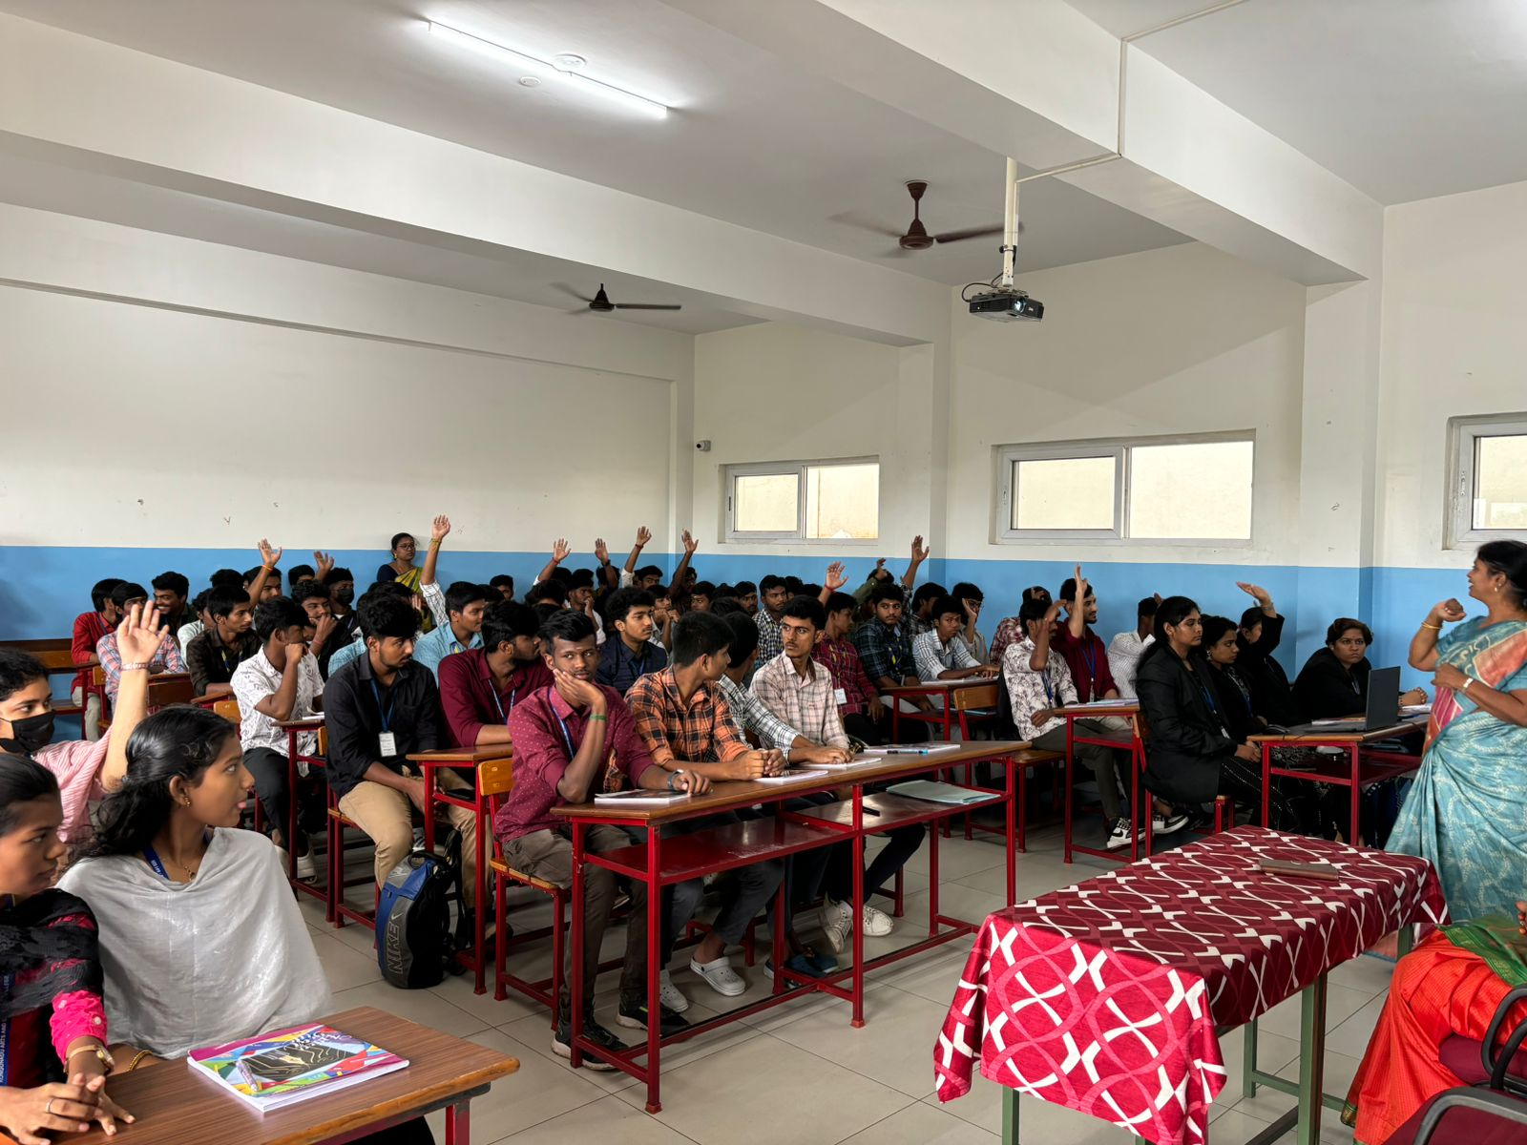

The Second day session started with the prayer song sung by Ms.M. Poornamirthaa, Ms.Surya Prabha, & Ms.S.Maria Jina of I BBA CA followed by the welcome address by Mr.R.Fayazof II BBACA, he gave a warm welcome to the guest of honor, HOD of BBACA, Staff members, and the students of BBACA & Ms.B.Aishwarya of II BBACA gave a brief Introduction about the chief guest.

Dr.B.DhivyaPriya, Associate Professor and Head, the Department of B.Com (IT) took over the session. She gave a very detailed idea of business and business models followed by various corporates and also explained the “Nine Building Blocks” applied by the corporates by giving examples of a few companies. The students were given activities to fit in “Nine Building Blocks” of Amazon, Skype etc.

The second day session ended up with the Vote of Thanks by Ms.M.Bhavatharani of II BBACA. 108 participants attended the session and benefited through the program.

