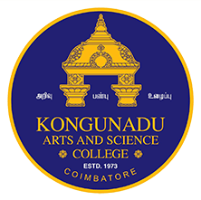 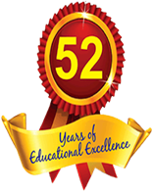 **KONGUNADU ARTS AND SCIENCE COLLEGE**

*(Autonomous)*

Re-accredited by NAAC with ‘A+’ Grade (4th Cycle)

*College of Excellence (UGC)*

*52nd Rank among Colleges in NIRF 2024*

***COIMBATORE - 641 029***

***DEPARTMENT OF BUSINESS ADMINISTRATION WITH COMPUTER APPLICATIONS (BBA CA)***

**“WORKSHOP ON SPSS: HANDS-ON SESSION”**

The Department of Business Administration with Computer Applications (BBA CA) organized a “Workshop on SPSS: Hands-on Session” on 26th February 2025. Dr.M.Iswarya, Assistant Professor - MBA, Hindusthan College of Engineering and Technology, Coimbatore was the resource person.   
The workshop was conducted with the primary aim of providing students with a  
comprehensive understanding of the fundamentals of data analysis, introducing commonly  
used statistical tests, and offering hands-on experience in solving data analysis problems  
using SPSS (Statistical Package for the Social Sciences).  
The sessions of the workshop were designed to be interactive, engaging, and focused  
on practical applications. The students were familiarized with the basics of data analysis,  
SPSS software and its functionalities. The resource person has provided a hands-on session  
on the interface, navigation, importing and managing data in SPSS.  
The Data Analysis with SPSS workshop successfully achieved its objectives by  
equipping students with the knowledge and skills necessary for effective data analysis.  
The combination of theoretical concepts, practical exercises, and hands-on experience with  
SPSS contributed to a well-rounded learning experience.

Number of Participants – 51 Students

