**KONGUNADU ARTS AND SCIENCE COLLEGE**

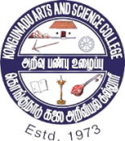**(Autonomous)**

**Reaccredited by NAAC with “A+” Grade (4th Cycle)**

**College of Excellence – (UGC)**

**52nd Rank among Colleges in NIRF 2024**

**Coimbatore – 641029, Tamilnadu India**

**Report on**

**“AI Training Program”**

**Organized by**

**Department of Computer Application,**

**Kongunadu Arts and Science College**

**Date: 1st to 7th July, 2024**

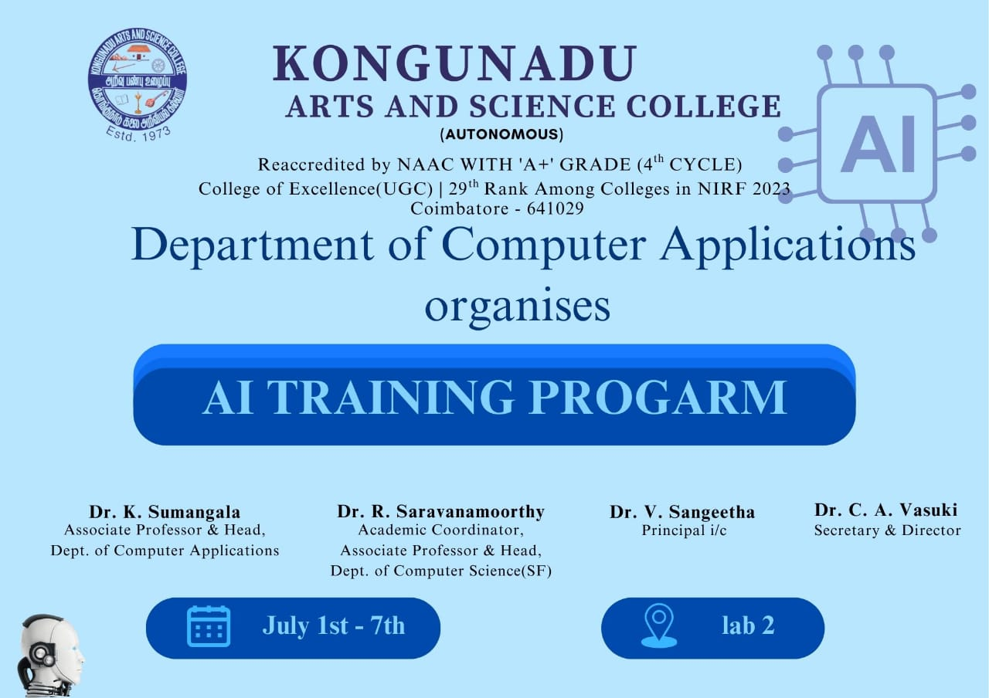

The Department of Computer Application organized a hands on workshop “AI Training Program” on 01/07/2024 to 07/07/2024. Around 30 students got benefited. Dr.S. Sundar Raman a distinguished leader with over 20 years of experience in business transformation through Artificial Intelligence and a Co-founder and Executive Advisor of OXI.AI Academy and OXI.AI India has been instrumental in training new talents in AI and Data Science. He explained AI product development, talent management, machine learning, and various programming languages to the students. A hand on training was given. Common credential for the participants was shared and worked effectively. Participants gained knowledge and got familiar with the working environment. We received good response from the audience and also they gave very good feedback.

