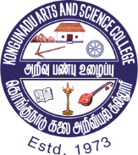 | KONGUNADU ARTS AND SCIENCE COLLEGE (AUTONOMOUS)  Re-accredited by NAAC with A⁺ Grade - 4th cycle,  College of Excellence - UGC  29th Rank among Colleges in NIRF 2023  Coimbatore - 641 029, Tamil Nadu, India

-REPORT-
Department of Commerce with Information Technology organised Workshop on ‘Smart Money: SIP and Mutual Funds’ on October 16th, 2023.
Objective: The main objective of the program is to enable students to understand the basics of investment, Mutual Funds and Systematic Investment Plan.
Resource Person: Mr. Mahesh Kumar Ponnusamy, Managing Director, Smart Wealth Assets Pvt. Limited, Mettupalayam was the resource person.
Benefits:
Students have developed with a basic understanding about the:
- Mutual Funds
- types of Mutual Funds
- Mutual Funds Scheme
- Risks and Returns
- Systematic Investment Plan
Number of Beneficiaries: Faculty: 04 Students: 162
Report:
Department of Commerce with Information Technology conducted a Workshop on Smart Money: SIP and Mutual Funds on October 16th, 2023. The main objective of the program is to enable students to understand the basics of investment, Mutual Funds and Systematic Investment Plan. Mr. Mahesh Kumar Ponnusamy, Managing Director, Smart Wealth Assets Pvt. Limited, Mettupalayam was the resource person. In his address, he highlighted the importance of planning for Investment. He gave an overview on Mutual Funds, types and various mutual funds scheme. He emphasised that choosing over the right mutual fund scheme is crucial for the safety and potential returns of SIP investments. Students have understood certain aspects to be considered for making sound investment decisions. Dr. B Divya Priya welcomed the gathering. Dr. K Sudha introduced the chief guest. Dr. K Saravanamoorthi offered felicitations. Mrs. M Princess Monica Victoria co-ordinated all the activities in connection with the programme. Dr. K Akila delivered vote of thanks.
INVITATION
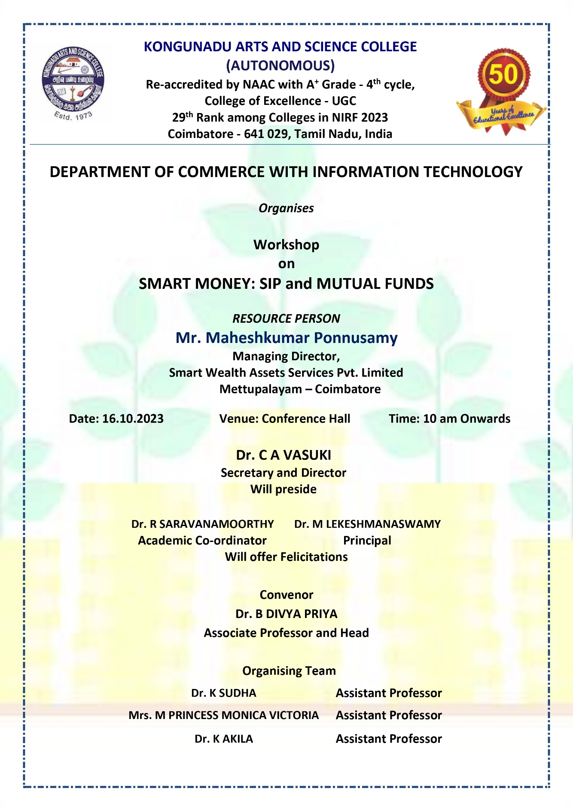

SNAPSHOT
