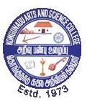 | Kongunadu Arts and Science College (Autonomous), Coimbatore – 29.  KASC - Institution Innovation Council (IIC)  &  Department of Commerce with Information Technology
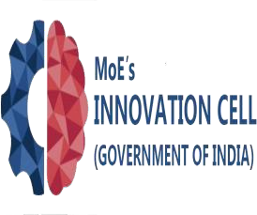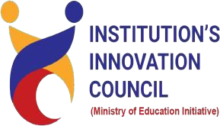 | -Report-  Title of the session: ‘Women and IP: Accelerating Innovation and Creativity’  Date: 9th August, 2023  Duration: 2 hour (10 am to 12 Noon)  Activity Category: IIC Celebration Day – World Intellectual Property (IP) Rights Day – August 21)  Theme: to enable emerging student entrepreneurs to understand importance of IP in accelerating Innovation and Creativity  Expert/Speaker Details:  Name: Dr. S Kalpana Devi  Designation: Assistant Professor of Commerce  Organization: Kongunadu Arts and Science College (Autonomous), Coimbatore  Brief about Expert/Speaker:  Dr. S Kalpana Devi, Assistant Professor of Commerce and Consumer Club Co-ordinator, Kongunadu Arts and Science College, Coimbatore.  Outcome of the activity: Students aspiring to become an entrepreneur have understood:  - Women and IP  - Importance of IPR  - Types of IPR  - Patent and Indian Women Inventor  - Barriers to Entry  Key Highlights:  - Knowledge Sharing on Importance of IP and women barriers of entry  Participant details: Nos: 62  Total no. of Student participation: 58  Total no. of Staff (Teaching/Non-teaching) participation: 04 | 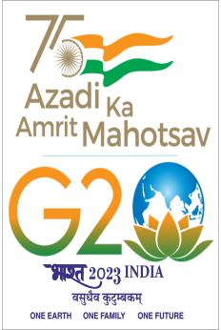

APPENDICES
INVITATION
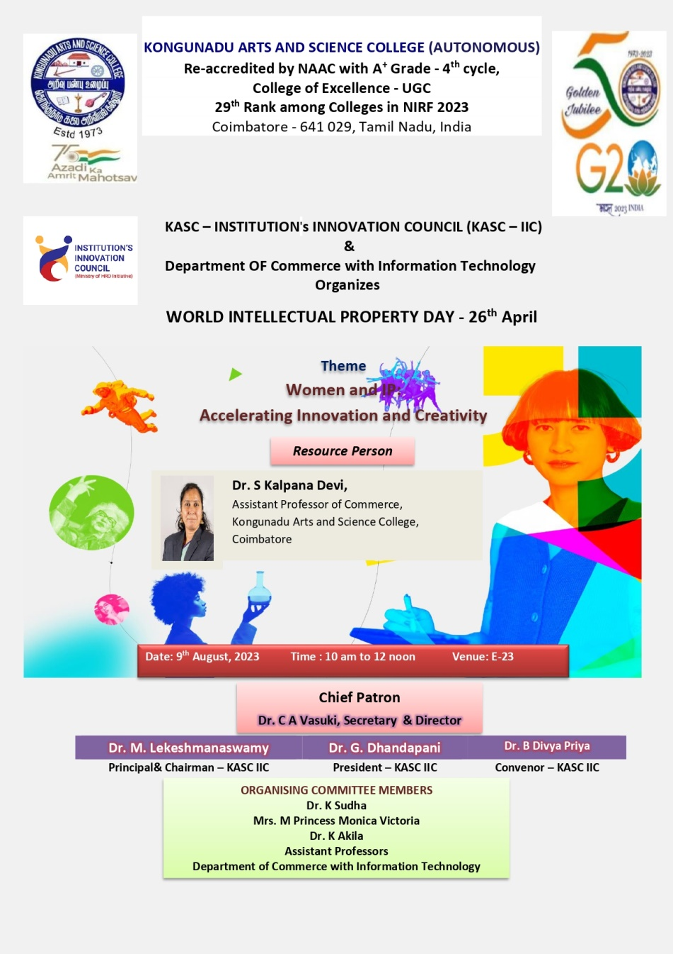

Glimpse of the Event
