Annexure - I
(Comprehensive Revision of Syllabus – Revised and Unrevised Courses)
(2021 – 2022)
Sl.  No. | Semester | Course Code | Name of the Course | Existing/  Revised | % of modification | Employability/  Entrepreneurship/  Skill Development
1. | I | 20PBC101 | Biomolecules. | Existing | 10 | Skill Development
2. | I | 20PBC102 | Bio analytical Techniques | Existing | 10 | Employability
3. | I | 20PBC103 | Enzyme and Enzyme Technology | Existing | 10 | Entrepreneurship
4. | I | 20PBC104 | Cell Biology | Existing | 10 | Skill Development
5. | II | 20PBC205 | Plant Biochemistry and Biotechnology | Existing | 10 | Skill Development
6. | II | 20PBC206 | Intermediary Metabolism | Existing | 10 | Skill Development

7. | II | 20PBC207 | Genetics and Molecular Biology | Existing | 10 | Employability
8. | II | 20PBC208 | Drug Biochemistry | Existing | 10 | Employability
9. | III | 20PBC309 | Immunology | Existing | 10 | Entrepreneurship
10. | III | 20PBC311 | Clinical Biochemistry | Existing | 10 | Entrepreneurship
% of change: Introduction of newcourse :100% Change of one unit: 20% #MinorChange : 10%

# Minor Change: Addition / Modification of one or two topics in a Unit.
Note: (i) Mere rearrangement of units will not be considered as any kind of change.
(ii) Change of prescribed text book / references with the existing syllabi will also not be considered as change.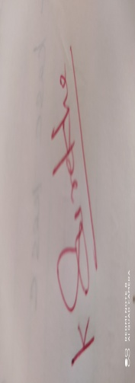
Signature of the Chairman of the Board

Signature of the Board Members
S.No. | Name of the  BOS Members | Designation, Official address E-Mail Id with Phone No. | Signature
1. | Dr.K.Surekha  (Chairman) | Associate Professor & Head(i/c)  Department of Biochemistry(PG)  Kongunadu Arts and Science College,  Coimbatore – 641029  Mobile : 98433 73085  Mail id: surekhabellie80gmail.com
2. | Dr. S. Viswanathan  (Member) | Assistant Professor  Department of Biochemistry(PG)  Kongunadu Arts and Science College,  Coimbatore – 641029  Mobile : 9597539286  Mail id: viswasundaram90@gmail.com
3. | Dr. J. Anitha  (Member) | Assistant Professor  Department of Biochemistry(PG)  Kongunadu Arts and Science College,  Coimbatore – 641029  Mobile : 9842684897  Mail id: janitha_bc@kongunaducollege.ac.in | 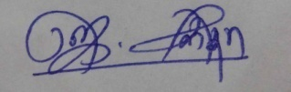
4. | Dr.V.Nandhini  (University Nominee) | Associate Professor & Head,  Department of Biochemistry,  CMS College of Science and Commerce,  Coimbatore –  Mobile -9994833303  Mail id-nandhini@cmscbe.com | 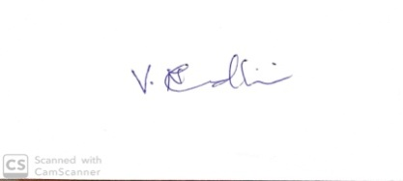
5. | Dr. V. Ragavan  (Subject Experts-Academic Council) | Associate Professor & Head,  Department of Biochemistry,  PSG College of Arts and Science,  Coimbatore – 641 014  Mobile: 9942059503  Mail Id: ragav.psg@yahoo.co.in | ABSENT
6. | Dr. T. Sathish Kumar  (Subject Experts-Academic Council) | Assistant Professor  Department of Biotechnology,  Kumaraguru College of Technology,  Coimbatore - 641049  Mobile: 9940851782  Mail Id: sathishkumar.t.bt@kct.ac.in
7. | Dr. U. Devaki  (Industrial Expert) | Serology HoD& Senior Biochemistry  Microbiological Laboratory  Coimbatore – 641 002  Mobile: 9787136247 | 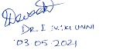
8. | Dr. .K.Gurusamy  (Alumini) | Assistant Professor  Department of Biochemistry,  Horticulture College and Research Institute for Women,  NavalurKuttapattu,  Trichy – 620027  Mobile: 9944591636  Mail Id:gurubio03 @gmail.com
9. | Ms. V. S. Yazhini  (Student Nominee) | II M.Sc Biochemistry,  Kongunadu Arts and Science College,  Coimbatore-641029

Signature of the Chairman of the Board

