KONGUNADU ARTS AND SCIENCE COLLEGE

(AUTONOMOUS) COIMBATORE – 641 029.

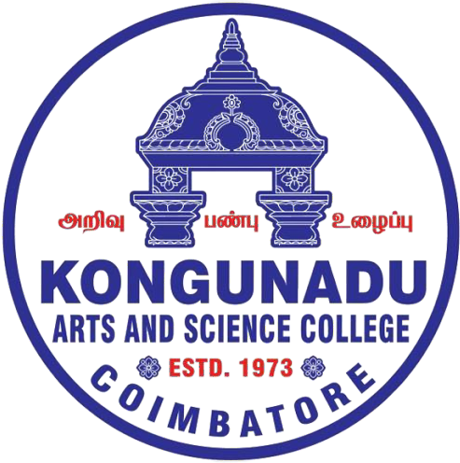

DEPARTMENT OF INFORMATION TECHNOLOGY

CURRICULUM AND SCHEME OF EXAMINATIONS (CBCS)
(2026 - 2027 onwards)

DEPARTMENT OF INFORMATION TECHNOLOGY

Vision:

- To achieve excellent standards of quality education by keeping pace with rapidly changing technologies.

- To create technical manpower of global standards with capabilities of accepting new challenges in Information Technology.

- Integral Formation and Empowerment of students for social transformation through Information Technology.

Mission:

- To provide outstanding education and training to our graduate students for their productive careers in industry, academia, and government.

- To impart quality and value-based education to raise satisfaction level of all stakeholders.
- To empower students with academic excellence, knowledge and training.

- To enable critical thinking among students towards development in IT with reference to social transformation.

- To apply new developments in Information Management and provide all possible support to promote research & development.

- To serve as a platform whereby the student enriches their personalities to assume greater responsibilities.

PROGRAMME SPECIFIC OUTCOMES (PSO)

PSO1 Apply the knowledge of computing and mathematics appropriate to the discipline.

PSO2 Apply current techniques, skills, and tools necessary for computing practical and to integrate IT-based solutions into the user environment effectively.

PSO3 Use design and development principles in the construction of software systems of varying complexity.

PSO4 An ability to use knowledge in various domains to identify real-world problems and hence to provide solution to new ideas and innovations.

PSO5 Design, document and develop robust applications by considering human, financial and environmental factors using cutting edge technologies to address individual and organizational needs.

