KONGUNADU ARTS AND SCIENCE COLLEGE

(AUTONOMOUS) COIMBATORE – 641 029.



DEPARTMENT OF INFORMATION TECHNOLOGY

CURRICULUM AND SCHEME OF EXAMINATIONS (CBCS)
(2026 - 2027 onwards)

DEPARTMENT OF INFORMATION TECHNOLOGY

Vision:

- To achieve excellent standards of quality education by keeping pace with rapidly changing technologies.

- To create technical manpower of global standards with capabilities of accepting new challenges in Information Technology.

- Integral Formation and Empowerment of students for social transformation through Information Technology.

Mission:

- To provide outstanding education and training to our graduate students for their productive careers in industry, academia, and government.

- To impart quality and value-based education to raise satisfaction level of all stakeholders.
- To empower students with academic excellence, knowledge and training.

- To enable critical thinking among students towards development in IT with reference to social transformation.

- To apply new developments in Information Management and provide all possible support to promote research & development.

- To serve as a platform whereby the student enriches their personalities to assume greater responsibilities.

PROGRAMME OUTCOMES (PO)

PO1 Enhance the skills and new computing technologies through practical and theoretical knowledge of computer science and software engineering.

PO2 Practice communication, problem solving and decision-making skills through the use of appropriate technology and with the understanding of the business environment.

PO3 Identify, design, and analyze complex computer systems and interpret the results from those systems

PO4 Configure and administer database servers to support contemporary business environments.

PO5 Apply the knowledge of mathematics, science and computing in the core information technologies.

PO6 Analyze the impact of computing on individuals, organizations, and society, including ethical, legal, security, and global policy issues.

PO7 Learn future technologies through acquired foundational skills and knowledge and employ them in new business environments.

PO8 Pursue higher education or practice as computing professionals to contributeto the economic development of the region, state and nation.

PROGRAMME SPECIFIC OUTCOMES (PSO)

PSO1 Apply the knowledge of computing and mathematics appropriate to the discipline.

PSO2 Apply current techniques, skills, and tools necessary for computing practical and to integrate IT-based solutions into the user environment effectively.

PSO3 Use design and development principles in the construction of software systems of varying complexity.

PSO4 An ability to use knowledge in various domains to identify real-world problems and hence to provide solution to new ideas and innovations.

PSO5 Design, document and develop robust applications by considering human, financial and environmental factors using cutting edge technologies to address individual and organizational needs.

KONGUNADU ARTS AND SCIENCE COLLEGE (AUTONOMOUS)
COIMBATORE – 641 029
Programme Name : B.Sc INFORMATION TECHNOLOGY [B.Sc IT]
Curriculum and Scheme of Examination under CBCS (Applicable to the students admitted during the Academic Year 2026-2027)
Semester | Part | Subject Code | Title of the Paper | Instruction hours/cycle | Exam. Marks |  |  | Duration of Exam (hours) | Credits
 |  |  |  |  | CIA | ESE | TOTAL | Duration of Exam (hours) | Credits
I | I | 26TML101 | Language I@ | 6 | 25 | 75 | 100 | 3 | 3
I | II | 26ENG101 | English -I | 6 | 25 | 75 | 100 | 3 | 3
I | III | 26UIT101 | Core Paper 1 - Computer Fundamentals and  Programming in C | 5 | 25 | 75 | 100 | 3 | 4
I | III | 26UIT1CL | Core Practical 1 – Programming Lab -PC  Hardware and Programming in C | 5 | 40 | 60 | 100 | 3 | 2
I | III | 26U IT1A1 | Allied Paper 1 - Mathematical Foundations for  Computer Science | 6 | 25 | 75 | 100 | 3 | 5
I | IV | 26EVS101 | Environmental Studies ** | 2 | - | 50 | 50 | 3 | 2
I | Total |  |  | 30 | - | - | 550 | - | 19
II | I | 26TML202 | Language II@ | 6 | 25 | 75 | 100 | 3 | 3
II | II | 26ENG202 | English –II | 6 | 25 | 75 | 100 | 3 | 3
II | III | 26UIT202 | Core Paper 2 – Data Structures using C++ | 5 | 25 | 75 | 100 | 3 | 4
II | III | 26UIT2CM | Core Practical 2-Programming Lab- Data  Structures using C++ | 5 | 40 | 60 | 100 | 3 | 3
II | III | 26UIT2A2 | Allied Paper 2 – Operations Research | 6 | 25 | 75 | 100 | 3 | 5
II | IV | 26VED201 | Value Education- Moral and Ethics** | 2 | - | 50 | 50 | 3 | 2
II | Total |  |  | 30 | - | - | 550 | - | 20
III | I | 26TML303 | Language III@ | 6 | 25 | 75 | 100 | 3 | 3
III | II | 26ENG303 | English –III | 6 | 25 | 75 | 100 | 3 | 3
III | III | 26UIT303 | Core Paper 3–Java Programming | 4 | 25 | 75 | 100 | 3 | 5
III | III | 26UIT3CN | Core Practical 3– Programming Lab - Java | 4 | 40 | 60 | 100 | 3 | 3
III | III | 26UIT3A3 | Allied Paper 3- Digital Fundamentals,  Architecture and Microprocessors | 6 | 25 | 75 | 100 | 3 | 5
III | IV | 26UGC3S1 | Skill Based subject 1- Basics of Cyber Security | 2 | 100 | - | 100 | 3 | 3
III | IV | 26TBT301/  26TAT301/  26UHR3N1 | Basic Tamil* / Advanced Tamil**/ Non-major elective- I** | 2 | - | 75 | 75 | 3 | 2
III | Total |  |  | 30 | - | - | 675 | - | 24
IV | I | 26TML404 | Language IV@ | 6 | 25 | 75 | 100 | 3 | 3
IV | II | 26ENG404 | English –IV | 6 | 25 | 75 | 100 | 3 | 3
IV | III | 26UIT404 | Core Paper 4-.NET and RDBMS | 4 | 25 | 75 | 100 | 3 | 5
IV | III | 26UIT4CO | Core Practical 4-Programming Lab- .NET  and RDBMS | 5 | 40 | 60 | 100 | 3 | 3
IV | III | 26UIT4AL | Allied Paper 4 – Data Analytics using R  Programming Lab | 5 | 40 | 60 | 100 | 3 | 5
IV | IV | 26UIT4S2 | Skill Based Subject 2 – Internet of Things | 2 | 25 | 75 | 100 | 3 | 3
IV | IV | 26TBT402/  26TAT402/  26UWR4N2 | Basic Tamil* / Advanced Tamil**/ Non-major elective- II** | 2 | - | 75 | 75 | 3 | 2
IV | Total |  |  | 30 | - | - | 675 | - | 24
V | III | 26UIT505 | Core Paper 5 – Python Programming | 6 | 25 | 75 | 100 | 3 | 5
V | III | 26UIT506 | Core Paper 6– Operating System | 5 | 25 | 75 | 100 | 3 | 4
V | III | 26UIT507 | Core Paper 7 - Data Communication and Networks | 5 | 20 | 55 | 75 | 3 | 4
V | III | 26UIT5CP | Core Practical 5-Programming Lab – Python | 6 | 40 | 60 | 100 | 3 | 3
V | III | 26UIT5E1 | Major Elective Paper - 1 | 5 | 25 | 75 | 100 | 3 | 5
V |  | 26UIT5OP | Cloud Computing Fundamentals ## | 1 | 25 | - | 25 | 2 | 1
V | IV | - | EDC | 2 | 100 | - | 100 | 3 | 3
V | - | 26UIT5IT | Internship Training **** | Grade
V | Total |  |  | 30 | - | - | 600 | - | 25

VI | III | 26UIT608 | Core Paper 8-Web Technology | 5 | 25 | 75 | 100 | 3 | 5
VI | III | 26UIT609 | Core Paper 9- Software Engineering and  Testing | 5 | 25 | 75 | 100 | 3 | 4
VI | III | 26UIT6CQ | Core Practical 6-Programming Lab- Web  Technology and Testing | 5 | 40 | 60 | 100 | 3 | 3
VI | III | 26UIT6CR | Core Practical 7 – Programming Lab - Gen  AI:RAG | 4 | 40 | 60 | 100 | 3 | 2
VI | III | 26UIT6E2 | Major Elective Paper – 2 | 5 | 25 | 75 | 100 | 3 | 5
VI | III | 26UIT6Z1 | Project and viva voce *** | 4  && | 20 | 80 | 100 | 3 | 5
VI | IV | 26UBI6S3 | Skill Based subject 3- Basics of Intellectual  Property Right’s | 2 | 100 | - | 100 | 3 | 3
VI | Total |  |  | 30 | - | - | 700 | - | 27
 | V | 26NCC $ / NSS/YRC  /PYE/ECC/ RRC/WEC101# | Cocurricular Activities* | - | 50 | - | 50 | - | 1
Grand Total |  |  |  | - | - | - | 3800 | - | 140
Note :
CBCS – Choice Based Credit system, CIA– Continuous Internal Assessment, ESE– End of Semester Examinations
$ For those students who opt NCC under Cocurricular activities will be studying the prescribed syllabi of the UGC which will include Theory, Practical & Camp components. Such students who qualify the prescribed requirements will earn an additional 24 credits.
@ Hindi/Malayalam/ French/ Sanskrit – 26HIN/MLM/FRN/SAN101 - 404
* - No End-of-Semester Examinations. Only Continuous Internal Assessment (CIA)
**- No Continuous Internal Assessment (CIA). Only End-of-Semester Examinations (ESE)

*** Project Report – 60 marks; Viva voce – 20 marks; Internal-20 marks && 4 hours allotted for project will not be allocated to staff work load.
**** The students shall undergo Internship training / field work for a minimum period of 14 working days at the end of the fourth semester during summer vacation and submit the report in the fifth semester which will be evaluated for 100 marks by the concerned guide and followed by an Internal Viva voce by the respective faculty or HOD as decided by the department. According to their marks, the grades will be awarded as given below:

Marks % | Grade
85 – 100 | O
70 – 84 | D
60 – 69 | A
50 – 59 | B
40 – 49 | C
< 40 | U (Reappear)
## One Credit Self Study Course
Major Elective Papers (2 papers are to be chosen from the following 8 papers)
- Embedded and Real Time Systems
- Mobile Computing
- Client / Server Technology
- Data Mining
- Artificial Intelligence
- Big Data Analytics
- Machine Learning
- Network Security

Non-Major Elective Papers

1. Human Rights
2. Women’s Rights
3. Consumer Affairs

Sub. Code & Title of the Extra Departmental Course (EDC) :

26UIT5XL – Advanced Excel Lab

# List of Cocurricular Activities:

- National Cadet Corps (NCC)
- National Service Scheme (NSS)
- Youth Red Cross (YRC)
- Physical Education (PYE)
- Eco Club (ECC)
- Red Ribbon Club (RRC)
- Women Empowerment Cell (WEC)
# List of Job Oriented Course :

- Ability Enhancement Lab
- DevOps Lab
- Mobile Application Development Lab
- Network Security Lab

Note: In core/ allied subjects, no. of papers both theory and practical are included wherever applicable. However, the total credits and marks for core/allied subjects remain the same as stated below.

Tally Table:

S.No. | Part | Subject | Marks | Credits
 | I | Language – Tamil / Hindi / Malayalam / French / Sanskrit | 400 | 12
 | II | English | 400 | 12
 | III | Core – Theory / Practical | 1600 | 60
 | III | Allied | 400 | 20
 | III | Electives / Project | 300 | 15
 | IV | Basic Tamil / Advanced Tamil (OR)  Non-major electives | 150 | 4
 | IV | Skill Based subject | 300 | 9
 | IV | EDC | 100 | 3
 | IV | Environmental Studies | 50 | 2
 | IV | Value Education | 50 | 2
 | V | Cocurricular Activities | 50 | 1
 |  | Total | 3800 | 140

- 100 % CIA for Basic of Cyber Security, EDC and Basics of Intellectual Property Right’s.

- The students should complete Health and Wellness Programme (26UHW401)### in the 4th semester and the completion marks should be submitted through the HoD to the Controller of Examinations. Extra credits will be given to the candidates who have successfully completed.

- The students should complete any MOOC course available for Online learning platforms like SWAYAM, NPTEL, Coursera$$, IIT Bombay Spoken Tutorial, e-Pathshala etc., before the completion of the 5th semester and the course completion certificate should be submitted through the HoD to the Controller of Examinations. Appropriate credits will be given to the candidates who have successfully completed.
$$Note: One course to be taken from coursera for all the under graduate students of self-finance stream during the even semester of the I year. Appropriate extra credits@@@ and certification as
applicable shall be awarded to the students who have completed the course.
@@@Note: Course Duration:

Duration | Extra Credits
< 10 hours | 0
> =10 hours and < = 20 hours | 1
> 20 hours | 2

- An Onsite Training preferably relevant to the course may be undertaken as per the discretion of the HoD.
- Extra credits shall be awarded for innovative products/ individual paper presentations and publications in reputed national/ international proceedings and in indexed journals by the UG students for their original research contributions.
- Product development through Technology Readiness Levels:
  - Phase 1 Level (TRL 1-3) : Basic research : 1 credits
  - Phase 2 Level (TRL 4 -6) : Development and validation : 2 credits
  - Phase 3 Level (TRL 7-9) : Deployment : 3 credits
- National / International level paper presentation in conferences and publications of full papers in reputed Scopus/ web of Science indexed journals
  - National Level : 1 credit/ paper
  - International Level : 2 credits/ paper
  - Open access Journals are not included
- Extra credits shall be awarded to students who prefer to opt any course out of their programme on self-learning mode. No internal components. 100% ESE.

Teaching Pedagogy
Smart ClassRoom/Powerpoint presentation/Seminar/Quiz/Discussion/Flipped Classroom/ Peer Learning/Experimental Learning/Blended learning
Flipped Classroom Preamble:
- Under flipped classroom model, students review foundational content before class, with class time dedicated to practice, discussion, and problem – solving where the role of the teachers will be facilitating discussions and enabling students to embark on a holistic learning perspectives
Work instructions:
- One flipped session / unit is made mandatory and the course In-charge shall identify and specify the topic to be covered in the flipped session in the lesson plan.
- Detailed session plans must be intimated to all students at least one week in advance.

- Curated content such as LORs, video lectures, animations, and other relevant digital content shall be provided to students in advance to facilitate effective preparation for the flipped classroom session.
Peer Learning Preamble:
- Peer Assisted learning enables students to learn from each other sharing knowledge in a collaborative
learning environment.
- Development of leadership skills and student engagement through student to student academic support.
- Reduce drop out/failure rates of the students and create a supportive academic culture where a high performing or trained student assists peers academically.
Work instructions:
- Course In-charge shall supervise the programme by periodically reviewing its implementation, conducting review meetings, and monitoring the progress reports.
- Course In-charge shall identify 5 to 6 fast learners based on their academic performance in internal and external examinations.
- Course In-charge shall also identify students who require additional academic support and assign 4 to 5 such students to each fast learner to facilitate peer learning.
- This team will operate remedial classes on a peer learning mode as per the following:
  - One session / week / course and each session shall be for 30 minutes in duration, with follow-up learning activities.
  - The faculty In-charge shall review attendance records and monitor the academic progress of the students.
Blended learning Preamble:
- Blended learning integrates traditional in class instruction with digital tools exposing students to a myriad options for learning from subject experts across the globe
- It is provided with online learning sessions on recorded videos, lecture captured sessions (included under guided library hours), digital resources, and guided sessions facilitated by internal faculty members and external experts through Zoom meets etc.,
Work instructions:
- For every course, students will be motivated to attend additional webinar/online courses through any interactive learning tools such as, telepresence systems, podcasts, interactive videos etc. with minimum of 2 sessions/course and maximum of 3 sessions/course.

I. COMPONENTS OF CONTINUOUS INTERNAL ASSESSMENT

Components |  |  |  | Marks | Total
Theory
CIA I |  | 75 |  | (75+75 = 150/10)  15 | 25
CIA II |  | 75 |  | (75+75 = 150/10)  15
Objective Capacity Testing */Seminar |  |  |  | 5
Attendance |  |  |  | 5
Theory (Applicable Course) (External : 55 marks)
(CIA : 20 MARKS, ESE : 55 MARKS)
 | CIA I |  | 55 | (55+55)  Converted to 10 | 20
 | CIA II |  | 55 | (55+55)  Converted to 10 | 20
 | Objective Capacity Testing / Seminar |  |  | 5 | 20
 | Attendance |  |  | 5 | 20
Practical
CIA Practical |  |  |  | 25 | 40
Observation Notebook |  |  |  | 10
Attendance |  |  |  | 5
Project
Review |  |  |  | 15 | 20
Regularity |  |  |  | 5

* Objective Capacity Testing:
For the first assessment, questions shall be set from 2 ½ units (25 questions) and evaluation for 5 marks. The assessment shall be conducted through any authentic online platform, one week prior to the commencement of I CIA theory examinations.
For the second assessment, questions shall be set from 2 ½ units (25 questions) and evaluation for 5 marks. The assessment shall be conducted through any authentic online platform, one week prior to the commencement of II CIA theory examinations.

The average of the first and second assessment scores shall be considered for the final 5 marks allocation.

BLOOM’S TAXONOMY BASED ASSESSMENT PATTERN
K1-Remembering; K2-Understanding; K3-Applying; K4-Analyzing; K5-Evaluating
- ESE Theory Examination:
  - CIA I & II and ESE: 75 Marks

Knowledge  Level | Section | Marks | Description | Total
K1  Q1 to 10 | A (Answer all) | 10 x 1 = 10 | MCQ | 75
K1 – K5 Q11 to 15 | B (Either or pattern) | 5 x 5 = 25 | Short Answers | 75
K2 – K5  Q16 to 20 | C (Either or pattern) | 5 x 8 = 40 | Descriptive /  Detailed | 75
  - CIA I & II and ESE: 55 Marks (Theory Applicable Course)

Knowledge  Level | Section | Marks | Description | Total
K1  Q1 to 10 | A (Answer all) | 10 x 1 = 10 | MCQ | 55
K2 – K4 Q11 to 15 | B (Either or pattern) | 5 x 3 = 15 | Short Answers | 55
K2 – K5 Q16 to 20 | C (Either or pattern) | 5 x 6 = 30 | Descriptive / Detailed | 55

- ESE Practical Examination:

Knowledge  Level | Section | Marks | Total
K3 | Experiments  Record Work | 50 | 60
K4 | Experiments  Record Work | 10 | 60
K5 | Experiments  Record Work | 10 | 60

- ESE Project Viva Voce:

Knowledge Level | Section | Marks | Total
K3 | Project Report  Viva voce | 60 | 80
K4 | Project Report  Viva voce | 20 | 80
K5 | Project Report  Viva voce | 20 | 80

Scheme of Evaluation - Health and Wellness Programme (26UHW401)###

Part | Description | Mark
A | Report | 40
B | Attendance | 20
C | Activities (Observation during Practice) | 40
Total |  | 100

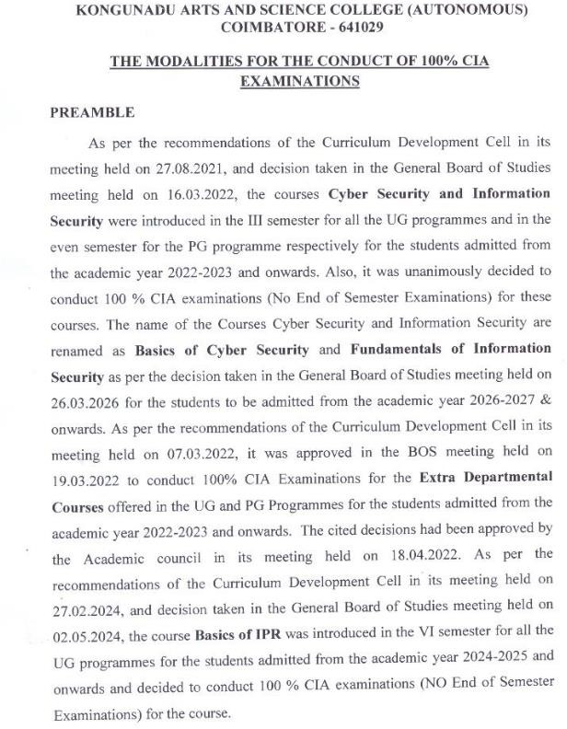

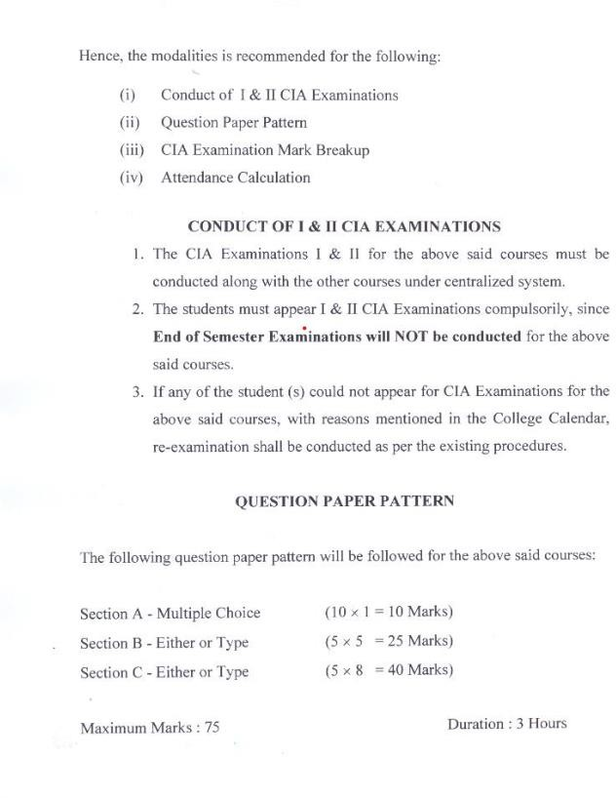

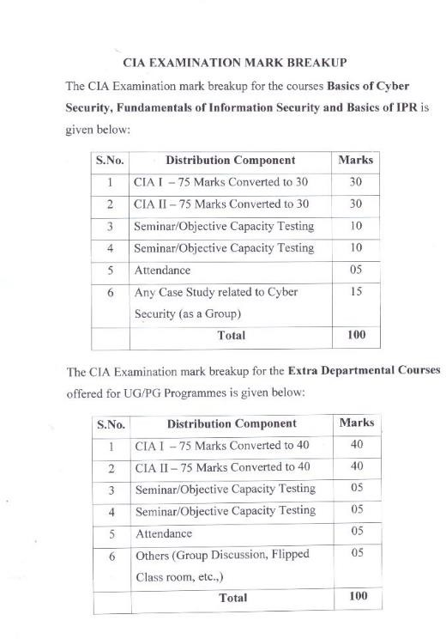

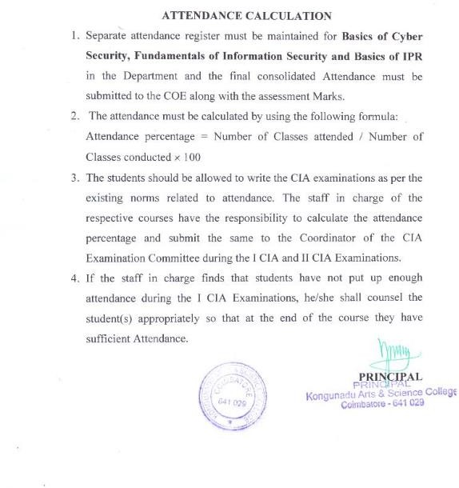

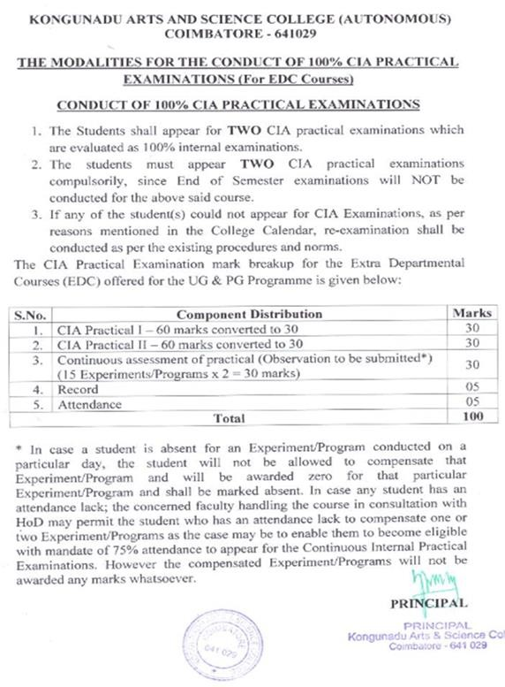

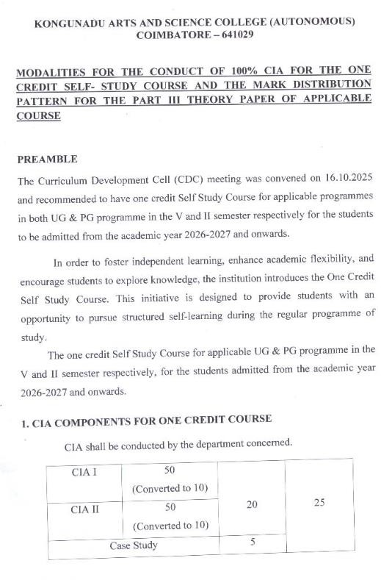

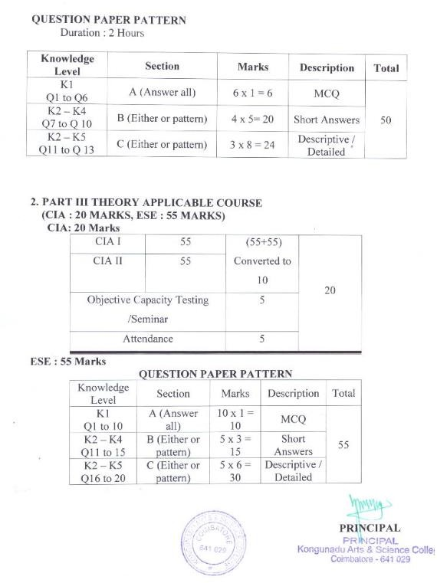

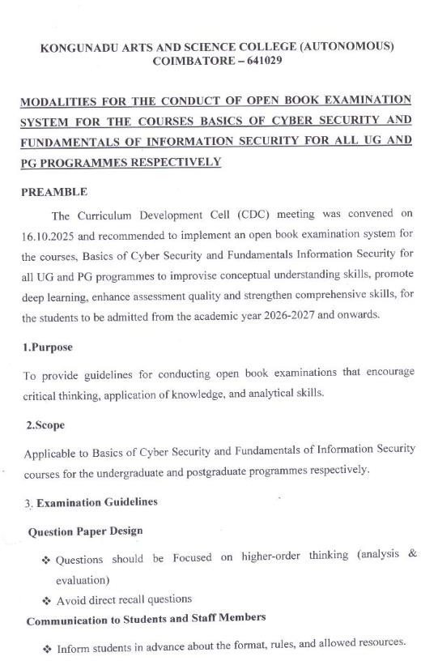

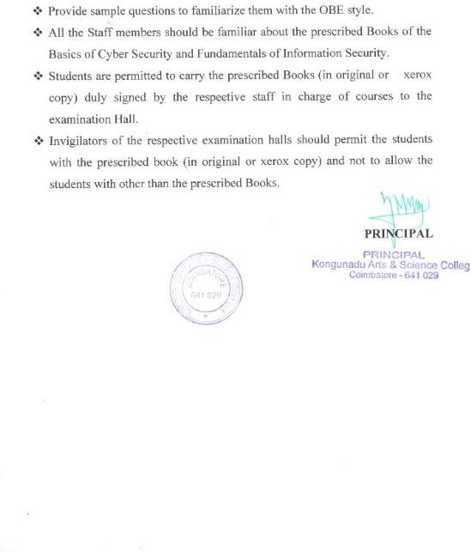

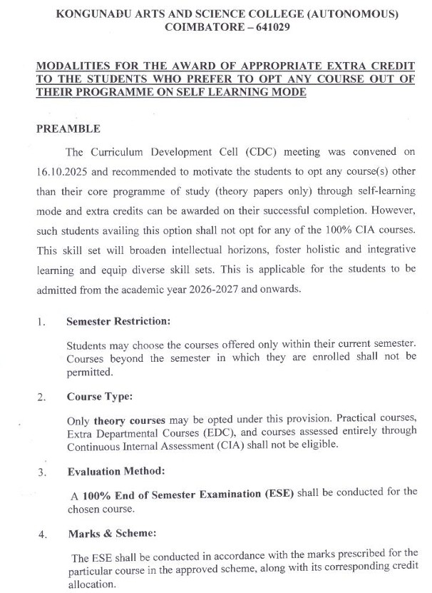

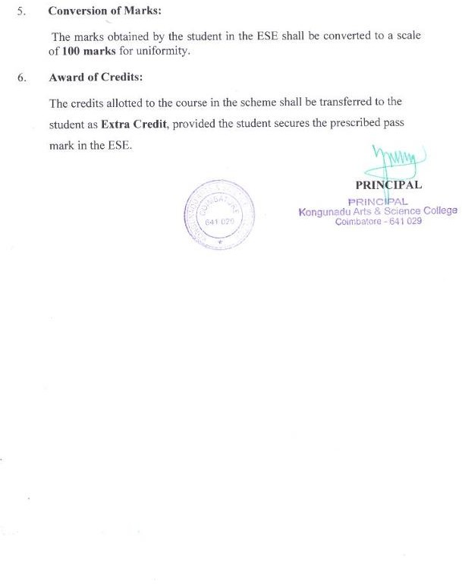

Programme Code: 12 | B.Sc. Information Technology
Title of the paper: Core Paper 1 – Computer Fundamentals and Programming in C
Batch  2026 – 2027 | Hours / Week  5 | Total Hours  75 | Credits  4 | Skill Development

Course Objectives
- To enable the students to know about the fundamentals of computer types of software and operating system.
- To impart adequate knowledge on the need of programming languages and problem-Solving techniques.
- To develop an in-depth understanding of functional and logical concepts of C Programming.
- To provide exposure to arrays, Structures and Union through C programming.
- To familiarize with the File Input and Output operation using C Language.

Course Outcomes (CO)

K1 to K5 | CO1 | Remember various computer Hardware and Software programming constructs.
K1 to K5 | CO2 | Understand the fundamentals of C programming.
K1 to K5 | CO3 | Apply the right data representation formats based on arrays, structures and unions.
K1 to K5 | CO4 | Implementing decision making using branching and looping statement.
K1 to K5 | CO5 | Execute programs using pointers, structures and files.

Sub. Code: 26UIT1CL

Programme Code: 12 | B.Sc. Information Technology
Title of the paper: Core Practical 1 – Programming Lab -PC Hardware and Programming in C
Batch  2026 - 2027 | Hours/Week  5 | Total Hours  75 | Credits  2 | Skill Development

Course Objectives
- To introduce the different parts of Motherboard, study of ROM and Assembling the PC.
- To develop an in-depth understanding of functional and logical concepts of C Programming.
- To enhance the analyzing and problem- solving skills in programming using C features.

Course Outcomes (CO)

K3 to K5 | CO1 | Understand basic parts of Motherboard and Set-up CMOS and examine about  assembling and disassembling the PC system.
K3 to K5 | CO2 | Apply Arithmetic operator, Conditional operator, logical operator, relational operators and other C constructs for developing programs.
K3 to K5 | CO3 | Develop C programs using decision making, branching, looping constructs.
K3 to K5 | CO4 | Develop programs using the Arrays, structures, functions, pointers and Strings
K3 to K5 | CO5 | Implement files and command line arguments.

Sub. Code: 26UIT202

Programme Code: 12 | B.Sc. Information Technology
Title of the Paper: Core Paper 2 – Data Structures using C++
Batch  2026 - 2027 | Hours/Week  5 | Total Hours  75 | Credits  4 | Skill Development

Course Objectives
- To develop a greater understanding of concepts of Object-Oriented Programming paradigms.

- To impart adequate knowledge on the need of object-oriented programming languages.

- To understand the concepts of Data Structures

Course Outcomes (CO)

K1 to K5 | CO1 | Remember the characteristics of Object-Oriented Programming Languages.
K1 to K5 | CO2 | Understand the fundamentals of C++ programming structure, function  overloading and constructors.
K1 to K5 | CO3 | Examine different C++ features such as composition of objects, Operator Overloading, inheritance, files and Exceptions.
K1 to K5 | CO4 | Analyze the efficiency of Stack, Queue and Lists
K1 to K5 | CO5 | Evaluate the usage of Sorting, Searching and Tree Techniques.

Programme Code: 12 | B.Sc. Information Technology
Title of the Paper: Core Practical 2-Programming Lab- Data Structures using C++
Batch  2026 - 2027 | Hours/Week  5 | Total Hours  75 | Credits  3 | Skill Development

Course Objectives
- To develop programs to understand and apply Object oriented features and OOPs concepts in C++.

- To apply the concept of polymorphism and inheritance.

- To enhance problem solving and programming skills in C+ + by implementing the Concepts of Data Structures.

Course Outcomes (CO)

K3 to K5 | CO1 | Implement the concepts of object-oriented programming.
K3 to K5 | CO2 | Apply string functions to perform operator overloading.
K3 to K5 | CO3 | Analyze virtual functions and inheritance.
K3 to K5 | CO4 | Design and implement Stack and Queue operations in C++
K3 to K5 | CO5 | Evaluate the implementation of Data structure sorting and searching operations.

Programme Code: 12 | B.Sc. Information Technology
Title of the Paper: Core Paper 3 – Java Programming
Batch  2026 - 2027 | Hours/Week  4 | Total Hours  60 | Credits  5 | Employability

Course Objectives
  - To learn the basic features of Java Programming.

  - To gain the knowledge about the concepts of Packages, Inheritance, Interfaces and Multithreading.

  - To develop the ability to create and run java programs using Applets, AWT, Swing and Connectivity.

Course Outcomes (CO)

K1 to K5 | CO1 | Remember the keywords, data types and Control Structures in Java.
K1 to K5 | CO2 | Understand the concept of Creating Classes, Functions and Objects.
K1 to K5 | CO3 | Apply the concepts of Packages, Inheritance, Exception Handling and Applet.
K1 to K5 | CO4 | Analyze the concepts of Files and AWT Controls.
K1 to K5 | CO5 | Evaluate the usage of Swings and JDBC in Java Applications

Programme Code: 12 | B.Sc. Information Technology
Title of the Paper: Core Practical 3– Programming Lab - Java
Batch  2026 - 2027 | Hours/Week  4 | Total Hours  60 | Credits  3 | Employability

Course Objectives

    - To develop the ability to build web-based applications using applets and AWT.

    - To implement the concept of event handling.

    - To apply the concepts of Multithreading, Inheritance and Packages, Swing and Connectivity.

Course Outcomes (CO)

K3 to K5 | CO1 | Recollect the concepts of control structures, inheritance in Java
K3 to K5 | CO2 | Implement the concept of interface, packages, multithreading, applets.
K3 to K5 | CO3 | Apply event handling mechanisms and AWT Controls.
K3 to K5 | CO4 | Develop the programs using file concept and swings.
K3 to K5 | CO5 | Access database through Java programs, using Java Data Base Connectivity (JDBC)

Programme Code: 12 | B.Sc. Information Technology
Title of the Paper: Allied Paper 3 – Digital Fundamentals, Architecture and Microprocessors
Batch  2026 - 2027 | Hours/Week  6 | Total Hours  90 | Credits  5 | Skill Development

Course Objectives
  - To know the different types of Number System
  - To gain knowledge about Digital Arithmetic and Logic Circuits.
  - To understand about the Combination circuit and Input Output Organization.
  - To understand various types of Microprocessor Architecture.
  - To Analyze the Parallel and serial Interfacing.

Course Outcomes (CO)

K1 to K5 | CO1 | Understand the basics of digital systems and computing
K1 to K5 | CO2 | Apply the basics in digital circuits
K1 to K5 | CO3 | Develop the various electronic circuits.
K1 to K5 | CO4 | Understand the architecture and functionalities of 8085 Microprocessor.
K1 to K5 | CO5 | Demonstrate an application or a working environment with Parallel and Serial Interfacing.

Sub. Code: 26UIT404

Programme Code: 12 | B.Sc. Information Technology
Title of the Paper: Core Paper 4 - .NET and RDBMS
Batch  2026– 2027 | Hours / Week  4 | Total Hours  60 | Credits  5 | Employability

Course Objectives
  - To understand the .Net Framework components.

  - To integrate variables and functions in developing .Net applications.

  - To learn the basic concepts of Database.

  - To understand the concepts of DDL, DML and PL/ SQL .

Course Outcomes (CO)

K1 to K5 | CO1 | Understand the properties and methods of the various tools.
K1 to K5 | CO2 | Apply the concept of .NET in developing windows applications.
K1 to K5 | CO3 | Understand and construct database using Structured Query Language  (SQL) in Oracle9i environment.
K1 to K5 | CO4 | Remembering the concept of Database.
K1 to K5 | CO5 | Learn basics of PL/SQL and develop programs using Triggers,  Exceptions, Procedures and Functions.

Sub. Code: 26UIT4CO

Programme Code: 12 | B.Sc. Information Technology
Title of the Paper: Core Practical 4 – Programming Lab – .NET and RDBMS
Batch  2026 - 2027 | Hours/Week  5 | Total Hours  75 | Credits  3 | Employability

Course Objectives
  - To become familiar with the tools and operations of VB.Net
  - To get a simple understanding of windows- based programming.
  - To design and build database systems and demonstrate their competence.
  - To gain knowledge in developing real time applications.

Course Outcomes (CO)

K3 to K5 | CO1 | Design and develop the event- driven applications using .NET Framework.
K3 to K5 | CO2 | Understand the concepts of .NET and Learn the advantages of Controls in .NET
K3 to K5 | CO3 | Understand and construct database using Structured Query Language (SQL) in Oracle9i environment.
K3 to K5 | CO4 | Remembering the concept of Database.
K3 to K5 | CO5 | Learn basics of PL/SQL and develop programs using Cursors, Exceptions, Procedures and Function

Programme Code: 12 | B.Sc. Information Technology
Title of the Paper: Allied Paper 4 – Data Analytics using R Programming Lab
Batch  2026 - 2027 | Hours/Week  5 | Total Hours  75 | Credits  5 | Skill Development

Course Objectives

  - To understand the fundamentals of data analytics, big data, and R programming basics.

  - To develop R programming skills using loops, functions, and data manipulation techniques.

  - To enable importing and exporting data from CSV, Excel, MySQL, and SPSS using R.

  - To equip students with data visualization and statistical analysis techniques using R.

  - To implement clustering, PCA, and classification models using R.

Course Outcomes (CO)

K3 to K5 | CO1 | To understand the fundamentals of data analytics, big data, and R programming  basics.
K3 to K5 | CO2 | To develop R programming skills using loops, functions, and data manipulation  techniques.
K3 to K5 | CO3 | To enable importing and exporting data from CSV, Excel, MySQL, and SPSS  using R.
K3 to K5 | CO4 | To equip students with data visualization and statistical analysis techniques using R.
K3 to K5 | CO5 | To implement clustering, PCA, and classification models using R.

Programme Code: 12 | B.Sc. Information Technology
Title of the Paper: Core Paper 5 – Python Programming
Batch  2026 - 2027 | Hours/Week  6 | Total Hours  90 | Credits  5 | Employability

Course Objectives
- To acquire programming skills in core Python and to learn and understand Python
- To Learn core Python scripting elements such as variables and flow control structures
- To gain an insight of developing dynamic webpage by using CSS and DHTML.
- To use Python data structures, lists, tuples, dictionaries.
- To Learn Basics of Numpy and Pandas.

Course Outcomes (CO)

K1 to K5 | CO1 | Develop algorithmic solutions to simple computational problems and Read write, execute by hand simple Python programs.
K1 to K5 | CO2 | Structure simple Python programs for solving problems.
K1 to K5 | CO3 | Represent compound data using Python lists, tuples, dictionaries and Sets.
K1 to K5 | CO4 | Read and write data from/to files in Python Programs
K1 to K5 | CO5 | Introduction to Numpy and Pandas.

Programme Code: 12 | B.Sc. Information Technology
Title of the Paper: Core Paper 6 – Operating System
Batch  2026 - 2027 | Hours / Week  5 | Total Hours  75 | Credits  4 | Skill Development

Course Objectives

  - To impart adequate knowledge on the Operating Systems.
  - To develop an in-depth understanding Process and memory management.
  - To familiarize with the basic difference between Deadlocks and Disk management.
  - To provide exposure to Linux and Windows.

Course Outcomes (CO)

K1 to K5 | CO1 | Understand the fundamentals of computer operating system.
K1 to K5 | CO2 | Remember various Process Management programming constructs
K1 to K5 | CO3 | Apply the right Memory Management representation formats.
K1 to K5 | CO4 | Implement the Disk Management concepts.
K1 to K5 | CO5 | Discussion about Linux and Windows

Programme Code: 12 | B.Sc. Information Technology
Title of the Paper: Core Paper 7 - Data Communication and Networks
Batch  2026 - 2027 | Hours/Week  5 | Total Hours  75 | Credits  4 | Employability

Course Objectives
- To learn about Protocol Standards, Transmission methods, Digital Signals.
- To Understand about Mode of Data Transmission, Transmission Media.
- To understand a basic knowledge of Network Topologies and Routing Algorithms.
- To know the outline of ISDN Architecture and Network Layers.
- Analyze the Problem in internetworking, TCP and UDP.

Course Outcomes (CO)

K1 to K5 | CO1 | Remember the basic of Data communication and Networks.
K1 to K5 | CO2 | Understanding the knowledge of mode of Data Transmission, Multiplexing Techniques and Transmission Media.
K1 to K5 | CO3 | Apply the concept of routing algorithms.
K1 to K5 | CO4 | Analyzing about ISDN, MAC and Internetworking Devices.
K1 to K5 | CO5 | Evaluate the applications and usage of TCP / IP and UDP Formats.

Sub. Code: 26UIT5CP

Programme Code: 12 | B.Sc. Information Technology
Title of the Paper: Core Practical 5 – Programming Lab – Python
Batch  2026 - 2027 | Hours/Week  6 | Total Hours  90 | Credits  3 | Employability

Course Objectives
- To gain knowledge about the concepts of python programming.
- To understand the concepts of Built-in functions and User-defined functions.
- To develop programs using String functions.

Course Outcomes (CO)

K3 to K5 | CO1 | Apply different types of operators in programming.
K3 to K5 | CO2 | Implement the concepts of built-in functions in programming.
K3 to K5 | CO3 | Analyze the use control structures in programming.
K3 to K5 | CO4 | Appling the concept of List, Tuple, Set and Dictionary.
K3 to K5 | CO5 | To Learn the Libraries Numpy and Pandas.

Programme Code: 12 | B.Sc. Information Technology
Title of the Paper: Cloud Computing Fundamentals
Batch  2026 - 2027 | Hours/Week  1 | Total Hours  15 | Credits  1 | Entrepreneurship

Course Objectives
- To introduce the fundamental concepts and principles of cloud computing.
- To understand different cloud service models.
- To familiarize students with cloud deployment models and architecture.
- To provide basic knowledge of virtualization technologies.
- To create awareness about cloud applications and security issues.

Course Outcomes (CO)

K1 to K5 | CO1 | Demonstrate a clear understanding of the fundamental concepts.
K1 to K5 | CO2 | Analyze and differentiate various cloud service models.
K1 to K5 | CO3 | Estimate different cloud deployment models.
K1 to K5 | CO4 | Implement front-end and back-end components.
K1 to K5 | CO5 | Examine security challenges and issues in cloud computing environments.

Sub. Code: 26UIT608

Programme Code: 12 | B.Sc. Information Technology
Title of the Paper: Core Paper 8-Web Technology
Batch  2026 - 2027 | Hours/Week  5 | Total Hours  75 | Credits  5 | Entrepreneurship

Course Objectives
- To acquire the knowledge about web programming and scripting languages.
- To learn the basic concepts of webpage design using HTML.
- To gain an insight of developing dynamic webpage by using CSS and DHTML.
- To develop the ability to create a well-formed and Valid XML documents.
- To enhance the skills to create and deploy the web applications.

Course Outcomes (CO)

K1 to K5 | CO1 | Remember the concepts of HTML for designing web pages.
K1 to K5 | CO2 | Understand the concepts of DHTML and CSS to create dynamic web pages.
K1 to K5 | CO3 | Apply PHP and Ajax for developing real time web applications.
K1 to K5 | CO4 | Analyze and validate the web pages by using Java script.
K1 to K5 | CO5 | Evaluate the Applications and usage of static and dynamic web pages.

Sub. Code: 26UIT609

Programme Code: 12 | B.Sc. Information Technology
Title of the Paper: Core Paper 9- Software Engineering and Testing
Batch  2026 - 2027 | Hours/Week  5 | Total Hours  75 | Credits  4 | Employability

Course Objectives
- To assist the students in understanding the basic theory of software engineering.
- To teach about various testing and debugging techniques.
- To gain knowledge about quality control and to develop good quality software.

Course Outcomes (CO)

K1 to K5 | CO1 | Remember the fundamentals of software engineering concepts.
K1 to K5 | CO2 | Understand common life cycle processes such as waterfall model, spiral model, prototyping model and evolutionary models.
K1 to K5 | CO3 | Applythe principles and techniques of software engineering in the architectural  design, detail design, and implementation of software applications.
K1 to K5 | CO4 | Analyze the developed software using different testing concepts.
K1 to K5 | CO5 | Evaluate the usage of Reengineering and Reverse Engineering.

Programme Code: 12 | B.Sc. Information Technology
Title of the Paper: Core Practical 6-Programming Lab- Web Technology and Testing
Batch  2026 - 2027 | Hours / Week  5 | Total Hours  75 | Credits  3 | Entrepreneurship

Course Objectives
  - To develop the ability to build web applications using various technologies like HTML,CSS, PHP and Ajax and construct the test cases.

  - To create dynamic web pages and validate it using Java script.

  - To design and implement real time applications by applying the concepts of PHP and Ajax.

  - To learn about the concepts of assert, verification, wait commands.
.

Course Outcomes (CO)

K3 to K5 | CO1 | Recollect the concept of designing web pages using HTML and validate it using Java  script.
K3 to K5 | CO2 | Understand the concepts of CSS and DHTML to create dynamic web pages and  implement the concepts of assert and verify
K3 to K5 | CO3 | Develop the webpage using the concepts of PHP and Ajax.
K3 to K5 | CO4 | Create web pages using XHTML and Cascading Style Sheets and apply essential characteristics of tool for test automation
K3 to K5 | CO5 | Build dynamic web pages using JavaScript and evaluate different strategies for Generating system test cases

Programme Code: 12 | B.Sc. Information Technology
Title of the Paper: Core Practical 7-Programming Lab- Gen AI:RAG
Batch  2026 - 2027 | Hours / Week  4 | Total Hours  60 | Credits  2 | Entrepreneurship

Course Objectives
  - To introduce the foundational Knowledge in Emerging AI Technologies
  - To understand the practical Competency in AI System Development
  - To familiarize Analytical Skills for Intelligent Data Processing
  - To provide evaluation and Optimization of AI Models
  - To create innovation in AI-Based Application Development.

Course Outcomes (CO)

K3 to K5 | CO1 | Demonstrate the fundamental concepts of Generative AI
K3 to K5 | CO2 | Analyze text pre-processing techniques such as document loading.
K3 to K5 | CO3 | Estimate embedding and utilize vector databases.
K3 to K5 | CO4 | Implement RAG-based systems by integrating retrieval mechanisms.
K3 to K5 | CO5 | Examine the performance of RAG systems based on relevance.

Sub. Code: 26UIT6Z1

Programme Code: 12 | B.Sc. Information Technology
Title of the Paper: Project and Viva-Voce
Batch  2026 - 2027 | Hours/Week  4 | Total Hours  60 | Credits  5 | Employability

Course Objectives
On successful completion of all the above courses
- To get the knowledge about selecting the task based on their course skills.
- To get the knowledge about analytical skill for solving the selected task.
- To gain confidence for implementing the task.
- To gain confidence for solving the real time problems.

Course Outcomes (CO)

K3 to K5 | CO1 | Apply the programming skill for solving the project.
K3 to K5 | CO2 | Analyze the task to collect the necessary information about the system.
K3 to K5 | CO3 | Evaluating the project based on the software.
K3 to K5 | CO4 | Apply testing techniques to test the different modules of the project.
K3 to K5 | CO5 | Implement the Project in the user environment.

Programme Code: 12 | B.Sc. Information Technology
Title of the paper: Elective–Embedded and Real Time Systems
Batch  2026 - 2027 | Hours/Week  5 | Total Hours  75 | Credits  5 | Skill Development

Course Objectives

- To teach the architecture and instruction set of different Microprocessors.
- To learn the architecture of ARM, and embedded programs.
- To understand the architectures of Real Time systems.

Course Outcomes (CO)

K1 to K5 | CO1 | Remember the Embedded system design process and ARM Processor.
K1 to K5 | CO2 | Understand the Bus-Based Computer Systems.
K1 to K5 | CO3 | Study about software performance optimization
K1 to K5 | CO4 | Analyze the Processes of Real time Operating Systems and multiprocessors.
K1 to K5 | CO5 | Evaluate the usage of networks and design techniques.

Programme Code: 12 | B.Sc. Information Technology
Title of the paper : Elective–Mobile Computing
Batch  2026 - 2027 | Hours/Week  5 | Total Hours  75 | Credits  5 | Entrepreneurship

Course Objectives

  - To explain fundamental of mobile computing.
  - To discuss a comprehensive understanding of TCP/IP protocols
  - To outline current and emerging trends in Telecommunication systems.
  - To analyze energy management in ad-hoc wireless networks.
  - To understand about the operating systems used in mobile platforms.

Course Outcomes (CO)

K1 to K5 | CO1 | Understand the several communication access techniques and determine the  functionality of MAC.
K1 to K5 | CO2 | Perceive knowledge about TCP and IP method
K1 to K5 | CO3 | Illustrate technical format, addressing and transmission strategies of packets
K1 to K5 | CO4 | Apply and Identifying a routing protocol for given Adhoc Networks Evaluate
K1 to K5 | CO5 | Understanding the platforms and mobile operating system techniques

Programme Code: 12 | B.Sc. Information Technology
Title of the Paper: Elective – Client / Server Technology
Batch  2026 - 2027 | Hours/Week  5 | Total Hours  75 | Credits  5 | Employability

Course Objectives
  - To know fundamentals of client server technology.
  - To gain the knowledge of client server data bases.
  - To Outline current and emerging trends in layered architecture.
  - To Analyze power of management skills in training and testing.
  - To understand about the future of client / server.
Course Outcomes (CO)

K1 to K5 | CO1 | Understand the basic concepts of client server Technology.
K1 to K5 | CO2 | Perceive knowledge about databases in client /server method.
K1 to K5 | CO3 | Understanding the applications, components and layered technology
K1 to K5 | CO4 | Apply and Identifying testing and training in client/ server applications
K1 to K5 | CO5 | Understanding the future techniques in client /server model

Programme Code: 12 | B.Sc. Information Technology
Title of the Paper: Elective - Data Mining
Batch  2026 - 2027 | Hours/Week  5 | Total Hours  75 | Credits  5 | Employability

Course Objectives
- To introduce the basic concepts of Data Mining algorithms, methods and tools.
- To develop and apply critical thinking, problem-solving, and decision-making skills.
- To discover interesting patterns, analyze supervised and unsupervised models and Estimate the accuracy of the algorithms.

Course Outcomes (CO)

K1 to K5 | CO1 | Remembering the data mining principles and techniques.
K1 to K5 | CO2 | Understanding the concept of raw data processing using data mining algorithms.
K1 to K5 | CO3 | Applying data mining algorithms to build analytical applications.
K1 to K5 | CO4 | Analyzing large amount of data to extract patterns and to solve problems.
K1 to K5 | CO5 | Evaluate the performance of various algorithms by comparing different approaches.

Programme Code: 12 | B.Sc. Information Technology
Title of the Paper: Elective – Artificial Intelligence
Batch  2026 - 2027 | Hours/Week  5 | Total Hours  75 | Credits  5 | Employability

Course Objectives
    - To understand the basic concepts of Artificial Intelligence (AI) and identify the AI problems and domains.
    - To provide search techniques to solve the problems.
    - To represent and access the domain specific knowledge.

Course Outcomes (CO)

K1 to K5 | CO1 | Remember the techniques of Artificial Intelligence in Problem Solving.
K1 to K5 | CO2 | Understand the nature of AI problems and task domains of AI.
K1 to K5 | CO3 | Apply the appropriate search procedures to solve the problems by using best  algorithms.
K1 to K5 | CO4 | Analyze and select the suitable knowledge representation method.
K1 to K5 | CO5 | Evaluate the techniques of representing knowledge using rules.

Programme Code: 12 | B.Sc. Information Technology
Title of the Paper: Elective – Big Data Analytics
Batch  2026– 2027 | Hours/Week  5 | Total Hours  75 | Credits  5 | Entrepreneurship

Course Objectives

  - To learn the basic concepts of Big Data and its technologies.
  - To learn about NoSQL and Big data Management
  - To gain knowledge about Hadoop and HDFS.
  - To learn about web mining, graph mining and social network mining.

Course Outcomes (CO)

K1 to K5 | CO1 | Remember big data and use cases from selected business domains
K1 to K5 | CO2 | Understand NoSQL big data management
K1 to K5 | CO3 | Apply map-reduce analytics using Hadoop.
K1 to K5 | CO4 | Analyze Graph Mining, Web Mining and Social Network Mining.
K1 to K5 | CO5 | Evaluate the usage of web mining in social networks.

Programme Code: 12 | B.Sc. Information Technology
Title of the Paper: Elective – Machine Learning
Batch  2026 - 2027 | Hours/Week  5 | Total Hours  75 | Credits  5 | Employability

Course Objectives
  - To understand pattern classification algorithms to classify multivariate data
  - To understand the Implementation of genetic algorithms
  - To gain knowledge about Q-Learning
  - To create new machine learning techniques.

Course Outcomes (CO)

K1 to K5 | CO1 | Develop and apply pattern classification algorithms to classify multivariate data.
K1 to K5 | CO2 | Understand and apply regression algorithms for finding relationships between data variables.
K1 to K5 | CO3 | Apply reinforcement learning algorithms for learning to control complex  systems.
K1 to K5 | CO4 | Analyze and select the suitable methods for Decision Tree Algorithm
K1 to K5 | CO5 | Evaluate the scientific reports on computational machine learning methods, results and conclusions.

Programme Code: 12 | B.Sc. Information Technology
Title of the paper : Elective–Network Security
Batch  2026 - 2027 | Hours/Week  5 | Total Hours  75 | Credits  5 | Employability

Course Objectives
- To Understand OSI security architecture.
- To Understand various block cipher and stream cipher models.
- To Study the principles of symmetric &amp; public key crypto systems.
- To learn the system security practices.

Course Outcomes (CO)

K1 to K5 | CO1 | Remember the OSI Security Architecture.
K1 to K5 | CO2 | Understanding Number theory and finite fields.
K1 to K5 | CO3 | Apply Block Ciphers and Data Encryption Standard.
K1 to K5 | CO4 | Evaluate Public Key Cryptography and RSA.
K1 to K5 | CO5 | Implement Hash functions.

Sub. Code: 26UGC3S1

Programme Code: 12 | B.Sc. Information Technology
Title of the Paper: Skill Based Subject 1 – Basics of Cyber Security
Batch  2026– 2027 | Hours/Week  2 | Total Hours  30 | Credits  3 | Skill Development

Course Objectives
- To provide fundamental knowledge of cyber security concepts and the digital environment.
- To create awareness about cyber threats, cybercrimes, and common online frauds.
- To develop the ability to identify risks associated with internet, mobile, and online transactions.
- To familiarize students with safe practices in email, social media, and digital communication.
- To introduce basic cyber laws, ethics, and responsible digital behavior.

Course Outcomes (CO)

On successful completion of the course, the students will be able to:

K Level | CO Code | Course Outcome
K1  K5 | CO1 | Apply the fundamental concepts of cyber security and digital safety at appropriate place
K1  K5 | CO2 | Identify various cyber threats, cybercrimes, and online frauds
K1  K5 | CO3 | Enable safe practices while using internet, mobile, and e-commerce platforms
K1  K5 | CO4 | Interpret security issues related to email and social media usage
K1  K5 | CO5 | Comprehend cyber laws, ethics, and legal responses to cybercrime

Programme Code: 12 | B.Sc. Information Technology
Title of the Paper: Skill Based Subject 2 – Internet of Things
Batch  2026– 2027 | Hours/Week  2 | Total Hours  30 | Credits  3 | Skill Development

Course Objectives

- To learn the concepts of IoT and its protocols.
- To learn how to analysis the data in IoT.
- To develop IoT infrastructure for popular applications.
- To report about the IoT privacy, security and vulnerabilities solution

Course Outcomes (CO)

K3 to K5 | CO1 | Understand the fundamentals of Internet of Things
K3 to K5 | CO2 | Know the basics of communication protocols and the designing principles of  Web connectivity.
K3 to K5 | CO3 | Analyze the knowledge of Internet connectivity principles
K3 to K5 | CO4 | Design and develop smart city in IoT
K3 to K5 | CO5 | Analyze and evaluate the data received through sensors in IOT.

Programme Code: 12 | B.Sc. Information Technology
Title of the Paper: Skill Based Subject 3 – Basics of Intellectual Property Right’s
Batch  2026 - 2027 | Hours/Week  2 | Total Hours  30 | Credits  3 | Skill Development

Course Objectives

  - To create awareness about recent trends in IPR and Innovation
  - To explore the basic concepts IPR
  - To focus upon trademarks, copyrights, patents, industrial designs and traditional knowledge.
  - To learn more about managing IP rights and legal aspects.

Course Outcomes (CO)
On successful completion of the course, the students will be able to

K1  K5 | CO1 | Know about basic concepts of IPR and patent
K1  K5 | CO2 | Understand copyrights, industrial designs and geographical indication of goods.
K1  K5 | CO3 | Differentiate between trademarks and trade secrets
K1  K5 | CO4 | Acquire knowledge on protection of traditional knowledge and plant varieties.
K1  K5 | CO5 | Manage and protect IP Rights

Programme Code: 12 | For all UG Degree students
Title of the Paper: Extra Departmental Course (EDC) – Advanced Excel Lab
Batch  2026 - 2027 | Hours /Week  2 | Total Hours  30 | Credits  3 | Employability

Course Objectives
- To include advanced functions in Excel.
- To understand the concepts of Range, Pivot Chart and Mathematical Functions in Excel.
- To introduce the basic concepts of Data Validation and Data Sorting.

Course Outcomes (CO)

K3 to K5 | CO1 | Apply Mathematical and Logical Functions.
K3 to K5 | CO2 | Analyze the use of Range Function.
K3 to K5 | CO3 | Implement the spreadsheet using Excel Tools.
K3 to K5 | CO4 | Apply Statistical and Reference functions.
K3 to K5 | CO5 | Create a Chart for the Table data.

Programme Code : |  | For B.A., BBA, B.Com, BCA and B.Sc., Degree Students
PART IV-ENVIRONMENTAL STUDIES
Batch  2026-2027 | Semester  I |  | Hours/Week  2 | Total Hours  30 | Credits  2

Course Objectives
- To provide a fundamental understanding of natural resources, environmental ethics, and the impact of modern practical conservation and sustainability.
- To inculcate knowledge and create awareness about concepts, components and function of ecosystems
- To appraise on the importance of biodiversity, its values, threats, indigenous and Traditional knowledge systems, conservation strategies, and modern identification tools, and cultivate conscious responsibility and awareness for biodiversity conservation and sustainability.
- To understand the environment threats and pollution, its impacts and mitigation strategies
- To develop an understanding of disasters (natural and man-made) and its preparedness

Course Outcomes
On successful completion of the course, the students will be able to

K1  K5 | CO1 | Formulate genetic resource conservation strategies and assess India’s  SDG performance through AI/ML tools.
K1  K5 | CO2 | Evaluate and predict the impact of humans on web of life, global  economy and quality
K1  K5 | CO3 | Think critically an develop strategies for biodiversity conservation,  sustenance and environmental equity through eco conscious approach
K1  K5 | CO4 | Demonstrate values and have compassion towards complex  environmental issues and take part in mitigating current environment challenges through sustainable solutions
K1  K5 | CO5 | Apply basic safety and preparedness measures in disaster situations in  society, household and workplace

Programme Code : | For B.A., BBA, B.Com, BCA and B.Sc., Degree Students
VALUE EDUCATION – Moral and Ethics
Batch  2026-2027 |  | Hours / Week  2 | Total Hours  30 | Credits  2

Course Objectives
      - To impart Value Education in every walk of life.
      - To help the students to reach excellence and reap success.
      - To impart the right attitude by practicing self-introspection.
      - To portray the life and messages of Great Leaders.
      - To insist the need for universal brotherhood, patience and tolerance.
      - To help the students to keep them fit.
      - To educate the importance of Yoga and Meditation.

Course Outcomes (CO)
After completing the course, the students will be able to:

K1 to K5 | CO1 | Will be able to recognize Moral values, Ethics, contribution of leaders, Yoga and its practice.
K1 to K5 | CO2 | Will be able to differentiate and relate the day to day applications of Yoga and Ethics in real life situations.
K1 to K5 | CO3 | Can emulate the principled life of great warriors and take it forward as a message to self and the society.
K1 to K5 | CO4 | Will be able to Analyse the Practical outcome of practicing Moral values in real life situation.
K1 to K5 | CO5 | Could Evaluate and Rank the outcome of the pragmatic approach to further develop the skills.

Sub. Code: 26UHR3N1

Programme Code : | For B.A., BBA, B.Com, BCA and B.Sc., Degree Students
PART IV –NON MAJOR ELECTIVE –I HUMAN RIGHTS
Batch  2026-2027 | Hours / Week  2 | Total Hours  30 | Credits  2

Course Objectives

- To prepare for responsible citizenship with awareness of the relationship between Human Rights, democracy and development.
- To impart education on national and international regime on Human Rights.
- To sensitive students to human suffering and promotion of human life with dignity.
- To develop skills on human rights advocacy
- To appreciate the relationship between rights and duties
- To foster respect for tolerance and compassion for all living creature.

Course Outcomes (CO)

K1 to K5 | CO1 | To understand the hidden truth of Human Rights by studying various provisions  the Constitution of India. | in  s.
K1 to K5 | CO2 | To acquire overall knowledge regarding the Feminist perspectives in the  Liberative Empowerment of Women. | in  s.
K1 to K5 | CO3 | To gain knowledge about various gender roles and stereotypes involved in the  comprehension of gender equality and women’s rights. | in  s.
K1 to K5 | CO4 | To comprehend the legal provisions and policies that foreground the safety of  children in the society and to promote awareness. | in  s.
K1 to K5 | CO5 | To gain enhanced knowledge about sexual and gender minorities to recognize,  celebrate and acknowledge the diversified forms of gender expressions and right | in  s.

Sub. Code: 26UWR4N2

Programme Code: | For B.A., BBA, B.Com, BCA and B.Sc., Degree Students
Programme Code: | Part IV -NON- MAJOR ELECTIVE – II WOMEN’S RIGHTS
Batch  2026-2027 | Hours / Week  2 | Total Hours  30 | Credits  2

Course Objectives

  - To know about the laws enacted to protect women against violence.
  - To impart awareness about the hurdles faced by women.
  - To develop a knowledge about the status of all forms of women to access to justice.
  - To create awareness about women’s rights.
  - To know about laws and norms pertaining to protection of women.
  - To understand the articles which enables the women’s rights.
  - To understand the Special Women Welfare laws.
  - To realize how the violence against women puts an undue burden on healthcare services.

Course Outcomes (CO)
After Completion of the Course the student will be able to

K1 to K5 | CO1 | Appraise the importance of Women’s Studies and incorporate Women’s Studies with other fields
K1 to K5 | CO2 | Analyze the realities of Women Empowerment, Portrayal of Women in Media, Development and Communication
K1 to K5 | CO3 | Interpret the laws pertaining to violence against Women and legal consequences
K1 to K5 | CO4 | Contribute to the study of the important elements in the Indian Constitution, Indian Laws for Protection of Women
K1 to K5 | CO5 | Spell out and implement Government Developmental schemes for women and create  awareness on modernization and impact of technology on Women

Programme Code : |  | For B.A., B.Sc., and BCA Degree Students
PART IV - NON- MAJOR ELECTIVE III - CONSUMER AFFAIRS
Batch  2026-2027 | Hours/Week  2 |  | Total Hours  30 | Credits  2

Course Objectives
- To familiarize the students with their rights and responsibilities as a consumer.
- To understand the procedure of redress of consumer complaints.
- To know more about decisions on Leading Cases by Consumer Protection Act.
- To get more knowledge about Organizational set-up under the Consumer Protection Act.
- To impart awareness about the Role of Industry Regulators in Consumer Protection.
- To understand Contemporary Issues in Consumer Affairs.

Course Outcomes (CO)

K1 to K5 | CO1 | Able to know the rights and responsibility of consumers.
K1 to K5 | CO2 | Understand the importance and benefits of Consumer Protection Act.
K1 to K5 | CO3 | Applying the role of different agencies in establishing product and service standards.
K1 to K5 | CO4 | Analyse to handle the business firms’ interface with consumers.
K1 to K5 | CO5 | Assess Quality and Standardization of consumer affairs

Sub. Code: 26UHW401

ALL UG COURSES
Title of the Paper: Health and Wellness
Batch  2026 – 2027 | Semester  IV | Credits  2

Skill Areas:
Physical Fitness, Nutrition, Mental Health, Awareness on Drug addiction and its effects.

Purpose:
The Health & Wellness course focuses on teaching the elements of physical, mental, emotional, social, intellectual, environmental well-being which are essential for overall development of an individual. The course also addresses the dangers of substance abuse and online risks to promote emotional and mental health.

Learning Outcomes:
Upon completion of the Health & Wellness course, students will be able to:
- Demonstrate proficiency in sports training and physical fitness practices.
- Improve their mental and emotional well-being, fostering a positive outlook on health and life.
- Develop competence and commitment as professionals in the field of health and wellness.
- Awareness on drug addiction and its ill effects

Focus:
During the conduct of the Health & Wellness course, the students will benefit from the following focus areas:
- Stress Management.
- Breaking Bad Habits.
- Improving Interpersonal Relationships.
- Building Physical Strength & Inner Strength.

Role of the Facilitator:

The faculty plays a crucial role in effectively engaging with students and guiding them towards achieving learning outcomes. Faculty participation involves the following areas:
- Mentorship & Motivation: The Facilitator mentors students in wellness and self-discipline while inspiring a positive outlook on health. Faculty teach stress management, fitness, and daily well-being.
- Promoting a Safe and Inclusive Environment: The facilitator ensures a safe, inclusive, and respectful learning environment for active student participation and benefit.
- Individualized Support and Monitoring Progress: The facilitator plays a crucial role in providing personalized support, monitoring and guidance to students.

Guided Activities:

In this course, several general guided activities have been suggested to facilitate the achievement of desired learning outcomes. They are as follows:

- Introduction to Holistic Well-being.
- Holistic Wellness Program- Nurturing Body and Mind
- Breaking Bad Habits Workshop.
- Improving the elements of physical, emotional, social, intellectual, environmental and mental well-being.
- Creating situational awareness, digital awareness.
- Understanding substance abuse, consequences and the way out.

Period Distribution
The following are the guided activities suggested for this Audit course. The Physical Director should plan the activities by the students.
Arrange the suitable Mentor/Guide for the wellness activities.
Additional activities and programs can be planned for Health and Wellness.

