KONGUNADU ARTS AND SCIENCE COLLEGE, (Autonomous)
Re-accredited by NAAC with ‘A+’ Grade (4th cycle)
College of Excellence (UGC)
29th Rank among Colleges in NIRF 2023
Coimbatore – 641 029, Tamilnadu, India.

DEPARTMENT OF INFORMATION TECHNOLOGY
Seminar on
“CRAFTING MACHINE LEARNING BRILLIANCE”

Date: 29.01.2024 Time: 2.00pm to 3.30pm Venue: Block C43

AGENDA

Prayer Song | Students of II BSc IT
Welcome Address | Mrs. D. PRINCY,  Assistant Professor,  Department of Information Technology
Introduction of the Chief Guest | Mrs. N. DEEPA,  Assistant Professor,  Department of Information Technology
Chief Guest Speech | Dr. L. MARY LOUIS,  Professor,  Kumaraguru College of Liberal Arts and Science
Vote of Thanks | Dr. N. ALAMELUMANGAI,  Assistant Professor,  Department of Information Technology
MoC By Students of II BSc IT

KONGUNADU ARTS AND SCIENCE COLLEGE, (Autonomous)
Re-accredited by NAAC with ‘A+’ Grade (4th cycle)
College of Excellence (UGC)
29th Rank among Colleges in NIRF 2023
Coimbatore – 641 029, Tamilnadu, India.

DEPARTMENT OF INFORMATION TECHNOLOGY
Seminar on
“CRAFTING MACHINE LEARNING BRILLIANCE”
REPORT
The Department of Information Technology organized a Guest Lecture on 29th January 2024 at 02.00 pm in Hall number C-43. The session began with the greetings of the enthusiastic MOC by Mr. K. Surya II Year B.Sc IT. All that begins well with the prayer song was sung by Ms. Sri Varshini and Team of II B.Sc IT.
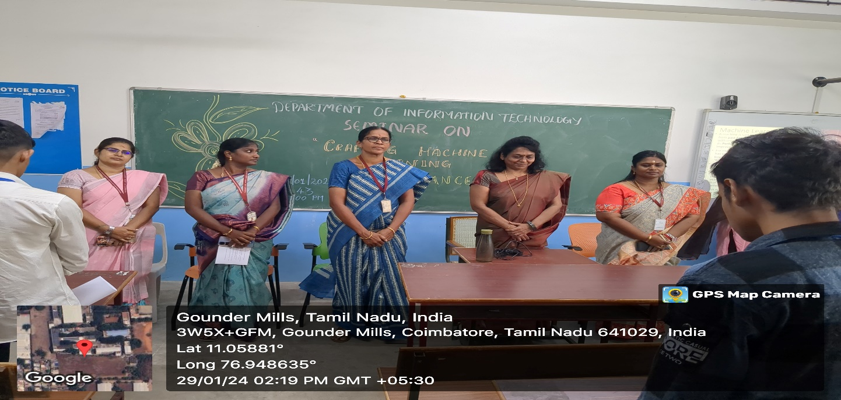
The MOC invited Mrs.D. Princy, Assistant Professor, Department of Information Technology to welcome the gathering cheerfully. In her address, she welcomed the Chief Guest, HOD, faculty and students. Further, to introduce the Chief Guest, Mrs. N. Deepa, Assistant Professor, Department of Information Technology was called by the MoC. She introduced Dr. L. Mary Louis as Professor in the Department of Data Analytics, Kumaraguru College of Liberal Arts and Science. In her introduction she enlightened the audience about the achievements of the Chief Guest.
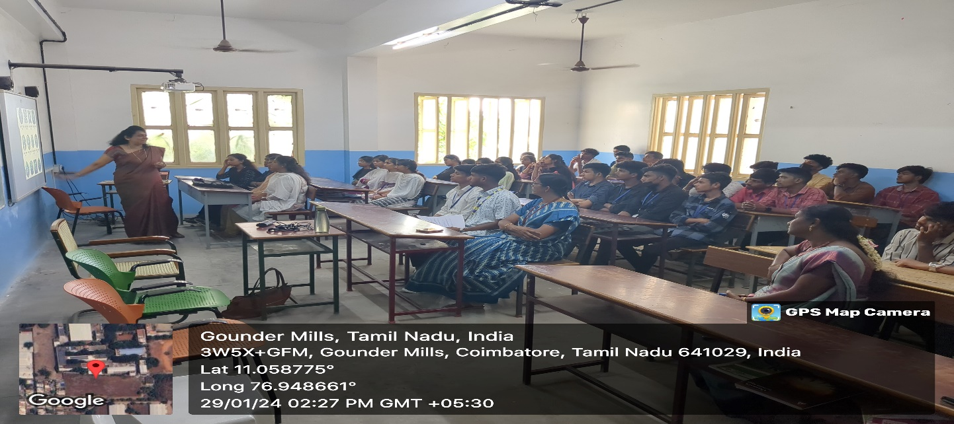
The session was the handed over to the chief guest with her invited talk on “CRAFTING MACHINE LEARNING BRILLIANCE”. In her guest talk Dr. L. Mary Louis highlighted the journey of building a machine learning model evolution of Machine Learning, usage of ChatGPT and its importance. Further, she in her presentation Course Era Courses were mentioned regarding to Machine Learning, types of Machine Learning were elaborated, importance of Analyst Job Roles were detailed, Online databases like Google Colab, Kaggle were introduced, present gaming technology was introduced and finally a brief introduction about Python and its libraries were demonstrated. Later, she concluded the recent trends in computers with its relevance.
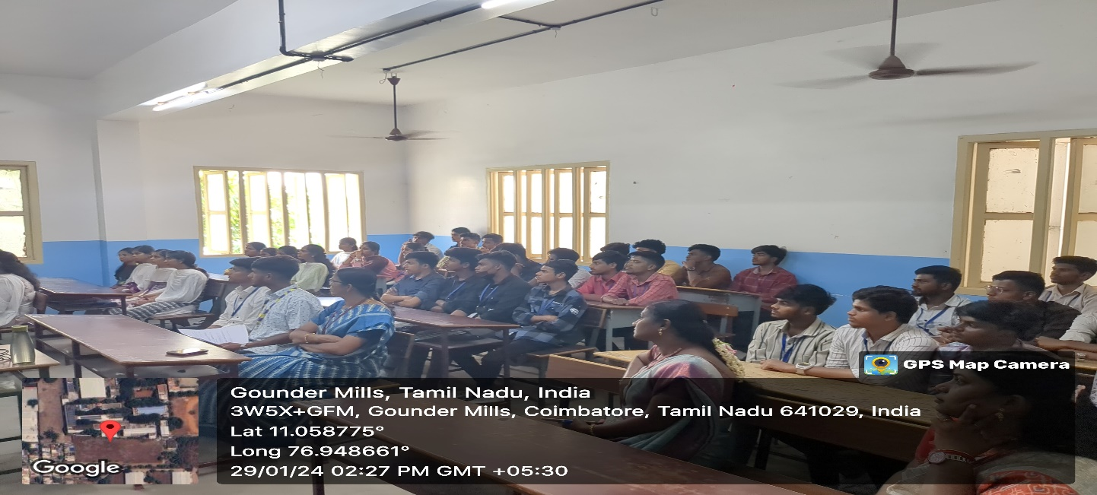
The seminar came to a conclusion with the vote of thanks by Dr.N.Alamelumangai, Assistant Professor, Dept of IT. In total 46 number of students were present for the session and were benefitted.

