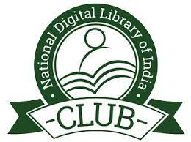
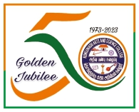
KONGUNADU ARTS AND SCIENCE COLLEGE (Autonomous)
Re-accredited by NAAC with ‘A+’ Grade (4th cycle)
College of Excellence (UGC)
29th Rank among Colleges in NIRF 2023
Coimbatore – 641 029.

DEPARTMENT OF INFORMATION TECHNOLOGY
& NDLI CLUB, KASC
Seminar on “Emerging Technologies of IT Trends”
Report
The Department of Information Technology and NDLI Club, KASC was conducted a Seminar on “Emerging Technologies of IT Trends” on 06.02.2024 at 11.00 AM. The Chief Guest Mr. K. Santhosh Kumar, Business Development and Zonal Manager, Accent Techno Soft Private Limited, Coimbatore, addressed the gathering about Emerging Technologies of IT Trends.
Dr. K. Dhanalakshmi, Assistant Professor and Head (i/c) of the Department of Information Technology, gave an introduction about National Digital Library and explained about the importance and how to search and get access e- contents from the National Digital Library. She in her speech explained about, how to access the video lectures of different subjects.
Ms.S.Subhashini of II B.Sc Information Technology welcomed the gathering. Mr.R.Sanjay of I B.Sc Information Technology introduced the Chief Guest.
Mr.K.Santhosh Kumar discussed about the Career, Job, Self-Assessment, Decision Making and Content Management. He also explained about Software Development Life Cycle, Emerging Technologies like Artificial Intelligence, Machine Learning, Deep Learning, Flutter and Cyber Security. In his speech, he mentioned the programming languages which are used in current IT Trends such as Python, R, Ruby, Perl, Go, Mat Lab, JavaScript, Ajax, etc., He mentioned the opportunities available in IT fields such as Social Media Analyst, Content Writer and Network Architect.
The meeting ended with the Vote of Thanks delivered by Ms.M.P.Kaviya of I B.Sc. Information Technology. 130 participants attended the meeting and got benefited through the programme.

