KONGUNADU ARTS AND SCIENCE COLLEGE

(AUTONOMOUS) COIMBATORE – 641 029.

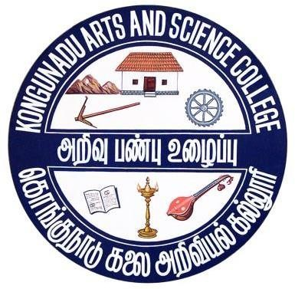

DEPARTMENT OF INFORMATION TECHNOLOGY

PROGRAMME SPECIFIC OUTCOMES (PSO) OF

B.SC INFORMATION TECHNOLOGY

For the students admitted in the
Academic Year 2023-2024

PROGRAMME SPECIFIC OUTCOMES (PSO)

PSO1 Apply the knowledge of computing and mathematics appropriate to the discipline.
PSO2 Apply current techniques, skills, and tools necessary for computing practical and to integrate IT-based solutions into the user environment effectively.
PSO3 Use design and development principles in the construction of software systems of varying complexity.
PSO4 An ability to use knowledge in various domains to identify real-world problems and hence to provide solution to new ideas and innovations.
PSO5 Design, document and develop robust applications by considering human, financial and environmental factors using cutting edge technologies to address individual and organizational needs.

