KONGUNADU ARTS AND SCIENCE COLLEGE, (Autonomous)
Re-accredited by NAAC with ‘A+’ Grade (4th cycle)
College of Excellence (UGC)
29th Rank among Colleges in NIRF 2023
Coimbatore – 641 029, Tamilnadu, India.

DEPARTMENT OF INFORMATION TECHNOLOGY
Technical Symposium
on
“BYTE BLAST’24”
REPORT
The Department of Information Technology organizedaIntra Department Technical Event on 13thMarch 2024 at 10.00am in Conference Hall. The session began with the prayer song was sung by I B.Sc. ITstudents.
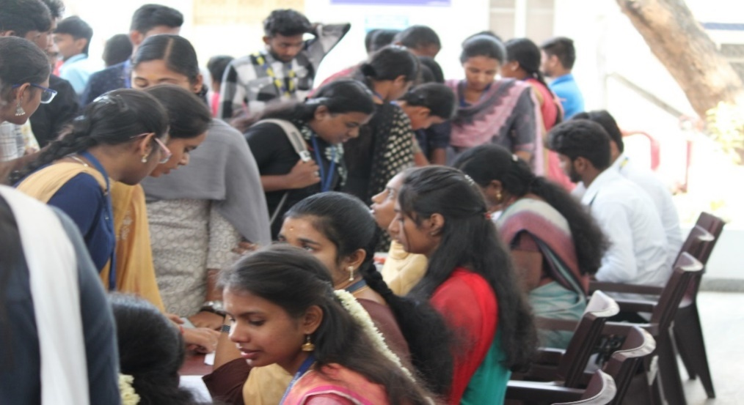
Inter Department Technical Event “BYTE BLAST’24”wasconducted on 13.03.2024 along with B.Sc. IT (Honours) Department. In this event, students from various other Departments actively took part and bagged prizes.During the day, Students participants had the opportunity to showcase their talent. The total number of students registered in this programme were 350 students approximately.
List of the Events organized includes:
1.Debugging
2. Quiz
3. Treasure Hunt
4. Connection
5.Adzap
6.Phtography
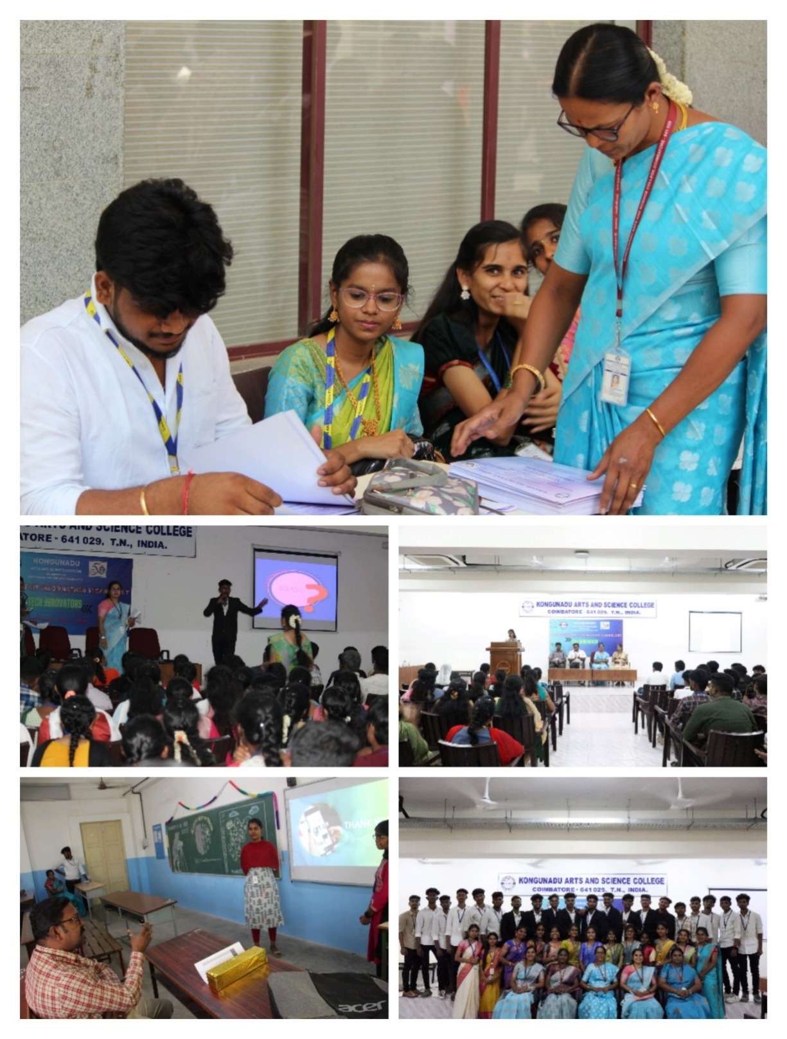
The MOC invited Mr. S. Nithin, Class Representative of IIIB.Sc. IT to welcome the gathering cheerfully. In his welcome address, he welcomed the dignitaries, the Academic Coordinator, HODs from other departments, faculty members and students.The session was handed over to,Dr.K.Dhanalakshmi, Assistant Professor and HOD(i/c), Department of Information Technologywho provided a detailed overview of the significantaccomplishment, Academicachievementsand successes achieved during the year of 2023 – 2024. Our MocinvitedDr.R.Saravanamoorthy, Academic Coordinator, KASCto encourage the students participants and prize winners to do the same in the upcoming years.
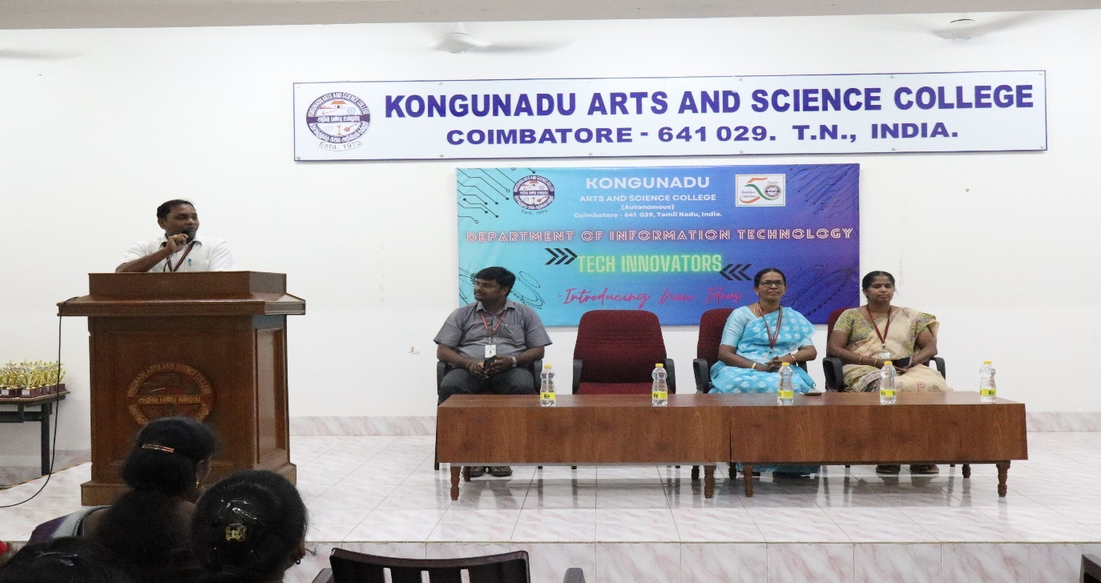

The MOC invited the Chief Guests to present the award for the prize winners.

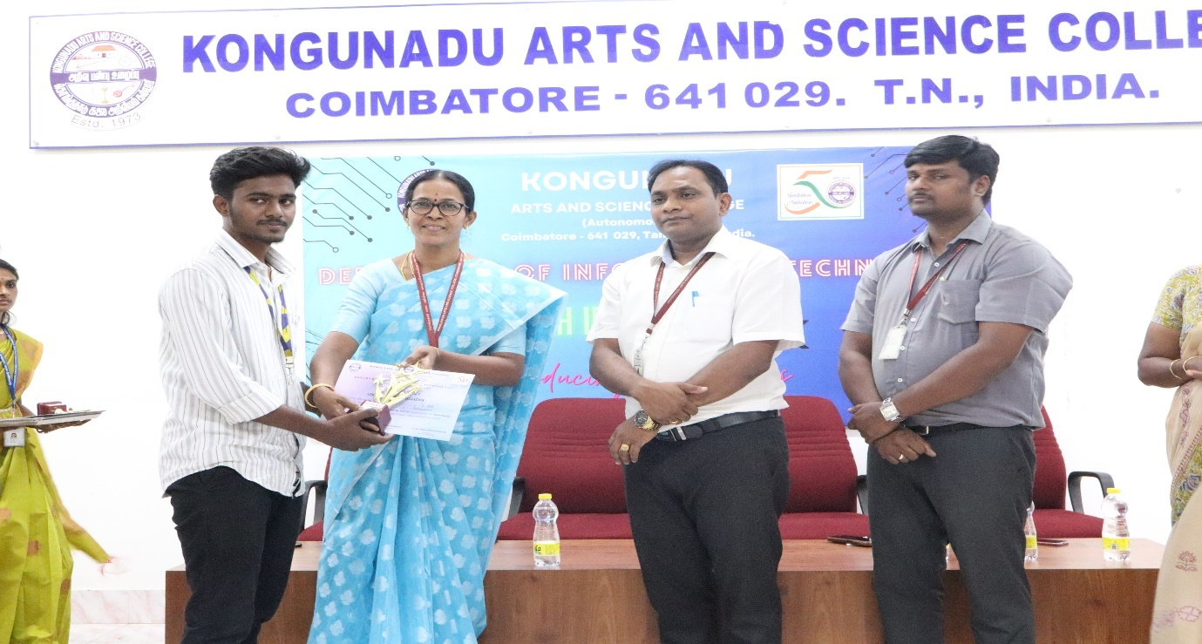
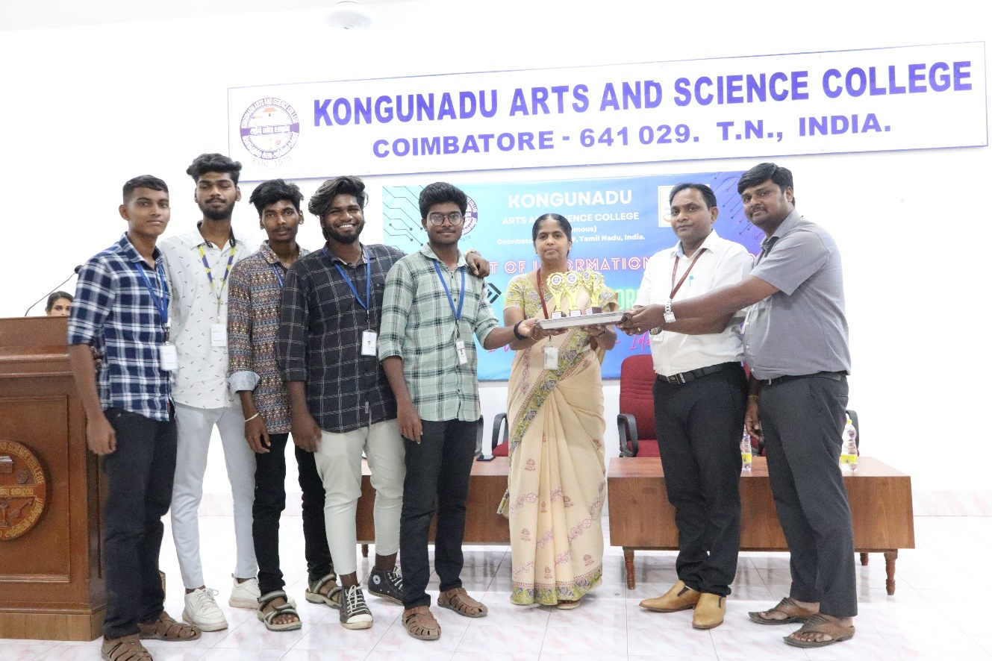
The Event came to a conclusion with the vote of thanks by Ms,M.Subashree, Students Council member, III B.Sc IT.

