
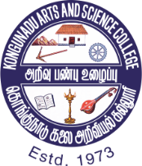
KONGUNADU ARTS AND SCIENCE COLLEGE
(AUTONOMOUS)
Affiliated to Bharathiar University
Re-accredited by NAAC with A⁺ Grade - 4th cycle, College of Excellence – UGC
29th Rank among Colleges in NIRF 2023
Coimbatore - 641 029, Tamil Nadu, India

DEPARTMENT OF MATHEMATICS
Under DBT STAR COLLEGE SCHEME
NATIONAL MATHEMATICS DAY CELEBRATIONS
INTER-SCHOOL COMPETITIONS
10.01.2024

REPORT
Name of the Event | NATIONAL MATHEMATICS DAY CELEBRATIONS -  INTER-SCHOOL COMPETITIONS
Date | 10.01.2024
Time | 10:00 AM
Venue of the Programme | Auditorium, Conference Hall, Room No G5, C15 – C19.
Objectives of the Programme | To eradicate the fear of Mathematics among School students and help them to learn Mathematics subject with more interest
Outcome of the Programme | Participants got a platform to exhibit their skill and enhance their subject knowledge in Mathematics
Number of Beneficiaries | 701 School students

Report of the Programme
The Department of Mathematics of Kongunadu Arts and Science College organized Inter-School Competitions for School Students under DBT STAR College Scheme as a part of National Mathematics Day Celebrations on 10.01.2024 with the motive of eradicating the fear of Mathematics among students and help them to learn Mathematics subject with more interest. Dr. C.A. Vasuki, Secretary and Director of the College inaugurated the event.
Brain Teaser (Quiz), Manculator, Math Art, Sudoku Star, Formula Master, Chess Wizard, Math Model, Math Connection, War of Words and Master Mind competitions were conducted. 701 students participated in this Inter-School Competitions and exhibited their talent.
Dr. M. Lekeshmanaswamy, Principal of the college distributed the prizes to all the winners and gave the participation certificates to all the students.
‘Srinivasa Ramanujan Rolling Trophy’ was bagged by Vidhya Niketan Public School.
Teachers, Parents and Students felt that the events were creative and highly informative.
Faculty members of Department of Mathematics taught Vedic Mathematics to the school students.
DBT STAR College Scheme mainly aims to strengthen Science Education and Training among students. These competitions provided the platform for the students to explore their Mathematical skills and helped them to upgrade their knowledge.
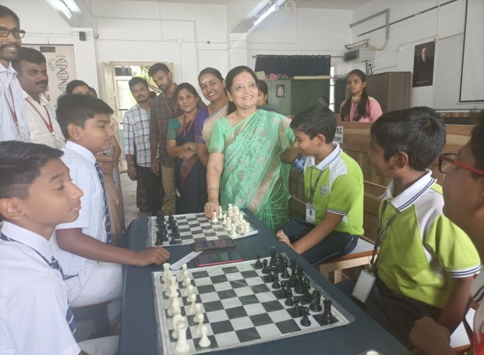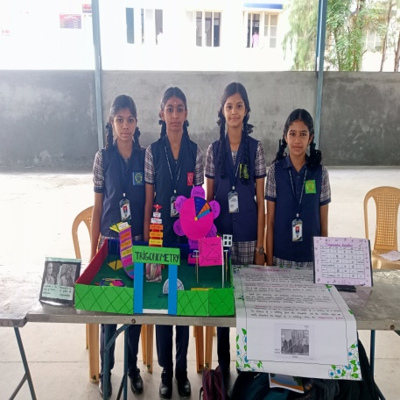
Model Exhibition by the Participants
Dr. C.A. Vasuki, Secretary and Director of the College inaugurates the Chess competition.

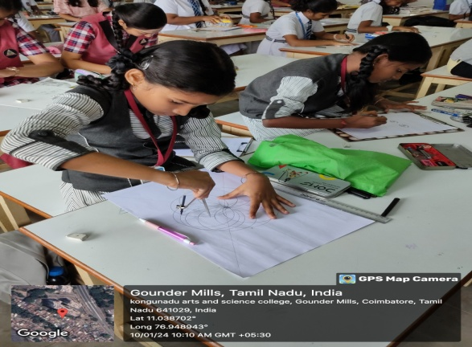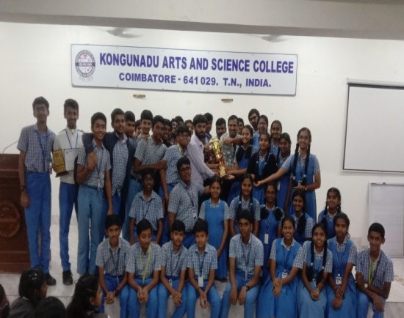
Participants of Vidhya Niketan Public School receiving the ‘Srinivasa Ramanujan Rolling Trophy’.

Enthusiastic Participants Drawing Math Art

