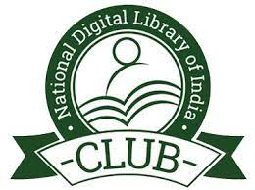KONGUNADU ARTS AND SCIENCE COLLEGE (Autonomous)

Re-accredited by NAAC with ‘A+’ Grade (4th cycle)

College of Excellence (UGC)

52nd  Rank among Colleges in NIRF 2024

Coimbatore – 641 029.

DEPARTMENT OF MATHEMATICS (SF)

&

NDLI CLUB, KASC

Lecture on

Life Coping Skills

The Department of Mathematics (UA) and NDLI club jointly organized a lecture on “Life Coping Skills” on 11.09.2024 at 11.00 am . The programme was started with the prayer song by the students of I BCA. Dr. A. Singaravelan,Head of the Department (UA) welcomed the gathering. Ms. S. Sowmiya from II BCA (Main) introduced the chief guest Dr. M. Balasubramaniam, Assistant Professor, Department of Education, Bharathiar University, Coimbatore-46. He gave a lecture on the topic “Life Coping Skills”. The session focused on balancing the life with healthy coping skills and coping mechanism.This session was very useful and informative. Around 190 participants along with 5 falculty members attened the meeting and got benifited.