|  |  |  |
| --- | --- | --- |
| https://www.kongunaducollege.ac.in/images/logo.jpg | **KONGUNADU ARTS AND SCIENCE COLLEGE**  **(AUTONOMOUS)**  **COIMBATORE – 641 029** |  |

**DEPARTMENT OF MATHEMATICS (UA)**

**Name of the Event:** Aptitude Training Class for Final Year Students

**Date of the Event:** 23. 09. 2024 **Venue of the Event:** Conference Hall

**No. of Students Participate:** 150

**Detail Descriptions of Event:**

The Department of Mathematics (UA) of Kongunadu Arts and Science College organized 10 days aptitude training for final year students. Dr. A. Singaravelan, Assistant Professor and HOD of Mathematics (UA), welcomed the gathering in Conference Hall. The inauguration of the aptitude training class was initiated by Dr. R. Saravanamoorthy, Academic Coordinator and HOD of Computer Science (UA) and explained the importance of aptitude problems to students in competitive examinations and job interview especially in IT companies. After the inauguration, the students were allocated into three batches namely Batch A, Batch B and Batch C.

Batch A students comprises of final year students of B.Sc DA, B.Sc AI &ML, B.Sc CT and B.Com A&F. Batch B students comprises of final year students of B.Com CA (Main and Additional), B.Com (Main and Additonal), M.Com, BBA CA and B.Com (IT). Batch C Students comprises of final year students of B.Sc CS, B.Sc Biotechnology, B.Sc IT and BCA (Main and Additional). The Aptitude classes were taken by the faculties of the department of mathematics from 30 – 09 – 2024 to 17 – 10 -2024 simultaneously. Batch A and Batch B classes was conducted at 8:00 am – 09:00am. Batch C class was conducted at 04:00pm – 05:00pm on all the ten days. Students are practised by aptitude questions in various topics like Time and Work, Time and Distance, Time and Speed, Problems on Ages and Problems on percentages. Overall it was a unique and different experience to the participated final year students.

**Photographs of the Inauguration Event:**

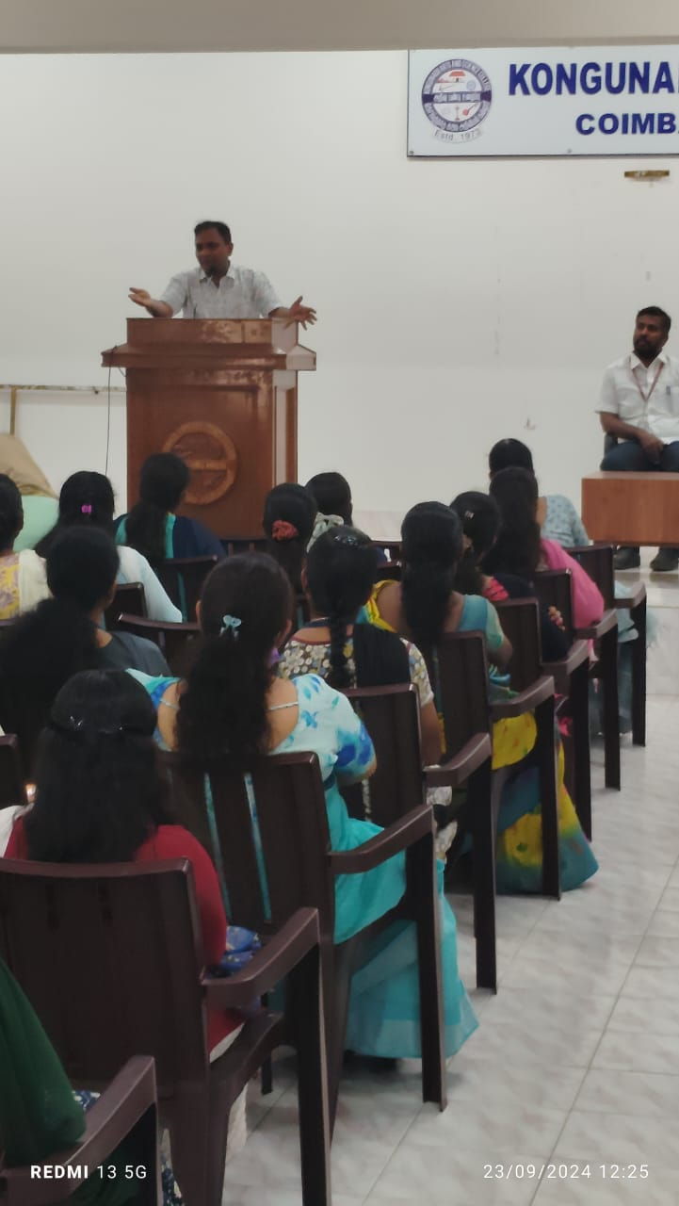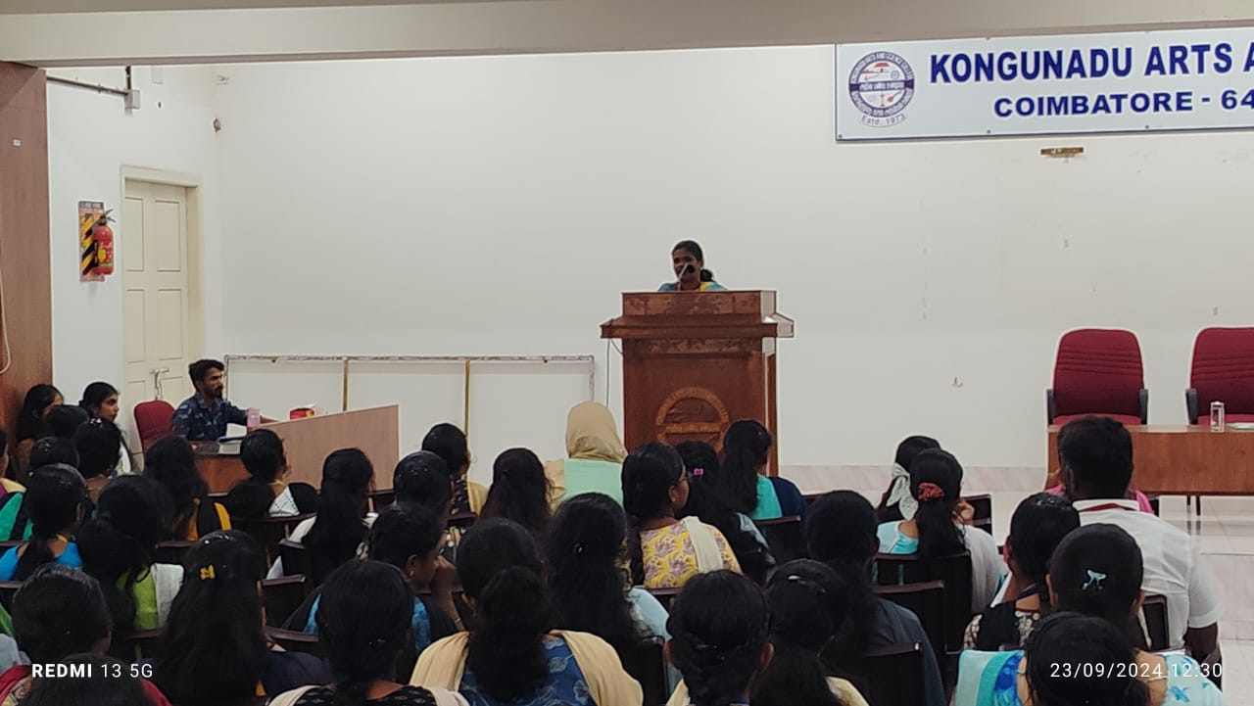

**Photographs of the Training class:**

