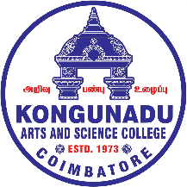


KONGUNADU ARTS AND SCIENCE COLLEGE
(AUTONOMOUS)

Re-accredited by NAAC with A⁺ Grade (4th Cycle)
College of Excellence (UGC)

TOP TEN STAFF LISTED IN SCOPUS DATA BASE
FROM THE COLLEGE

ACADEMIC YEAR 2025-2026

S.No. | Name | Designation
 | Dr.C.Ravichandran | Assistant Professor in Mathematics (A)
 | Dr.M.Venkatachalam | Assistant Professor in Mathematics (A)
 | Dr.K.Saminathan | Assistant Professor in Chemistry (UG)
 | Dr.K.Kannan | Assistant Professor in Zoology
 | Dr.P.Matheswaran | Assistant Professor in Physics
 | Dr.R.T.Narendhirakannan | Assistant Professor in Biochemistry (UG)
 | Dr.N.Mohanapriya | Assistant Professor in Mathematics (A)
 | Dr.K.Sowndhararjan | Assistant Professor in Botany
 | Dr.B.Chadar Shekar | Associate Professor in Physics
 | Dr.B.Gokul | Assistant Professor in Physics

