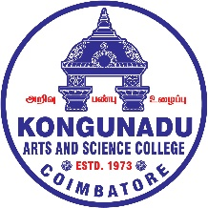**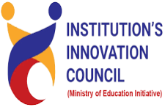KONGUNADU ARTS AND SCIENCE COLLEGE   
(AUTONOMOUS) Re-Accredited by NAAC with A+ Grade (4th cycle)52nd Rank among Colleges in NIRF 2024College of Excellence (UGC)Coimbatore - 641 029, Tamil Nadu, India**

**Session Details:** Activities Focuses on prototype, design, process development

**Title of the session:** Workshop on Prototype/ Process Design and Development

**Date:** 28.08.2025 and 29.08.2025

**Duration**: 2 days

**Activity Category:** IIC Calendar

**Theme:** To develop prototype or process design

**Expert/Speaker Details:**

1. Ganesh Babu Balamurugan, Founder and CEO of Web Epic Technologies Pvt Ltd, Coimbatore
2. Sundarmoorthi S, Executive Member, Safaari, Coimbatore

**Name:** Ganesh Babu Balamurugan / Sundarmoorthi S

**Designation:** Founder and CEO / Executive Member

**Organization:** Web Epic Technologies Pvt Ltd / Safaari

**Brief about Expert/Speaker:**

Mr. Ganesh Babu Balamurugan’s leadership has been instrumental in steering the company to new heights within the competitive IT industry, fostering innovation and strategic growth. Commitment to Integrity and Responsibility Company success is not only measured by technical achievements but also by our unwavering commitment to ethical business practices.

Mr. Sundarmoorthi S is an executive member who helps guide the company’s plans and goals. He focuses on improving the business, supporting the team, and making sure the company grows successfully.

**Outcome of the activity:**

The overall goal of the Workshop on Prototype/Process Design and Development is to equip participants with the knowledge and skills to transform ideas into tangible, testable prototypes using structured design methodologies. It aims to foster innovation, problem-solving, and collaborative thinking in the development of efficient and user-centered processes or products. By the end of the workshop, participants should be capable of creating and refining prototypes that align with real-world requirements and project goals.

* Participants gain a deeper understanding of systematic design thinking, enabling them to approach prototype and process development with a structured methodology.
* The workshop equips attendees with hands-on experience using various tools and techniques to create functional prototypes, from basic models to advanced digital simulations.
* Through collaborative exercises and real-world case studies, participants learn to identify user needs, analyze design challenges, and develop innovative, practical solutions
* Teams develop preliminary design and development plans for their own projects, including timelines, resource identification, and evaluation metrics, ready for further refinement and implementation.

**Key Highlights:**

Participants learned key concepts about:

* Structured Design Thinking.
* Hands-On Prototyping Skills.
* Project Planning and Innovation.

**Participant details:**

**Total no. of Student participation:** 81

**Total no. of Staff (Teaching/Non-teaching) participation:** 5 Teaching staffs.

**Three to four Photographs/Screenshots that show the participation of students and Staffs (Teaching/Non-teaching):**

**DAY 1:**

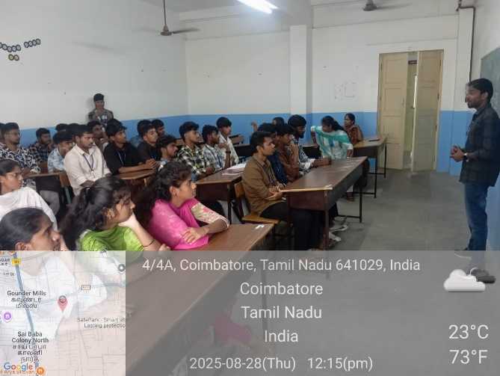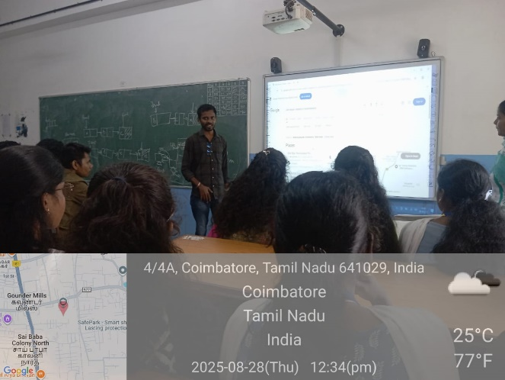

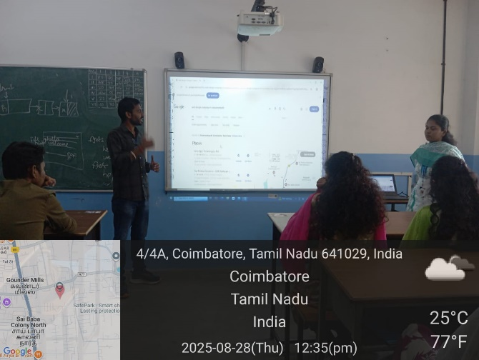

**DAY 2:**

